April 12-13, 2022 North Louisiana Severe Weather Outbreak

By: Don Wheeler, Meteorologist

April is traditional the peak of severe weather season for the state of Louisiana and is the month with the highest average number of tornadoes. On April 12 and 13, 2022 a strong cold front and preceding upper-level disturbances produced multiple rounds of severe weather across north Louisiana that produced widespread wind damage and power outages as well as six tornadoes (one additional tornado in southwest Arkansas) over the course of the two-day period. In addition to the tornadoes, there were 52 reports of strong wind and/or wind damage and 3 reports of large hail (see damage report maps in the appendix).

Much of the damage from the storms was confined to snapped and uprooted trees. Most of the structural damage from the wind and tornadoes was due to falling trees or tree limbs onto the structures with a few occurrences of damage attributed directly to high wind and tornadoes. Fortunately, no fatalities were reported with this event and only one minor injury associated with the Swartz, Louisiana tornado.

The multiday, multievent severe weather outbreak occurred in three phases: 1) Swartz, Louisiana supercell and tornado during the early evening of April 12; 2) QLCS Squall Line during the evening and early morning hours of April 12/13, and; 3) QLCS Squall Line and supercell during the afternoon/evening of April 13.

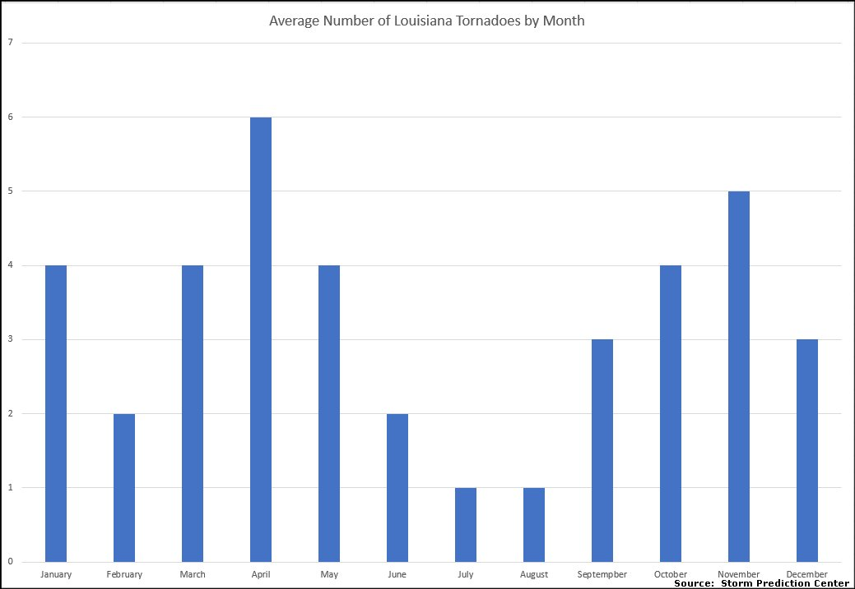

April 12 Synopsis
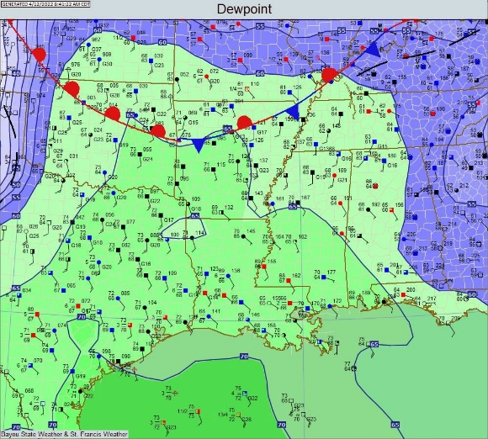
The morning surface analysis at 12Z (7AM CDT) showed a 1027mb high off of the eastern seaboard east of North Carolina that was ridging west across the deep south into Louisiana and eastern Texas. Winds were southerly across Louisiana and east Texas which was allowing for moisture to advect north into those areas at the surface. The morning dewpoint map showed dewpoint values well into the 60s surging north across all of Louisiana and east Texas and into portions of southwest Arkansas and southeast Oklahoma.

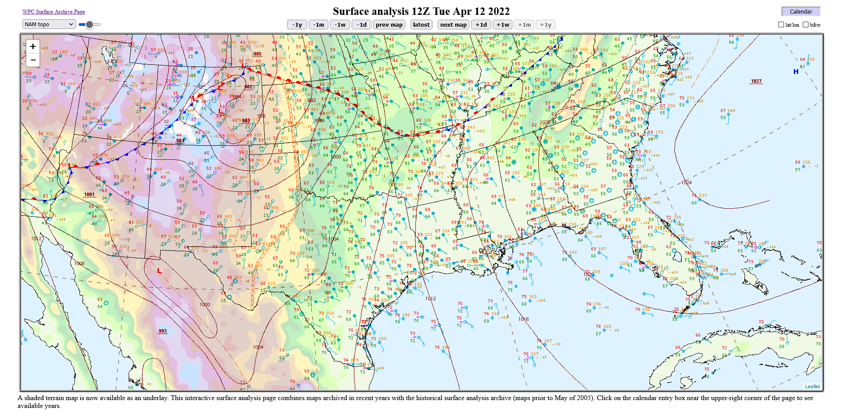

Further west, a dryline was noted extending south out of western Kansas into eastern sections of the Oklahoma and Texas panhandles and then into southwest Texas. A developing area of low pressure was noted across Colorado with a warm front extending southeast across Kansas and then east along the Arkansas and Missouri border. A cold front extended southwest from the Colorado low into northern Arizona. This system would not significantly affect the weather in Louisiana until April 13; however, the dryline would surge east and, in combination with an approaching upper-level disturbance, would produce a squall line later in the evening.

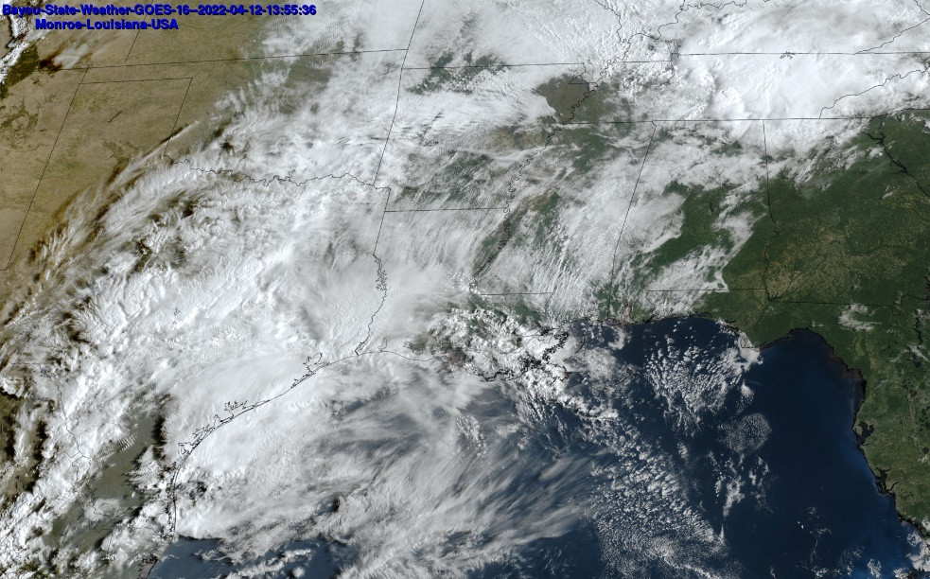
Satellite imagery on the morning of April 12 showed an upper-level disturbance moving northeast out of Texas toward Louisiana. As this system moved northeast during the day, it had the potential to produce showers and thunderstorms with daytime heating across the state. In addition, some of the storms would have the potential to become severe, although the primary threat would be later in the evening with storms enhanced by the eastward surge of the dryline as the main axis of the upper-level disturbance pushed across the region.

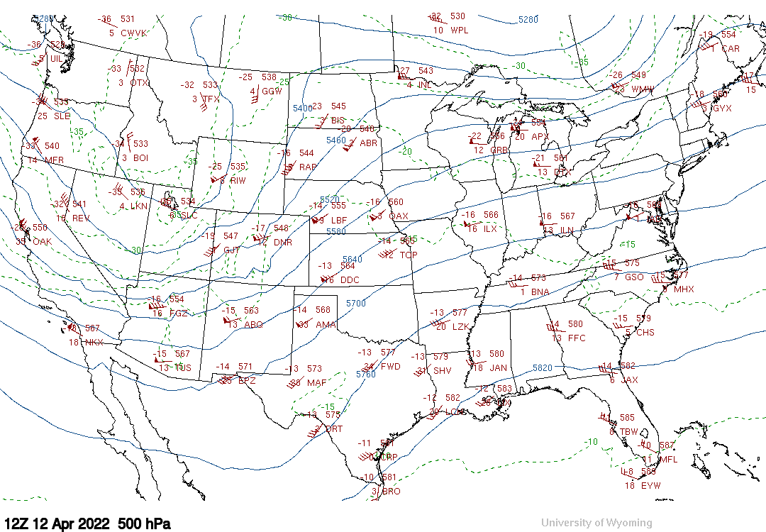
The 500 mb chart showed a flattening ridge across the eastern U.S. with a large trough digging into the western U.S. The upper-level disturbance seen on satellite imagery over Texas would ride northeast along the southeastern periphery of the trough. This trough would also migrate east with time allowing a strong cold front so surge southeast the next day.

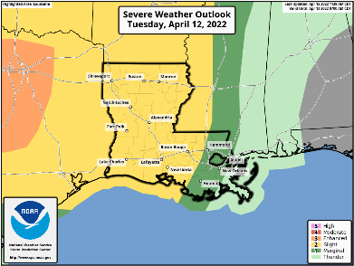
The Storm Prediction Center placed much of Louisiana under a “Slight Risk” for severe thunderstorms during the day with the primary threats being damaging wind gusts (15%) and large hail (15%). The tornado threat was only a 5% probability of a tornado within 25 miles of any given point.

By the afternoon of April 12, scattered showers and a few thunderstorms developed across much of the state but remained below severe limits. Late in the afternoon a line of strong to severe thunderstorms were developing across central Texas west and southwest of the Dallas/Ft. Worth area. These storms would continue to organize as they moved east and push across north Louisiana during the evening and overnight hours.

Ouachita Parish – Swartz Tornado, April 12.

A lone cluster of showers and thunderstorms developed over central Louisiana between Ft. Polk and Colfax around 21Z (4PM CDT) while moving northeast. As the storms pushed into Ouachita Parish around 22:38Z (5:38PM CDT), a very broad and weak circulation pattern was noted south of Richwood, but nothing remarkable. The storm had two lobes, one to the north of I-20 which was slightly elongated from west to east, and the other extending south of Monroe to south of Richwood along U.S. 165.

At 23:16Z (6:16PM CDT) the northern lobe of the cluster had dispersed with the southern portion remaining somewhat strong. Still, little evidence of circulation was detected by NWS Radar in Shreveport. As the storm was moving into southern Ouachita Parish, however, it moved into the typical zone of range folding which makes any circulation a bit more difficult to detect. In addition, the radar beam’s lowest scan was at around 9,000 feet.

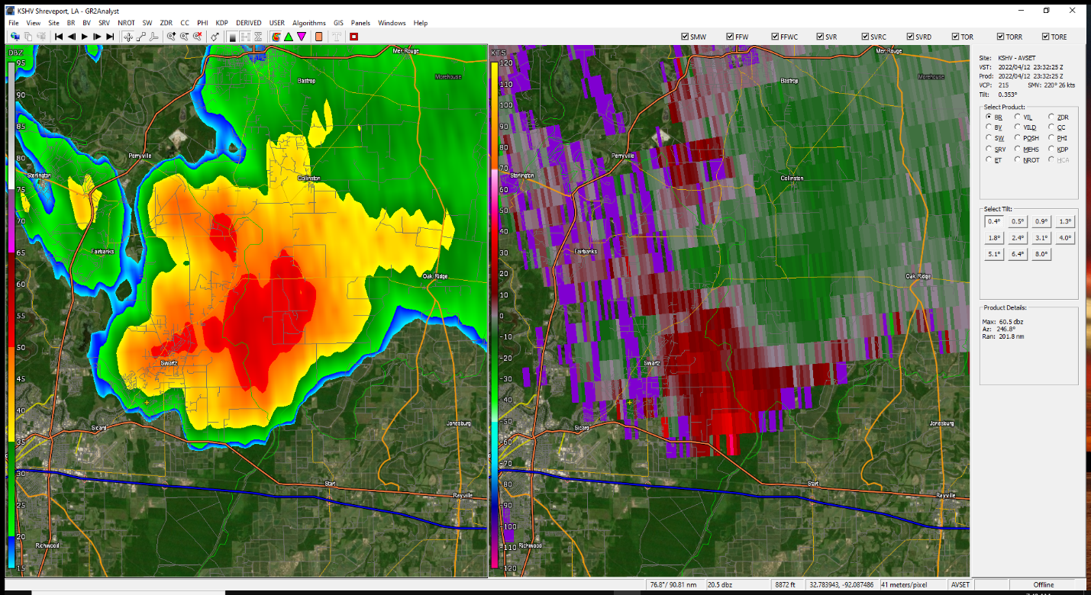

At 23:25Z (6:25PM CDT) this writer observed and videoed a rapidly rotating wall cloud with strong upward motion along with convergence as the storm was departing to the northeast. This feature was approximately two miles south-southwest of Swartz moving north-northeast. An inquiry was made to the National Weather Service via NWS Chat if any rotation was observed. The reply was, “We are not seeing anything on our end.” Another quick inquiry was made to a local TV station in West Monroe that has Doppler radar. They also reported as not seeing anything significant.
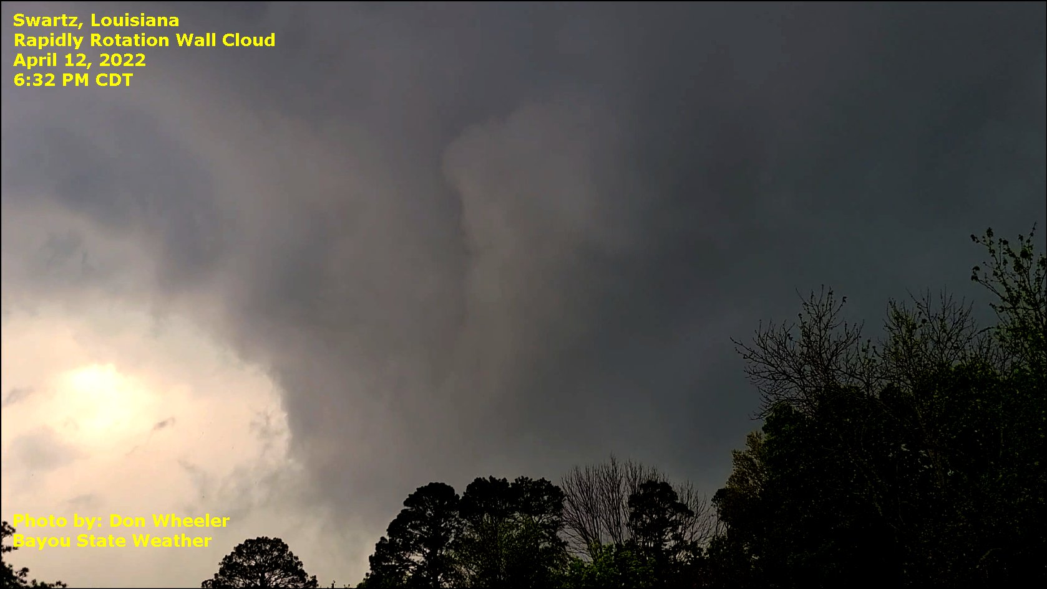

At 23:41Z (6:41PM CDT) reports of a tornado near the Swartz area began to come into local media. Damage was mainly confined to large uprooted and/or snapped trees, some of which fell on homes. One home did receive some wind-driven roof damage to its metal roof along with extensive damage to a nearby mobile home. This tornado produced EF1 damage with estimated winds of 110 mph.
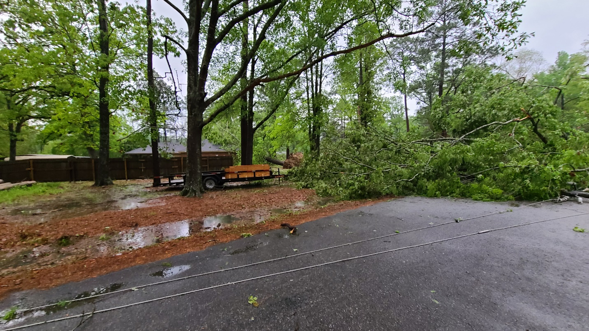

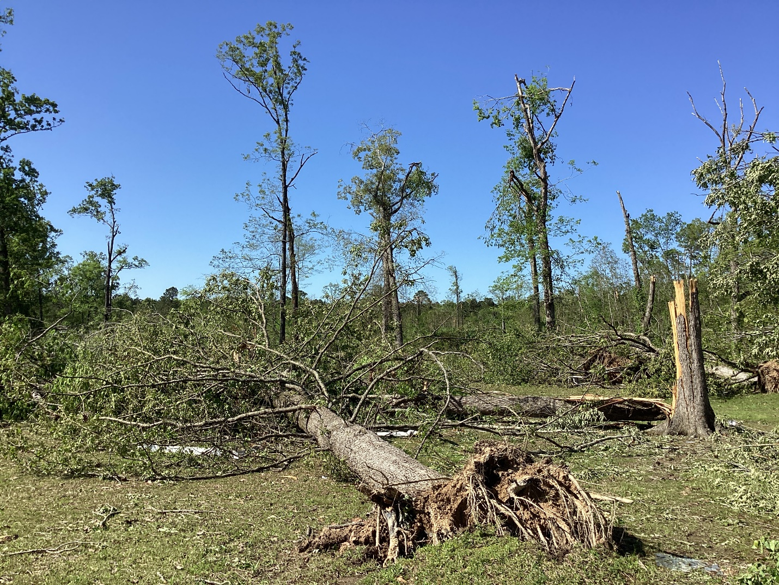

It is interesting that this particular tornado occurred with no watches or warnings issued. Radar scans showed little in the way of significant rotation that warranted any warnings. Perhaps the circulation in this storm was somewhat lower than usual preventing radar from detecting a significant circulation. The radar beam at the location of the tornado was approximately 9,300 feet. Unfortunately, the University of Louisiana at Monroe’s radar was out of service and unable to provide additional supporting data.

Below is the summary from the National Weather Service Survey.

Tornado #1...Swartz in Ouachita Parish, LA...
Rating: EF1
Estimated Peak Wind: 110 mph
Path Length /statute/: 2.5698 miles
Path Width /maximum/: 300.0 yards
Fatalities: 0
Injuries: 1
Start Date: 04/12/2022
Start Time: 06:34 PM CDT
Start Location: Swartz / Ouachita Parish / LA
Start Lat/Lon: 32.5619 / -91.9872
End Date: 04/12/2022
End Time: 06:39 PM CDT
End Location: 2 N Swartz / Ouachita Parish / LA
End Lat/Lon: 32.5985 / -91.9812
Survey Summary:
This tornado, originating from a supercell thunderstorm, began
in the Swartz community near Woodmont Drive. It tracked just east
of due north for around two and a half miles over a largely
residential area. Direct damage was primarily to trees, although
many structures and homes were damaged due to falling trees and
tree limbs. Tree damage was near the EF-0 to EF-1 threshold for
most of the track with many more tree uproots than trunk snaps
(and usually snapping of trunks requires more wind than uproots).
However, near the end of the tornado along and north of Highway
139, the level of tree damage indicated a strengthening of the
tornado, in particular along Trichel Lane. It is near the end of
that road that approximately one hundred tree uproots and trunk
snaps occurred, warranting a peak wind estimate of 110 mph, which
is a high-end EF-1. Unfortunately, one of these trees destroyed
a mobile home and a resident inside was injured, although
apparently not critically.

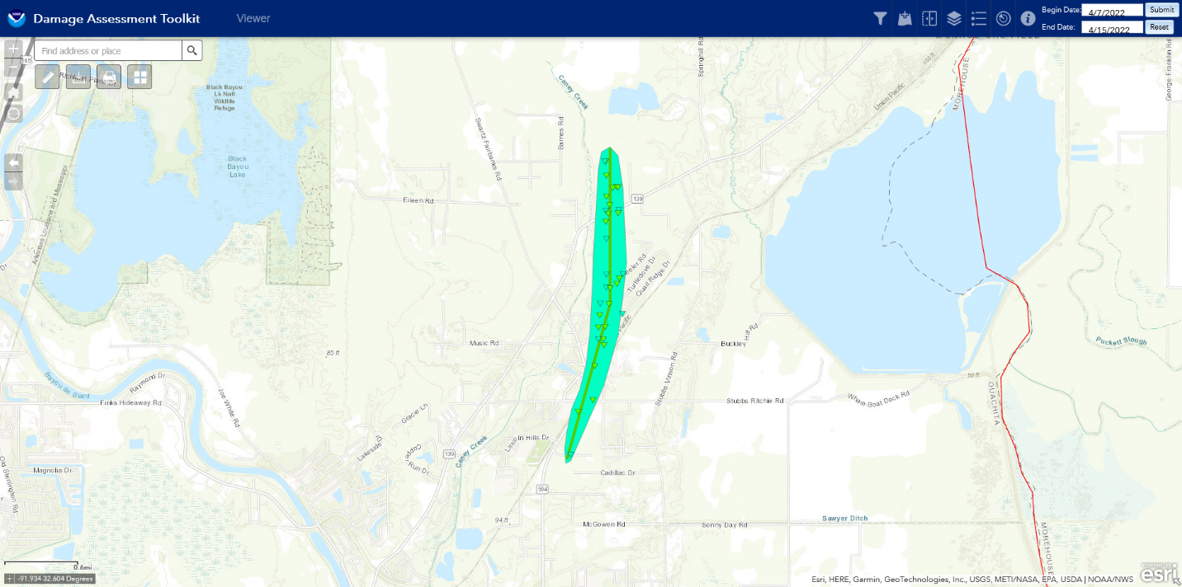

Round Two – The Squall Line/QLCS

During early evening hours of April 12 while the lone tornadic storm was occurring over Ouachita Parish, a line of strong to severe thunderstorms was developing over northcentral Texas from near the Dallas/Ft. Worth area southward to near Temple, Texas. Over the course of the evening the line would continue to solidify into a Quasi-Linear Convective System (QLCS). A quasi-linear convective system (QLCS) is a type of Mesoscale Convective System (MCS) that features a convective line or line segments that are much longer than they are wide (American Meteorological Society).

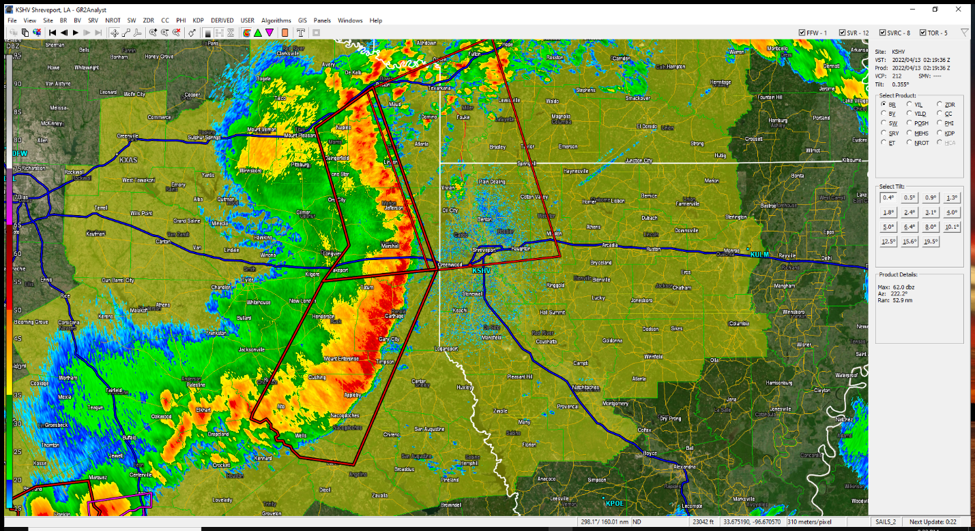

Note that as the line was approaching northwest Louisiana that it was taking on a bow feature producing very strong and damaging wind. Once this line entered northwest Louisiana individual bowing segments, a Line Echo Wave Pattern (LEWP), began to form within the line. The apex of these smaller segments can produce damaging wind gusts as well as tornadoes, sometimes called a QLCS tornado, at the top of the bow feature. These types of tornadoes spin up quickly and usually do not last very long when compared to a typical supercell tornado which makes for a short lead time for warnings. While short-lived, a QLCS tornado can be rather destructive. An additional danger is that they are usually embedded in rain and difficult to spot as they approach.

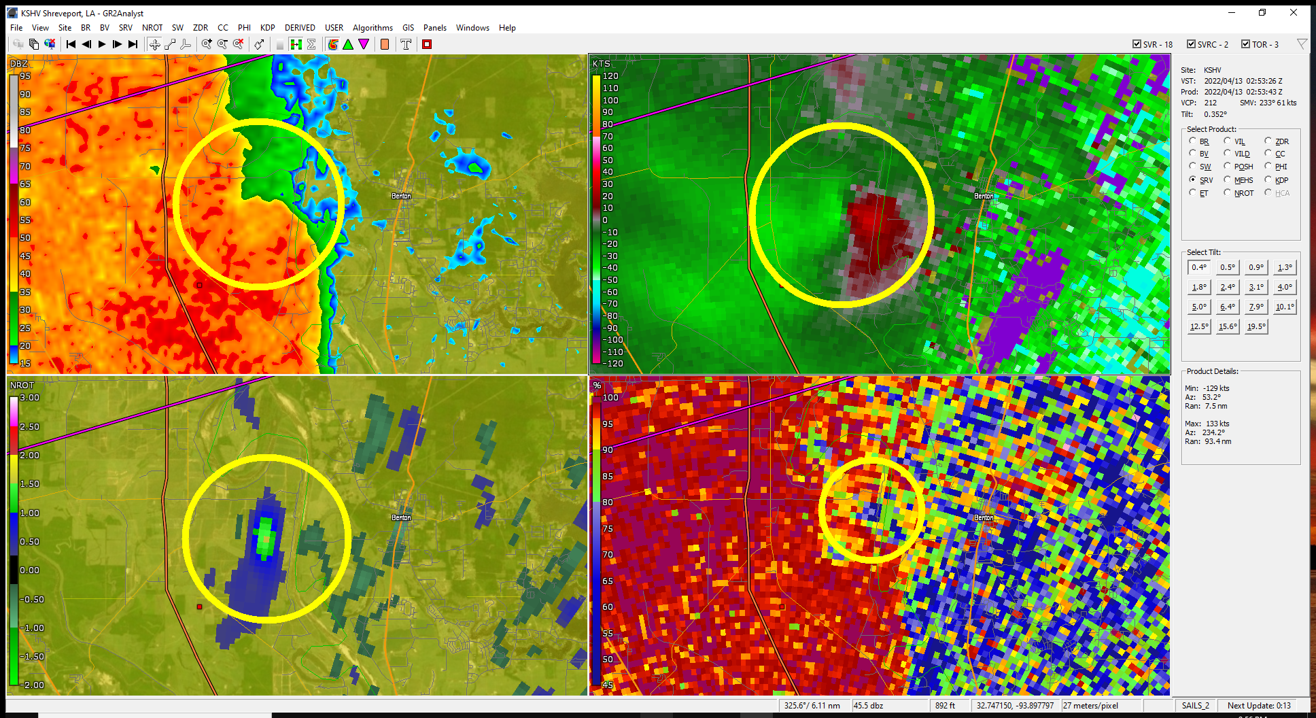
This radar image at 0253Z (9:53PM CDT) shows four panels of a confirmed tornado just west of Benton, Louisiana. Reflectivity is in the upper left, storm relative velocity in the upper right, rotation in the lower left, and correlation coefficient in the lower right. The reflectivity is showing only a small notch on the north side of a bow feature while the velocity is showing strong rotation. Correlation coefficient is showing a debris signature.

Numerous “spin-ups” began to occur within the line across much of northwest Louisiana. During the evening several reports of wind damage were received by the National Weather Service along with four confirmed tornadoes across northwest Louisiana and a fifth in southwest Arkansas. A particularly long significant wind damage path was noted over southeast Claiborne and southwest Union Parishes.

Confirmed tornado touchdowns occurred northwest of Benton in Bossier Parish (EF1 – 110 mph), south Shreveport in Caddo Parish (EF0 – 85 mph), northwest of Hosston in Caddo Parish (EF0 – 80 mph), Castor in southern Bienville Parish (EF1 – 100 mph), and near Prescott, Arkansas in Nevada County (EF0 – 85 mph). Damage path maps of these tornadoes are found in the appendix.

The aforementioned significant wind damage path in Claiborne and Union Parishes consisted of 14.6 mile path that ranged from one to three miles wide with damage consistent with 70 to 90 mph winds. According to the National Weather Service survey, there were no indications of a tornado as “trees were almost exclusively downed to the northwest to north with little evidence of damage convergence typically characteristic of a tornado.” The damage path map is found in the appendix.

By midnight, the northern portion of the line continued to push east into northeast Louisiana and began to cross the Mississippi River in northeast Louisiana around 1AM. The southern portion of the line became more west to east oriented from near the upper end of Toledo bend to between Olla and Jena then northeast to near Tallulah and Lake Providence. The line at this stage had begun to weaken and was no longer producing tornado signatures but continued to produce heavy rainfall and spotty strong wind gusts.

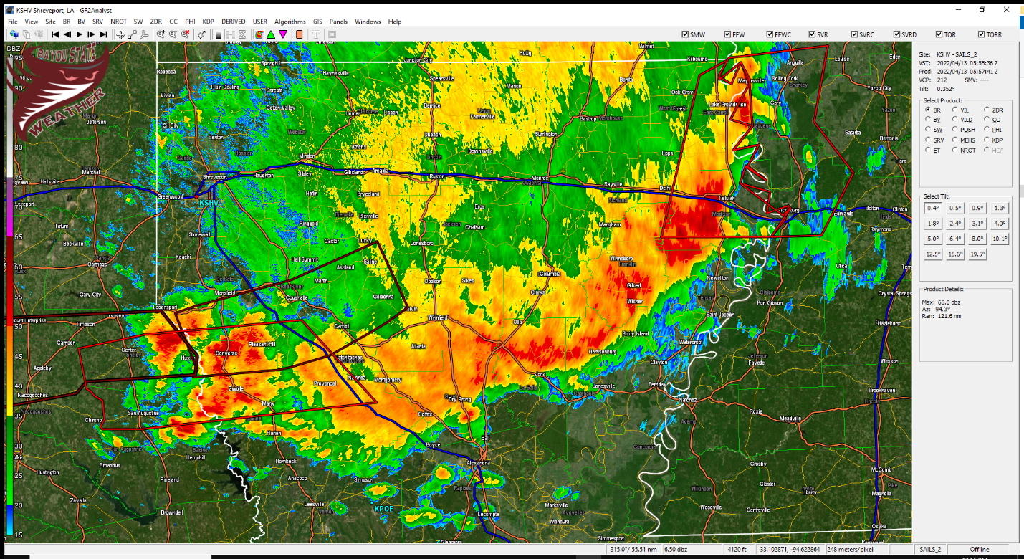

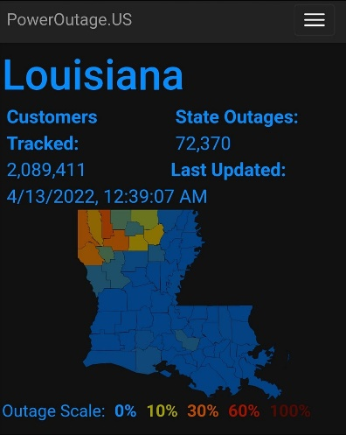
Widespread power outages occurred with this intense line of storms across all of north Louisiana. According to PowerOutage.US some 72,370 customers were without power as of 12:39AM on April 13. A look at the outage map to the left shows most of the outages were across northwest and northcentral Louisiana.

April 13 Synopsis

After two significant rounds of severe weather the previous day (April 12), much of Louisiana was under the gun for round three during the afternoon and early evening hours of Wednesday, April 13. The cold front that had been lingering over the Rockies had begun to surge southeast but had slowed upon its approach to northwest Louisiana at 15Z (10AM CDT). The front was forecast to resume its southeast motion during the afternoon and trigger another round of showers and thunderstorms through the evening hours with some of the storms potentially becoming severe.

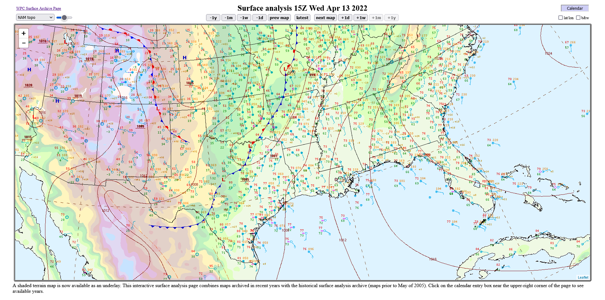
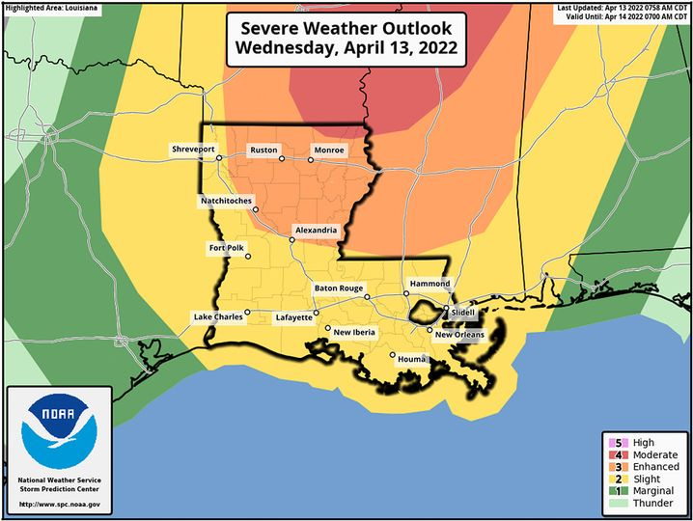
The Storm Prediction Center (SPC) placed much of northeast Louisiana under an “Enhanced Risk” with a small portion of extreme northeast Louisiana seeing a “Moderate Risk” for severe weather. The remainder of the state was under a “Slight Risk.” Analysis from the SPC indicated a potential tornado threat from both QLCS tornadoes as well as from individual supercells that may develop ahead of the squall line.

As the cold front approached northwest Louisiana early in the afternoon, showers and thunderstorms began forming across much of north Louisiana with a squall line in the formative stages along the approaching front across southwest Arkansas, northeast Texas, and extreme northwest Louisiana.

At 20:45Z (3:45 PM CDT) two tornado warnings were issued – one for northern Claiborne Parish and the other for southern DeSoto Parish. These storms were part of a broken squall line that was still trying to develop and intensify along and ahead of the cold front that was across northwest Louisiana. The northern portion of the line generally along and north of I-20 struggled to organize during the afternoon while the southern portion of the line generated damaging wind gusts.

Winn/Caldwell Parish Tornado

At 21:06Z (4:06 PM CDT) a lone supercell storm had developed ahead of the advancing squall line between Natchitoches and Winnfield moving northeast. Ft. Polk radar was indicating rotation developing as well as a “hook” feature on the southwestern end of the thunderstorm 3.5 miles south-southeast of Natchitoches.

At 4:17 PM the National Weather Service in Shreveport issued a tornado warning for this storm for northcentral Grant and southwestern Winn Parishes. The circulation continued to move northeast at 40mph passing two nautical miles south of Winnfield. This circulation weakened but then quickly intensified eight miles east-northeast of Winnfield.

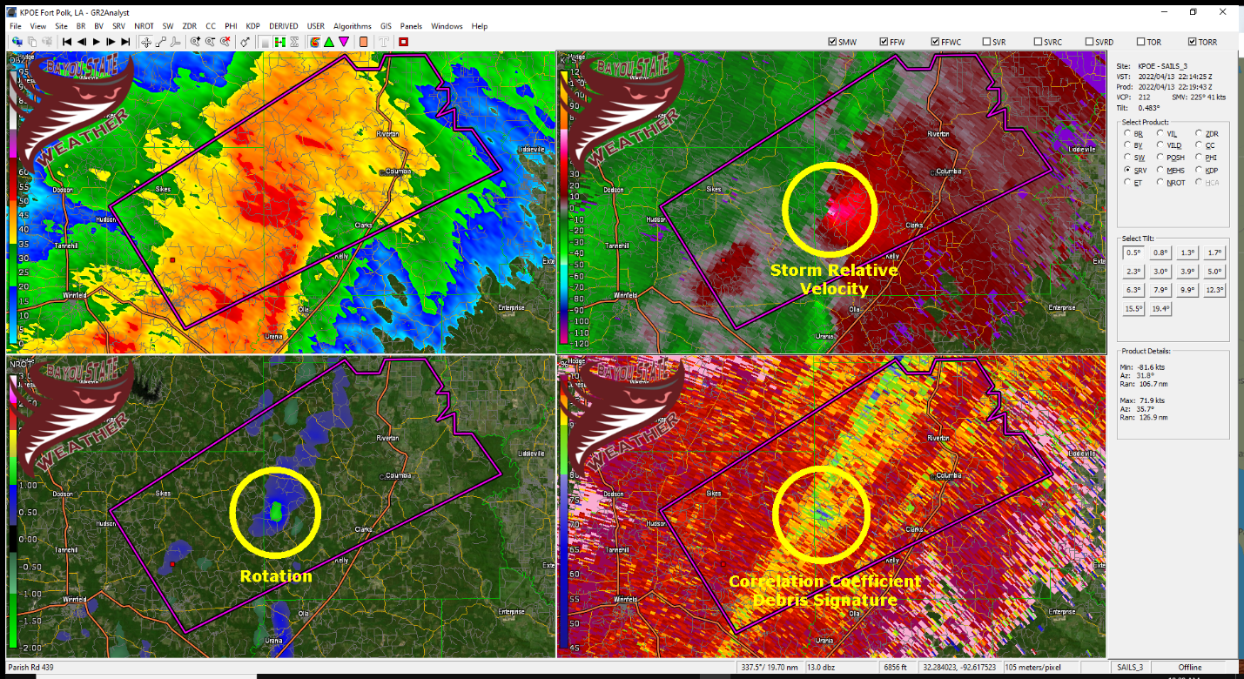

The first tornado warning for this storm was replaced and a new one issued further downstream at 4:40 PM for northeastern Winn Parish. The storm continued to push northeast at 40 mph. At 5:11 PM a third tornado warning was issued for Caldwell, southeastern Jackson, and northeastern Winn. This tornado warning was upgraded to “Confirmed Tornado” status.

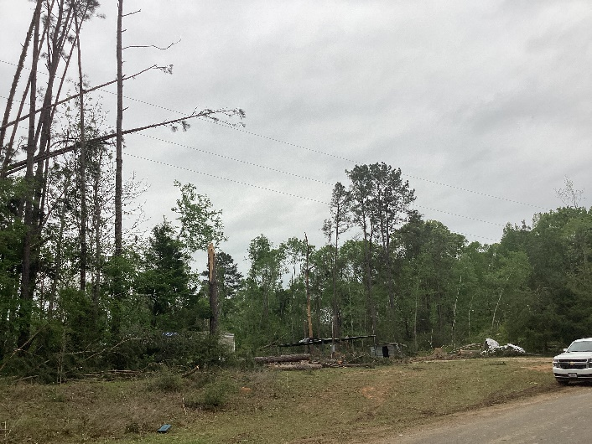
As of the 22:12Z (5:12 PM CDT) radar sweep from the Ft. Polk radar, a debris signature became visible 13 miles east-northeast of Winnfield or 12 miles northwest of Olla. The circulation and debris signature continued as it crossed into Caldwell Parish around 22:17Z (5:17 PM CDT). According to the final damage survey from the National Weather Service, the tornado dissipated two miles northwest of Columbia at 5:28 PM.

The final survey of this storm indicated that it established EF2 status with maximum estimated wind speeds of 115 mph. The path length was 19.3 miles with a maximum width of 625 yards. It was on the ground for approximately 17 minutes. EF2 damage was found to be near Childress Road in western Caldwell Parish.

Below is the damage survey report from the National Weather Service in Shreveport.

Tornado #7...Northeast Winn/Western Caldwell Parish, LA...
Rating: EF2
Estimated Peak Wind: 115 mph
Path Length /statute/: 19.2683 miles
Path Width /maximum/: 625.0 yards
Fatalities: 0
Injuries: 0
Start Date: 04/13/2022
Start Time: 5:11 PM CDT
Start Location: 7 SE Sikes / Winn Parish / LA
Start Lat/Lon: 32.0117 / -92.4006
End Date: 04/13/2022
End Time: 5:28 PM CDT
End Location: 2 NW Columbia / Caldwell Parish / LA
End Lat/Lon: 32.1195 / -92.1070
Survey Summary:
An EF-2 tornado with estimated maximum winds near 115 mph touched
down in a heavily wooded area just west of Highway 127 southeast
of Sikes in Northeast Winn Parish, where it snapped and uprooted
numerous trees. This tornado tracked northeast across another heavily
wooded area northeast of Highway 127, which was inaccessible by
vehicle. However, the Ft. Polk Doppler radar indicated a tornadic
debris signature northeast of Highway 127 near the Caldwell Parish
line, with the tornado continuing east-northeast into Western Caldwell
Parish. Much of this area remained inaccessible by vehicle, but the
tornadic debris signature remained from radar, as the tornado tracked
across Childress Road. This is where the strongest winds occurred,
where numerous trees were snapped and uprooted, and a couple falling
on homes. Remarkably, most of the homes avoided significant damage, as
the densely wooded area shielded the higher winds from these homes. The
tornado continued northeast across Highway 126 and Wiles Road, where
numerous trees were snapped and uprooted. Again, several homes were
protected from these trees with little if any damage, where the
tornado reached its widest point along Wiles Road and as it crossed
Highway 4 west of Columbia. Numerous trees were uprooted in front of a
residence opposite of the intersection of Highway 3239, with the tornado
continuing northeast and finally lifting northwest of Columbia before
reaching Highway 165 between Columbia and Riverton. These storms then
transitioned into a damaging straight line wind event as several large
tree limbs were snapped along both sides of Highway 165, with additional
straight line wind damage noted along Highway 133 in the Hebert
community along the Caldwell/Richland Parish line. Several trees were
uprooted and large limbs were snapped in this location. However, the
tree debris here all were lying in a southeasterly direction.

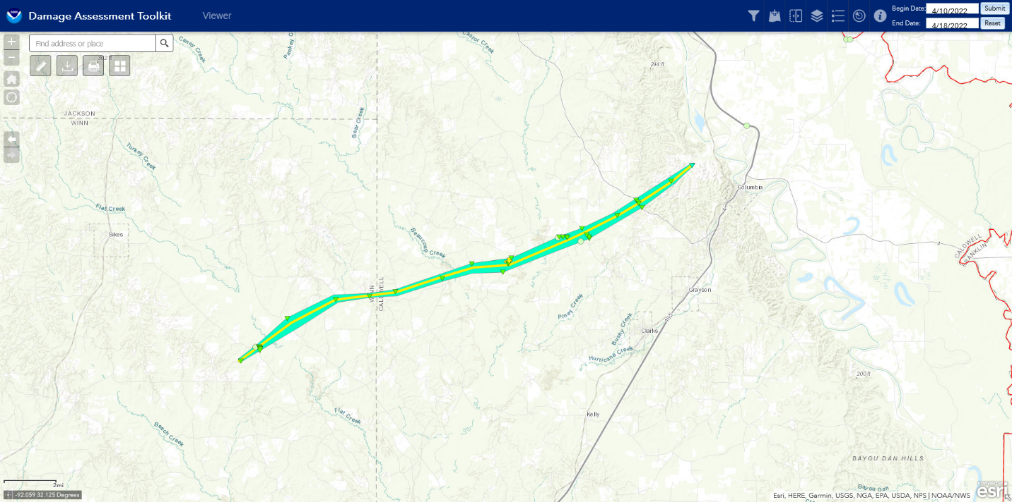

Appendix

Damage Survey from National Weather Service – Shreveport, Louisiana
Note: some portions irrelevant to this report were deleted

Public Information Statement
National Weather Service Shreveport LA
807 PM CDT Sat Apr 16 2022
...NWS Damage Survey for the April 12th-13th Tornado Event....Seven tornadoes and five wind damage swaths were confirmed thus
far from April 12th-13th.
Tornado #1...Swartz in Ouachita Parish, LA...
Rating: EF1
Estimated Peak Wind: 110 mph
Path Length /statute/: 2.5698 miles
Path Width /maximum/: 300.0 yards
Fatalities: 0
Injuries: 1
Start Date: 04/12/2022
Start Time: 06:34 PM CDT
Start Location: Swartz / Ouachita Parish / LA
Start Lat/Lon: 32.5619 / -91.9872
End Date: 04/12/2022
End Time: 06:39 PM CDT
End Location: 2 N Swartz / Ouachita Parish / LA
End Lat/Lon: 32.5985 / -91.9812
Survey Summary:
This tornado, originating from a supercell thunderstorm, began
in the Swartz community near Woodmont Drive. It tracked just east
of due north for around two and a half miles over a largely
residential area. Direct damage was primarily to trees, although
many structures and homes were damaged due to falling trees and
tree limbs. Tree damage was near the EF-0 to EF-1 threshold for
most of the track with many more tree uproots than trunk snaps
(and usually snapping of trunks requires more wind than uproots).
However, near the end of the tornado along and north of Highway
139, the level of tree damage indicated a strengthening of the
tornado, in particular along Trichel Lane. It is near the end of
that road that approximately one hundred tree uproots and trunk
snaps occurred, warranting a peak wind estimate of 110 mph, which
is a high-end EF-1. Unfortunately, one of these trees destroyed
a mobile home and a resident inside was injured, although
apparently not critically.
A special thanks goes out to the Ouachita Parish Office of
Homeland Security and Emergency Preparedness for their
assistance in locating damage and getting details on the survey.

Wind damage swath #3...Southern Hills in South Shreveport, LA...
Rating: TSTM/Wind
Estimated Peak Wind: 85 mph
Path Length /statute/: 2.2 miles
Path Width /maximum/: 1400.0 yards
Fatalities: 0
Injuries: 0
Start Date: 04/12/2022
Start Time: 9:47 PM CDT
Start Location: 8 SW Shreveport / Caddo Parish / LA
Start Lat/Lon: 32.4050 / -93.8120
End Date: 04/12/2022
End Time: 9:49 PM CDT
End Location: 6 SSW Shreveport / Caddo Parish / LA
End Lat/Lon: 32.4170 / -93.7800
Survey Summary:
A band of damaging straight line winds estimated between 75-85 mph developed
along the leading edge of a quasi-linear convective system (QLCS) across a
portion of the Southern Hills neighborhood of South Shreveport, from the parent
storm that would later spawn an EF-0 tornado over Southeast Shreveport and
South Bossier City only 6-15 minutes later. Multiple large trees were snapped
and uprooted in an area bounded by Bert Kouns Industrial Loop to the south,
Walker Road to the west, Highway 3132 to the north, and Kingston Road to the
east. Trees fell on at least four homes in this area, with numerous large limbs
snapped as well. A large portion of a metal roof was peeled off of the back
of a used car company on Mackey Lane, with numerous shingles removed off of
a business in the South Park Village. The front facade of another adjacent
business in South Park Village was also blown into the parking lot. All of
the snapped and uprooted trees throughout Southern Hills as well as the
roof/facade damage in the South Park Village were all blown/lying in a
north-northeast direction, indicative of straight line winds.
Tornado #2...Northwest of Benton in Bossier Parish, LA...
Rating: EF1
Estimated Peak Wind: 110 mph
Path Length /statute/: 4.3067 miles
Path Width /maximum/: 200.0 yards
Fatalities: 0
Injuries: 0
Start Date: 04/12/2022
Start Time: 09:54 PM CDT
Start Location: 4 WSW Benton / Caddo Parish / LA
Start Lat/Lon: 32.6792 / -93.8091
End Date: 04/12/2022
End Time: 09:57 PM CDT
End Location: 2 NNW Benton / Bossier Parish / LA
End Lat/Lon: 32.7183 / -93.7515
Survey Summary:
A tornado which was embedded in a quasi-linear convective system
(QLCS) first touched down on a farm to the northeast of Blanchard
in Caddo Parish. A center pivot irrigation system was flipped by
the tornado as it crossed an open field. The tornado then snapped
tree branches before partially removing the roofs of four metal
farm buildings along Sentell Road. It then crossed the Red River
and moved into Bossier Parish.
As the tornado passed to the northwest of Benton, it strengthened
to an EF-1 along Willow Bend Road. There it began to uproot and
snap hardwood and softwood trees. The most intense damage was to a
guest house which was shifted off of its foundation and destroyed.
The tornado continued on to remove a large portion of the roof of
a two-story single family home. Two children on the second story
of the home were saved by their father who got the Tornado Warning
via a Wireless Emergency Alert (WEA) on his wireless phone and
then moved them to a tornado shelter in the center of the house on
the first floor.
The tornado continued on to damage another single family home and
then cross Old Plain Dealing Rd. After crossing Old Plain Dealing
Rd, the tornado removed the roof of a small metal outbuilding and
snapped and uprooted several more hardwood and softwood trees.
The tornado continued on into a forested area before lifting.
A special thanks goes out to the Bossier Office of Homeland
Security and Emergency Preparedness (OHSEP) for their assistance
locating damaging during this survey.

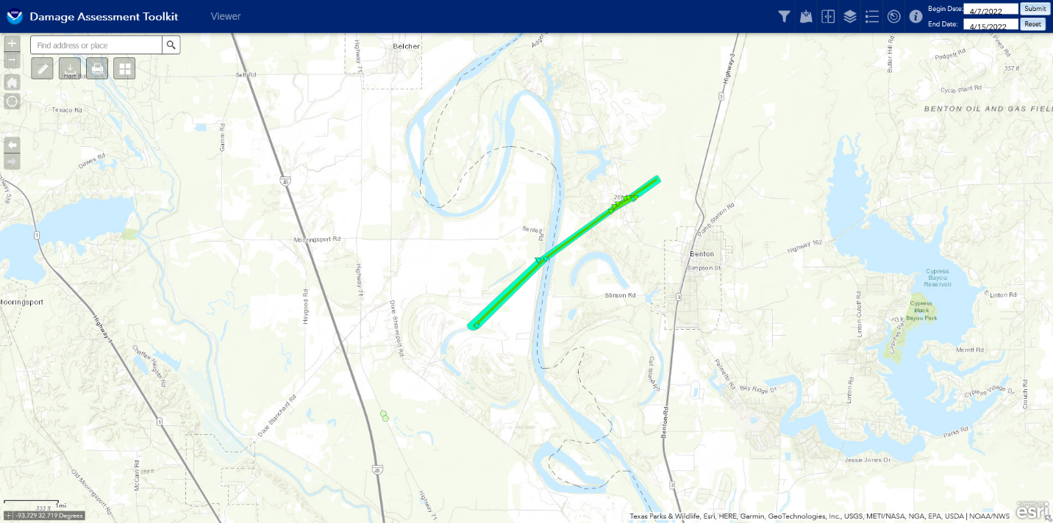
Tornado #3...South Shreveport in Caddo Parish, LA to Southern Bossier Parish, LA...
Rating: EF0
Estimated Peak Wind: 85 mph
Path Length /statute/: 12.1267 miles
Path Width /maximum/: 400.0 yards
Fatalities: 0
Injuries: 0
Start Date: 04/12/2022
Start Time: 09:55 PM CDT
Start Location: 6 SE Shreveport / Caddo Parish / LA
Start Lat/Lon: 32.4197 / -93.7138
End Date: 04/12/2022
End Time: 10:04 PM CDT
End Location: 10 E Bossier City / Bossier Parish / LA
End Lat/Lon: 32.5150 / -93.5419
Survey Summary:
The tornado embedded within a quasi-linear convective system
(QLCS) first touched down along Sophia Lane and Brunswick Drive in
Shreveport. There, large branches of hardwood and softwood trees
were broken and twisted off of the trees. The tornado continued on
to damage a food stand as it crossed Youree Drive. The tornado
continued to do mostly damage to large branches with a couple of
trees uprooted and minor shingle damage to single family homes in
a neighborhood adjacent to LSU-Shreveport. The tornado continued
on across the LSU-Shreveport campus, uprooting trees and downing
large branches. It also caused damage to the soccer and baseball
fields at LSU-Shreveport before crossing E Harts Island Rd. and
the Red River.
After the tornado crossed the Red River, in Bossier Parish, it
continued on to uproot trees and down and twist large tree
branches. It also uprooted trees which split at least three
manufactured homes off of Alfred Lane as they fell and damaged
several others. The tornado continued on to General Ewell Dr. and
then moved toward a forested area on Barksdale Air Force Base.
Barksdale Air Force Base personnel relayed that trees were uprooted
and that large branches were broken via pictures as the tornado
crossed the southern and eastern forested portions of the base.
Beyond Barksdale Air Force Base, only thunderstorm wind damage was
found off of Union Texas Rd and Academy Lane by Haughton Elementary
School.
A special thanks goes out to the teams at Barksdale Air Force Base,
the LSU-Shreveport Police Department, the Caddo Parish Office of
Homeland Security and Emergency Preparedness (OHSEP), and Bossier
Parish OHSEP for their assistance in locating damage on the survey.

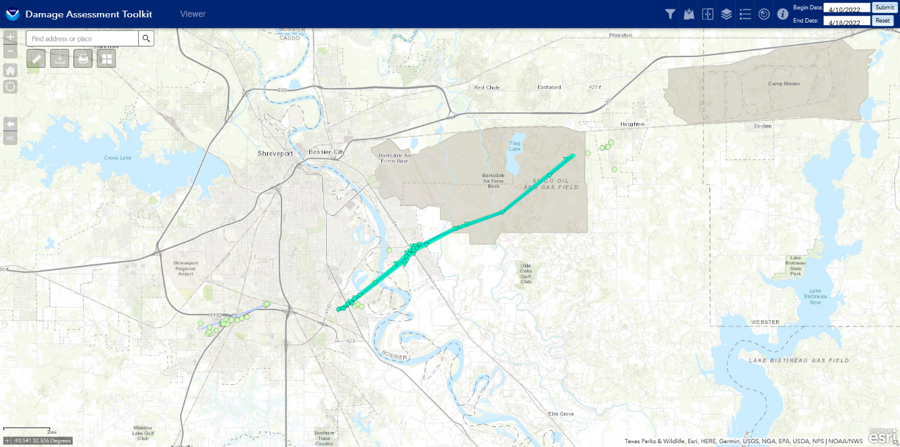
Tornado #4...Northwest of Hosston in Caddo Parish, LA...
Rating: EF0
Estimated Peak Wind: 80 mph
Path Length /statute/: 1.2315 miles
Path Width /maximum/: 50.0 yards
Fatalities: 0
Injuries: 0
Start Date: 04/12/2022
Start Time: 09:57 PM CDT
Start Location: 1 NW Hosston / Caddo Parish / LA
Start Lat/Lon: 32.8992 / -93.8991
End Date: 04/12/2022
End Time: 09:58 PM CDT
End Location: 2 N Hosston / Caddo Parish / LA
End Lat/Lon: 32.9131 / -93.8858
Survey Summary:
A tornado that was embedded within a quasi-linear convective
system (QLCS) briefly touched down along Hosston Rodessa Road.
There, it twisted and broke off small and large hardwood tree
branches. The tornado went on to down more tree branches along
Christian St. before lifting as it crossed US-71.

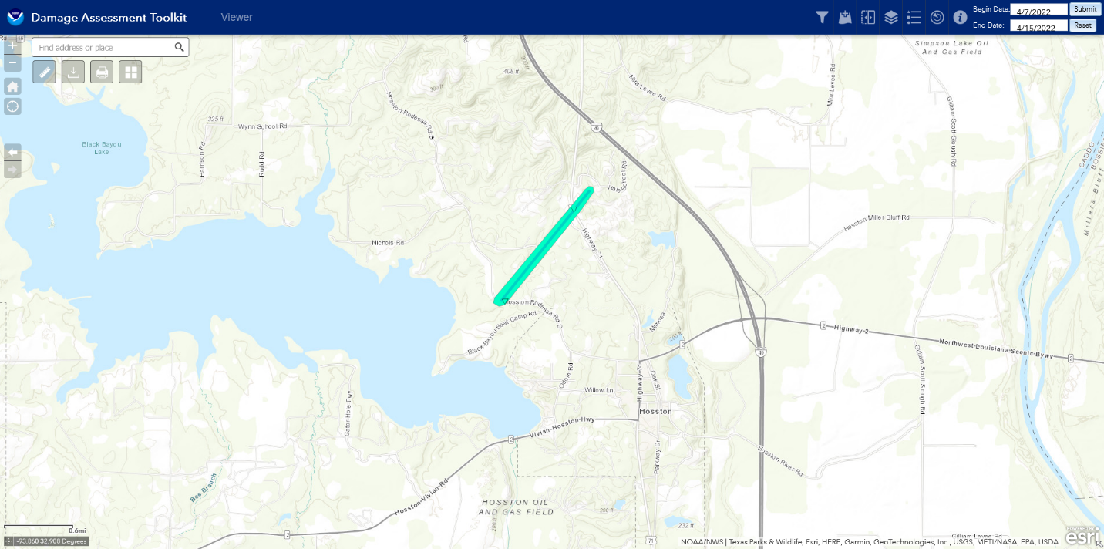
Tornado #5...Castor, LA in Southern Bienville Parish, LA...
Rating: EF1
Estimated Peak Wind: 100 mph
Path Length /statute/: 11.5744 miles
Path Width /maximum/: 525.0 yards
Fatalities: 0
Injuries: 0
Start Date: 04/12/2022
Start Time: 10:23 PM CDT
Start Location: 5 W Castor / Bienville Parish / LA
Start Lat/Lon: 32.2493 / -93.2595
End Date: 04/12/2022
End Time: 10:34 PM CDT
End Location: 6 NE Castor / Bienville Parish / LA
End Lat/Lon: 32.3229 / -93.0837
Survey Summary:
An EF-1 tornado with estimated maximum winds near 100 mph touched
down in a wooded area west of Layfield Road west of Castor, and
tracked northeast across Highway 4, snapping and uprooting
numerous trees along its path. One area of maximum winds was
found in an open field just west of Layfield Road where 10-
11 wooden power poles were snapped just west of Highway 4. The
tornado continued northeast across Highway 792 north of Castor,
where it tracked along and just north of Ayers Road and across a
logging camp, where a second area of maximum winds were found on
Kepler Road just north of Ayers Road. The tornado continued to
track northeast over a heavily wooded area inaccessible by
vehicle, but Doppler radar indicated a tornadic debris signature
north of Highway 4 and west of Highway 9. The tornado lifted
prior to reaching Highway 9 and the community of Bienville,
although straight line winds estimated to be near 90 mph were
found as numerous trees were snapped and uprooted, but lying in a
northeasterly direction.
Many thanks goes out to the Bienville Parish Office of Homeland
Security and Emergency Preparedness for their assistance in
locating this damage.

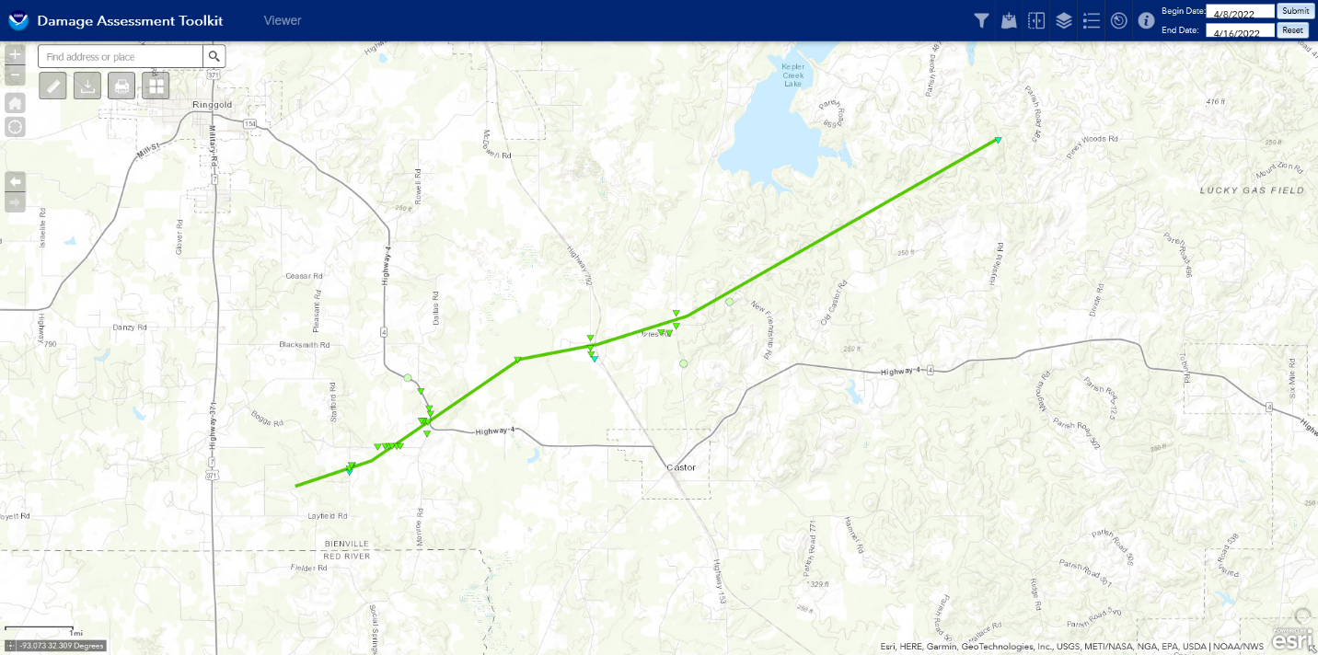
Tornado #6...Prescott in Nevada County, AR...
Rating: EF0
Estimated Peak Wind: 85 mph
Path Length /statute/: 0.2191 miles
Path Width /maximum/: 50.0 yards
Fatalities: 0
Injuries: 0
Start Date: 04/12/2022
Start Time: 10:41 PM CDT
Start Location: 1 S Prescott / Nevada County / AR
Start Lat/Lon: 33.7813 / -93.3883
End Date: 04/12/2022
End Time: 10:42 PM CDT
End Location: 1 S Prescott / Nevada County/ AR
End Lat/Lon: 33.7827 / -93.3849
Survey Summary:
A strong thunderstorm developed in southwest Arkansas during the
evening hours on Wednesday, April 13th. The storm strengthened as
it moved northeast through Hempstead County. As it moved into
west central Nevada County, the storm started to show signs of
rotation. As the storm moved east of Emmet, AR the rotation
tightened up enough to prompt a tornado warning. As the storm
moved across Rosston Highway, about a mile south of Prescott, AR,
a weak EF-0 tornado briefly touched down and uprooted a number of
trees on the west and east side of Rosston Highway. While
straightline winds were considered, trees were uprooted in a
southeast direction which indicated some sort of rotation on the
ground briefly at this location. Rotation weakened significantly
as it moved north of Highway 24 east of Prescott, AR. While the
rotation diminished the storm went on to produce straightline
wind damage on Nevada 18 Road near Nevada 249 Road north of AR
Highway 24 east of Prescott.
Special thanks goes out to Nevada County Emergency Management for
their assistance in finding this damage.
Wind damage swath #4...Sharon community through Bernice, LA...
Rating: TSTM/Wind
Estimated Peak Wind: 90 mph
Path Length /statute/: 14.6583 miles
Path Width /maximum/: 5000.0 yards
Fatalities: 0
Injuries: 0
Start Date: 04/12/2022
Start Time: 11:00 PM CDT
Start Location: 4 ESE Lisbon / Lincoln Parish / LA
Start Lat/Lon: 32.7503 / -92.798
End Date: 04/12/2022
End Time: 11:15 PM CDT
End Location: 4 S Spearsville / Union Parish / LA
End Lat/Lon: 32.8813 / -92.6003
Survey Summary:
An intensive survey of tree damage, running from the southeast
portions of Claiborne Parish and northeast through Bernice and
at least the west-central portions of Union Parish, revealed a
1 to 3 mile wide swath of 70 to 90 mph winds. Trees were almost
exclusively downed to the northwest to north with little evidence
of damage convergence typically characteristic of a tornado. Some
indirect structural damage did occur in spots due to falling
large limbs and tree trunks and this was especially the case
in Bernice. Fortunately, there were no accounts of injuries so
far. Reports of similar tree damage with straight line indications
extended up into north central Union Parish near the community of
Truxno. Interestingly, this whole swath occurred near the north
edge of the potent thunderstorm complex plowing east through
northern Louisiana in the mid to late evening hours of April 12th.
Usually straight line wind damage to trees from such a complex
would indicate a tree fall to the east. But this case, as
mentioned above, was different and the survey team can best explain
this by a combination of weaking convection on the northern edge
causing downburst surface wind dynamics and that the mesohigh
associated with the complex was anchored to the south of the
wind damage swath.
A special thanks goes out to the teams at the Claiborne and Union
Parishes Office of Homeland Security and Emergency Preparedness for
their assistance in locating damage on the survey.
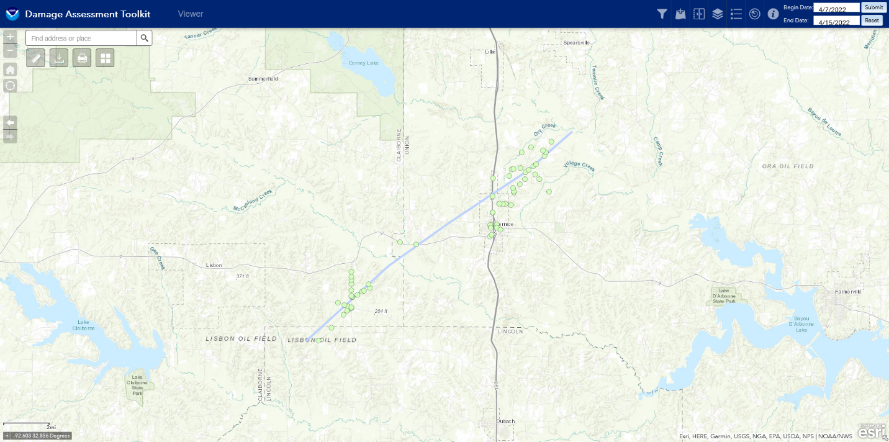

Tornado #7...Northeast Winn/Western Caldwell Parish, LA...
Rating: EF2
Estimated Peak Wind: 115 mph
Path Length /statute/: 19.2683 miles
Path Width /maximum/: 625.0 yards
Fatalities: 0
Injuries: 0
Start Date: 04/13/2022
Start Time: 5:11 PM CDT
Start Location: 7 SE Sikes / Winn Parish / LA
Start Lat/Lon: 32.0117 / -92.4006
End Date: 04/13/2022
End Time: 5:28 PM CDT
End Location: 2 NW Columbia / Caldwell Parish / LA
End Lat/Lon: 32.1195 / -92.1070
Survey Summary:
An EF-2 tornado with estimated maximum winds near 115 mph touched
down in a heavily wooded area just west of Highway 127 southeast
of Sikes in Northeast Winn Parish, where it snapped and uprooted
numerous trees. This tornado tracked northeast across another heavily
wooded area northeast of Highway 127, which was inaccessible by
vehicle. However, the Ft. Polk Doppler radar indicated a tornadic
debris signature northeast of Highway 127 near the Caldwell Parish
line, with the tornado continuing east-northeast into Western Caldwell
Parish. Much of this area remained inaccessible by vehicle, but the
tornadic debris signature remained from radar, as the tornado tracked
across Childress Road. This is where the strongest winds occurred,
where numerous trees were snapped and uprooted, and a couple falling
on homes. Remarkably, most of the homes avoided significant damage, as
the densely wooded area shielded the higher winds from these homes. The
tornado continued northeast across Highway 126 and Wiles Road, where
numerous trees were snapped and uprooted. Again, several homes were
protected from these trees with little if any damage, where the
tornado reached its widest point along Wiles Road and as it crossed
Highway 4 west of Columbia. Numerous trees were uprooted in front of a
residence opposite of the intersection of Highway 3239, with the tornado
continuing northeast and finally lifting northwest of Columbia before
reaching Highway 165 between Columbia and Riverton. These storms then
transitioned into a damaging straight line wind event as several large
tree limbs were snapped along both sides of Highway 165, with additional
straight line wind damage noted along Highway 133 in the Hebert
community along the Caldwell/Richland Parish line. Several trees were
uprooted and large limbs were snapped in this location. However, the
tree debris here all were lying in a southeasterly direction.
Many thanks goes out to the Caldwell Parish Office of Homeland
Security and Emergency Preparedness and the Caldwell Parish Sheriff`s
Office for their assistance in locating this damage.

EF Scale: The Enhanced Fujita Scale classifies tornadoes into the
following categories:
EF0...Weak......65 to 85 mph
EF1...Weak......86 to 110 mph
EF2...Strong....111 to 135 mph
EF3...Strong....136 to 165 mph
EF4...Violent...166 to 200 mph
EF5...Violent...>200 mph
NOTE:
The information in this statement is preliminary and subject to
change pending final review of the events and publication in NWS
Storm Data.

Damage Report Maps

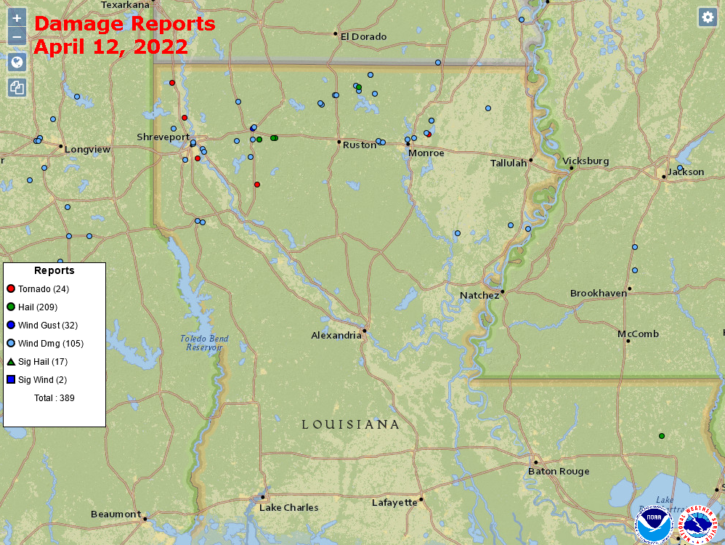

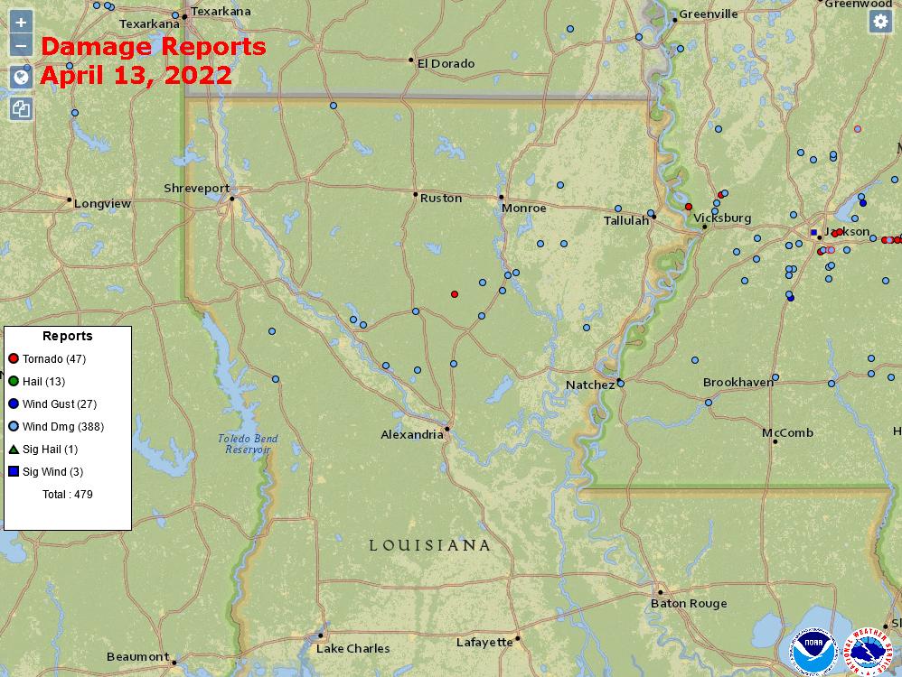

Swartz Tornado Damage

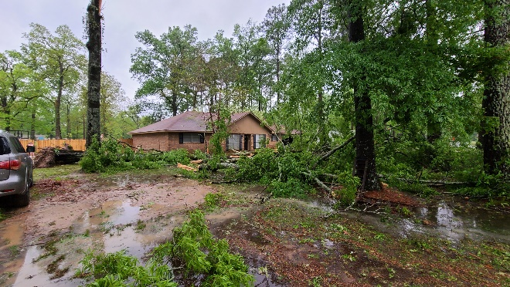  Courtesy Bayou State Weather | 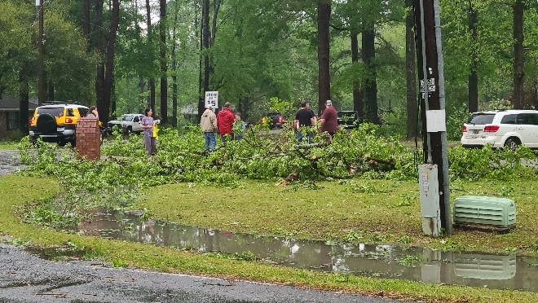  Courtesy Bayou State Weather
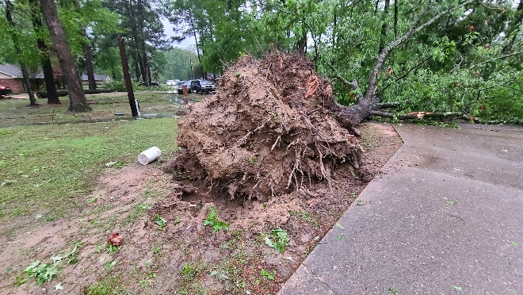  Courtesy Bayou State Weather | 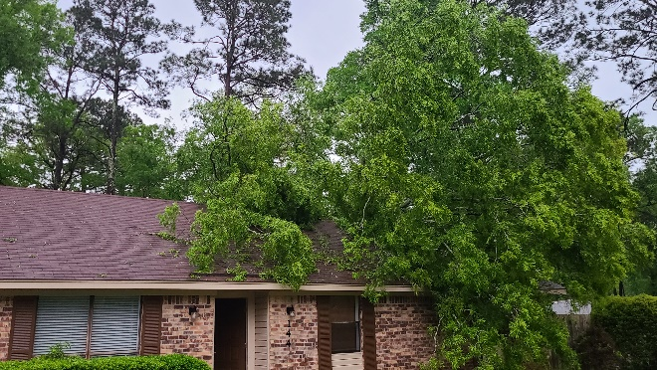  Courtesy Bayou State Weather
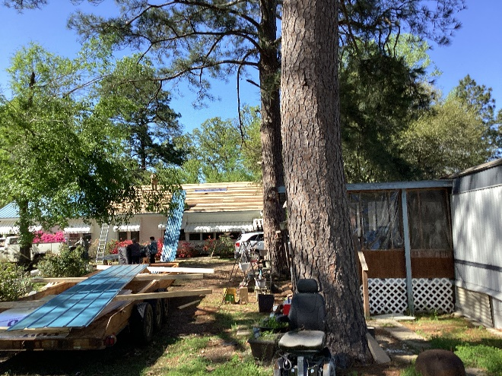  Courtesy National Weather Service-Shreveport | 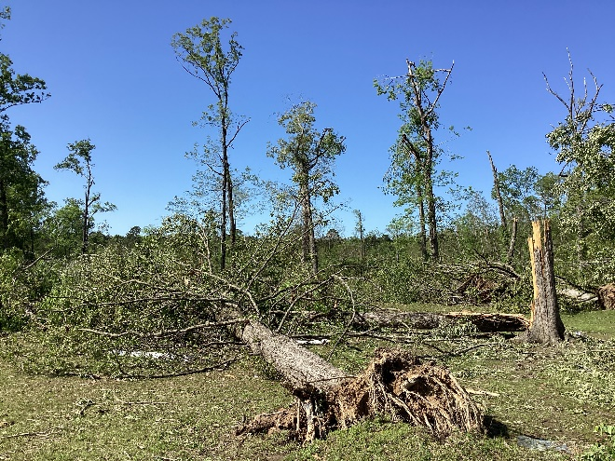  Courtesy National Weather Service-Shreveport

Winn/Caldwell Parish Tornado Damage

Images below courtesy of the National Weather Service – Shreveport, Louisiana

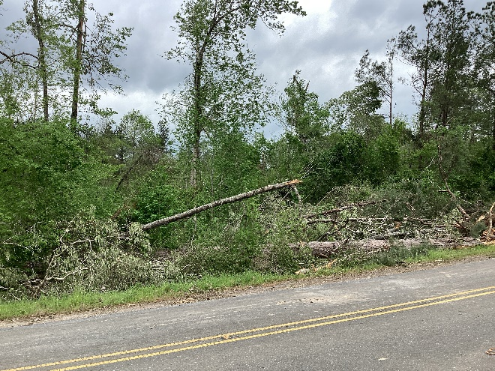 | 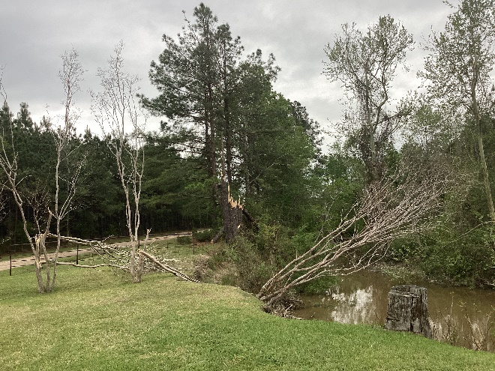
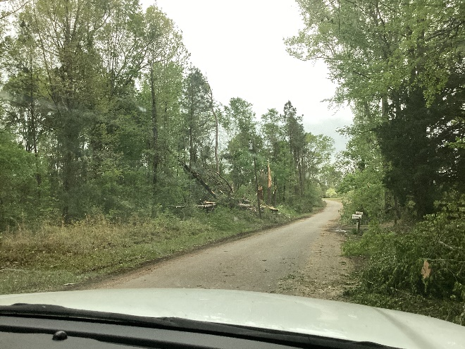 | 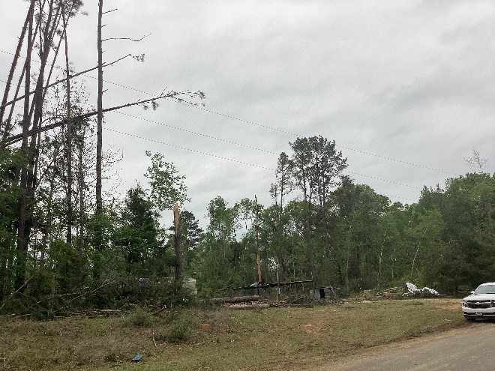
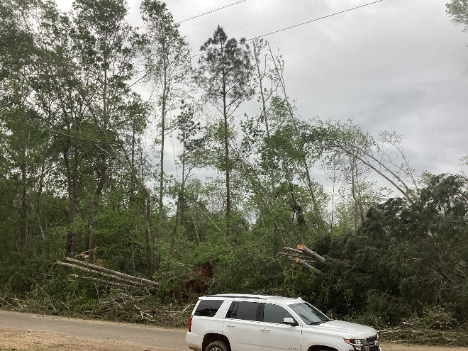 | 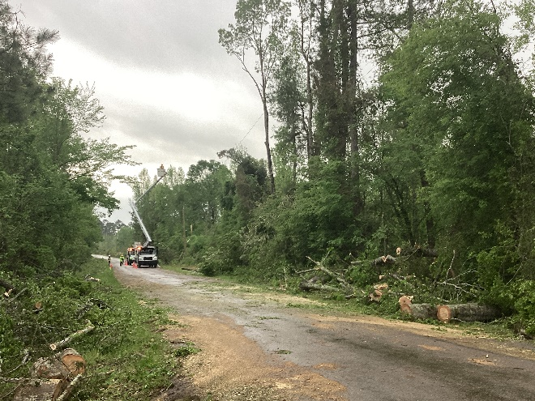

Sources

American Meteorological Society
Bayou State Weather, LLC
National Weather Service, Shreveport, Louisiana
NCEP/NOAA – Weather Prediction Center
PowerOutage.US
Storm Prediction Center
University of Wyoming

