March 22, 2022 North Louisiana Rainfall Event

By: Don Wheeler, Meteorologist

Synopsis and Overview

The 12Z surface map for Tuesday, March 22, 2022 depicted a cold front slowly moving southeast across southeast Oklahoma into east Texas. A warm front was noted across northeast Arkansas into eastern Mississippi putting all of Louisiana in the warm sector of the system. Dewpoint values were in the upper 60s and lower 70s across south Louisiana and into upper 50s across north Louisiana. Another remnant frontal boundary was noted over southeast Texas.

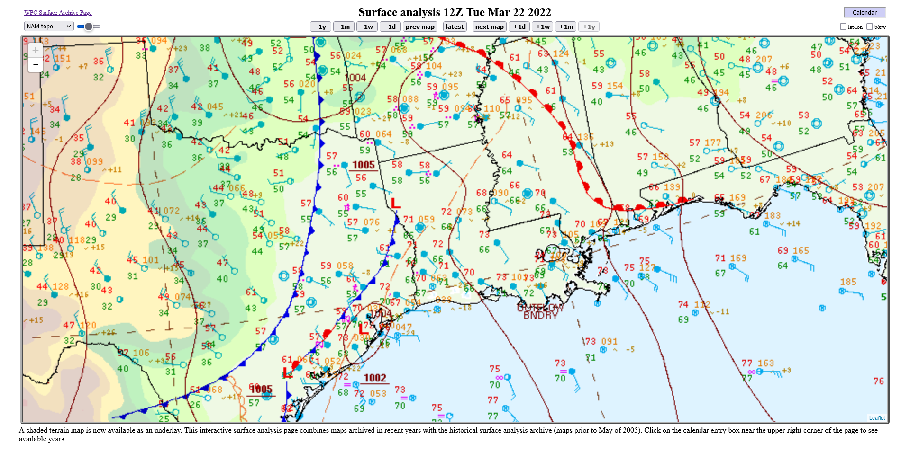

An upper-level disturbance was moving northeast along and ahead of the surface front across east Texas and southwest Louisiana. The disturbance in combination with the aforementioned surface features allowed for a strong line of thunderstorms to develop across southwest Arkansas, southeast Oklahoma, and Northeast Texas during the evening hours of Monday, March 21, 2022.

The line of showers and thunderstorms, some of which were severe, began to move into northwest Louisiana shortly after the midnight hour March 22 and dropped heavy rainfall amounts of five to over six inches across northwest Louisiana during the overnight and morning hours. The line slowly progressed east while individual thunderstorm cells developed within the line and moved northeast producing a training effect as storms moved over the same general area.

The initial line of storms pushed into northwestern Ouachita Parish just after 5AM on the 22nd but was not as intense as when it was over northwest Louisiana. None-the-less, it continued to put down heavy rainfall amounts and isolated severe weather. At 7 AM, one such storm developed over Jackson Parish and pushed northeast. The National Weather Service issued a Severe Thunderstorm Warning for this storm for Jackson and Ouachita Parishes at 7:19 AM. At 8 AM, this storm quickly weakened as it moved across U.S. 165 in the eastern portion of the parish.

Over the course of the morning hours, repeated rounds of moderate to occasionally heavy rain fell across the area. A particularly large band of moderate to heavy rain developed from near El Dorado to Monroe and then arcing southwest to Winnfield. This band put down an additional 1 to 1.5 inches of rainfall between 11AM and 12:45 PM.

By 1:30 PM the last of the moderate rain associated with the initial band departed the northeastern portion of Ouachita Parish. Additional light to moderate rain showers then developed behind the main line around 2:30 PM and lasted until 4 PM producing spotty amounts of ¼ of an inch or less.

Finally, a small band of showers developed just along the advancing cold front during the early evening hours. This band quickly dissipated as it entered the western portion of Ouachita Parish between 8:00 and 8:15 PM and produced only very light rainfall amounts of less than 0.05”.

Summary

Rainfall totals for this event from the CoCoRaHS rainfall network indicates that just over three-inches of rain fell between 5 AM and 8:15 PM. The majority of the amounts over Ouachita Parish fell between 7 AM and 12:30 PM. Radar estimates from the National Weather Service radar is slightly less than actual amounts reported, minus the few amounts over central and southern portions of the parish. These are areas where the aforementioned severe thunderstorm moved across and likely produced hail that overestimated the values in those spots.

While no formal Flash Flood Warnings were issued with this system across Ouachita Parish, some isolated flash flooding likely occurred in low-lying areas that are prone to flooding. A Flash Flood Watch had been issued for all of the area and a Flood Advisory was issued from 10:48 AM until 1:45 PM for Ouachita Parish (and surrounding parishes) for urban and small stream flooding.

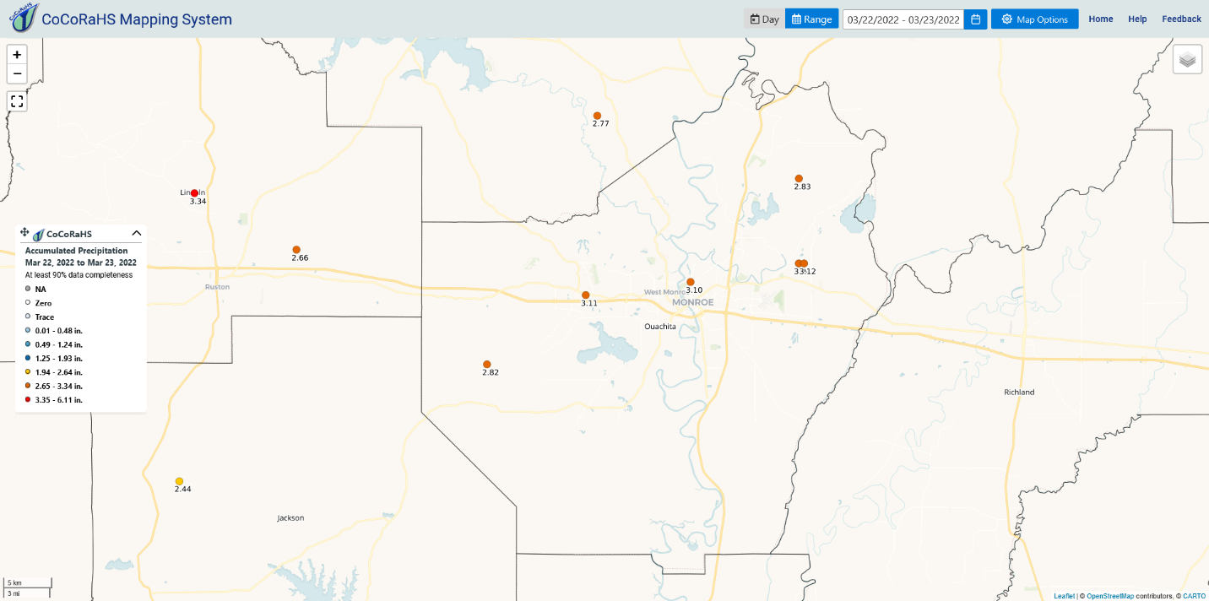
Storm totals across Ouachita Parish were just over 3-inches at most locations.

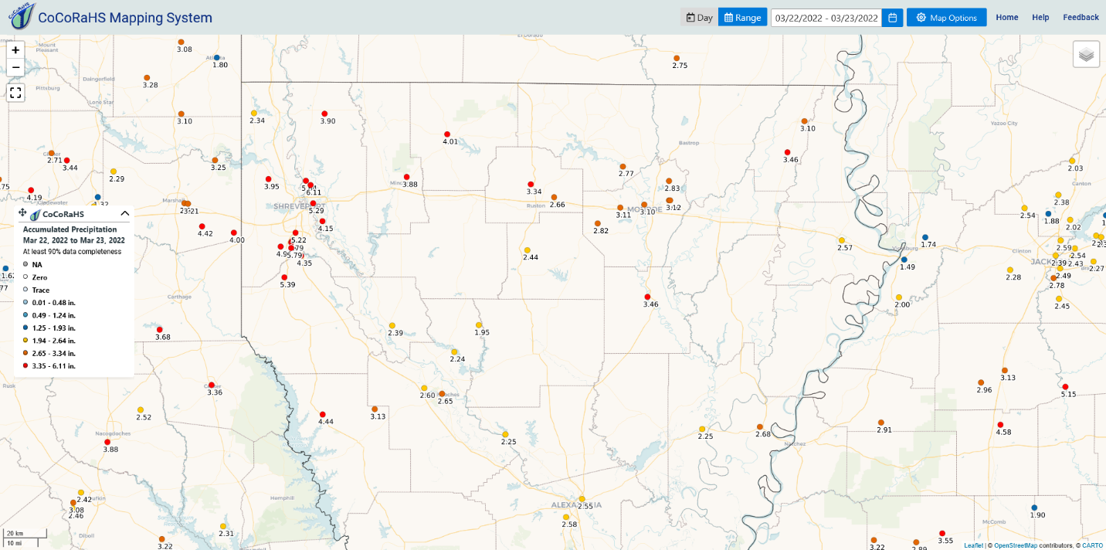
Storm totals across north Louisiana indicated that amounts of three to just over six inches fell along the I-20 corridor with the highest totals across northwest Louisiana.

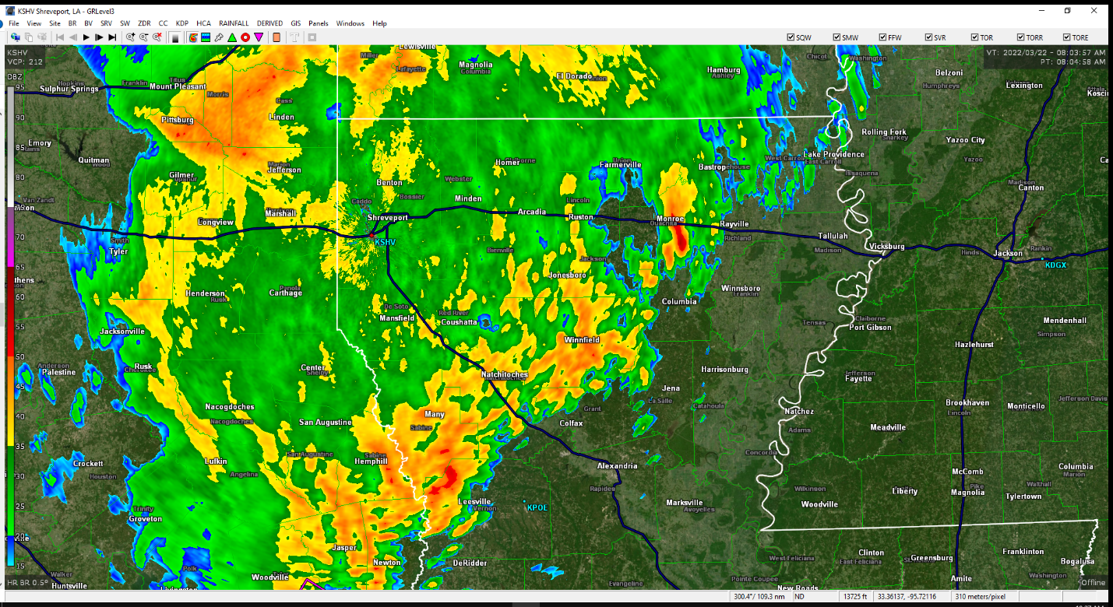
Radar image at 8:04 AM showing the initial band across Ouachita Parish with rainfall extending back into northeast Texas.

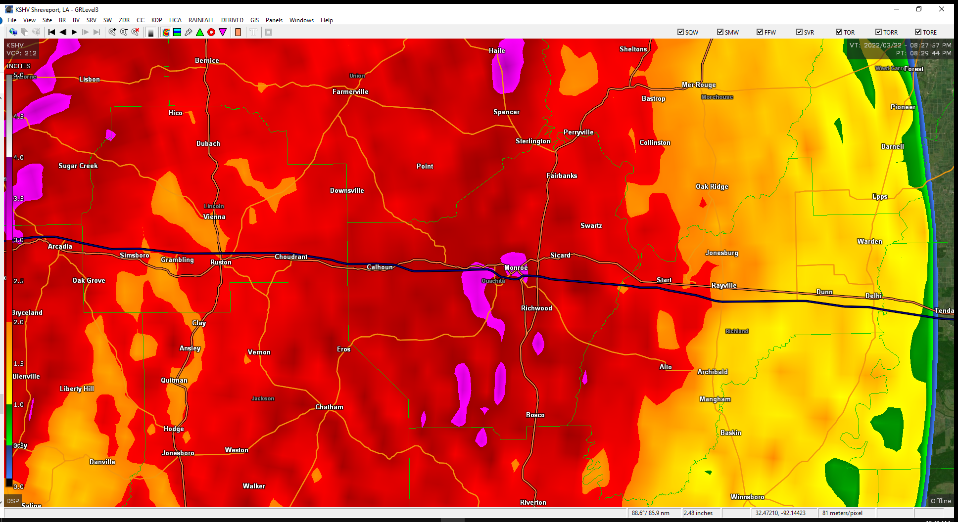
Storm total radar estimates showing general amounts in the upper 2-inch range with some pockets of 3-plus inches. Actual amounts were just over 3-inches across the parish.

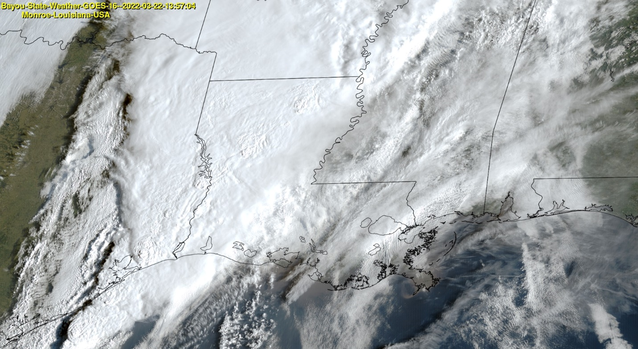
Visible satellite imagery at 1357Z (8:57 AM) showing and extensive line of showers and thunderstorms across the northwestern half of our state.

