North Louisiana Severe Weather Outbreak
January 2, 2023
By: Don Wheeler, Meteorologist

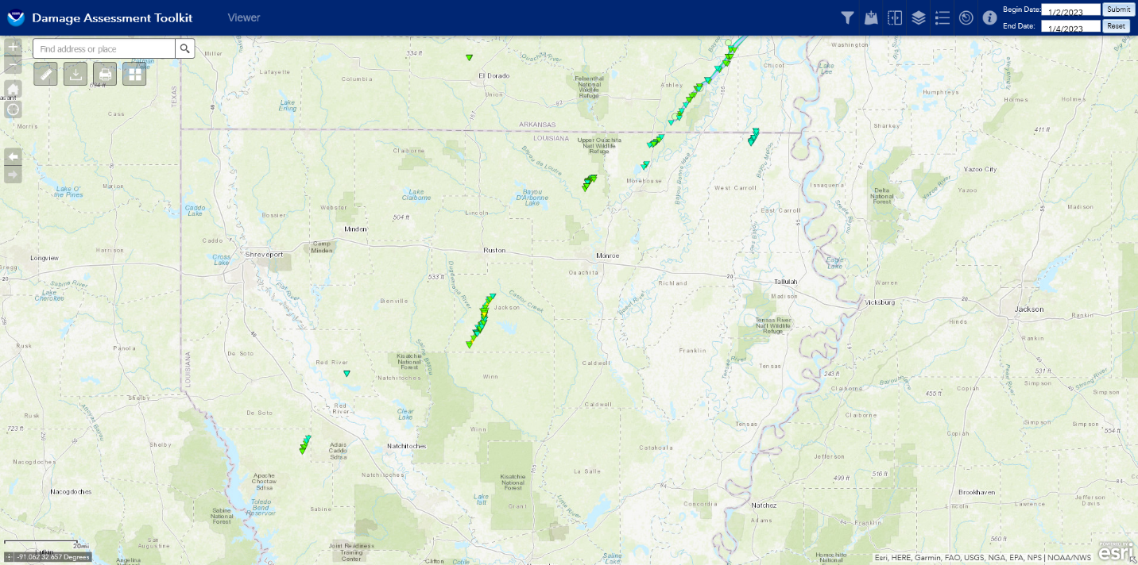
Figure 1 - Seven Confirmed Tornado Paths in Louisiana
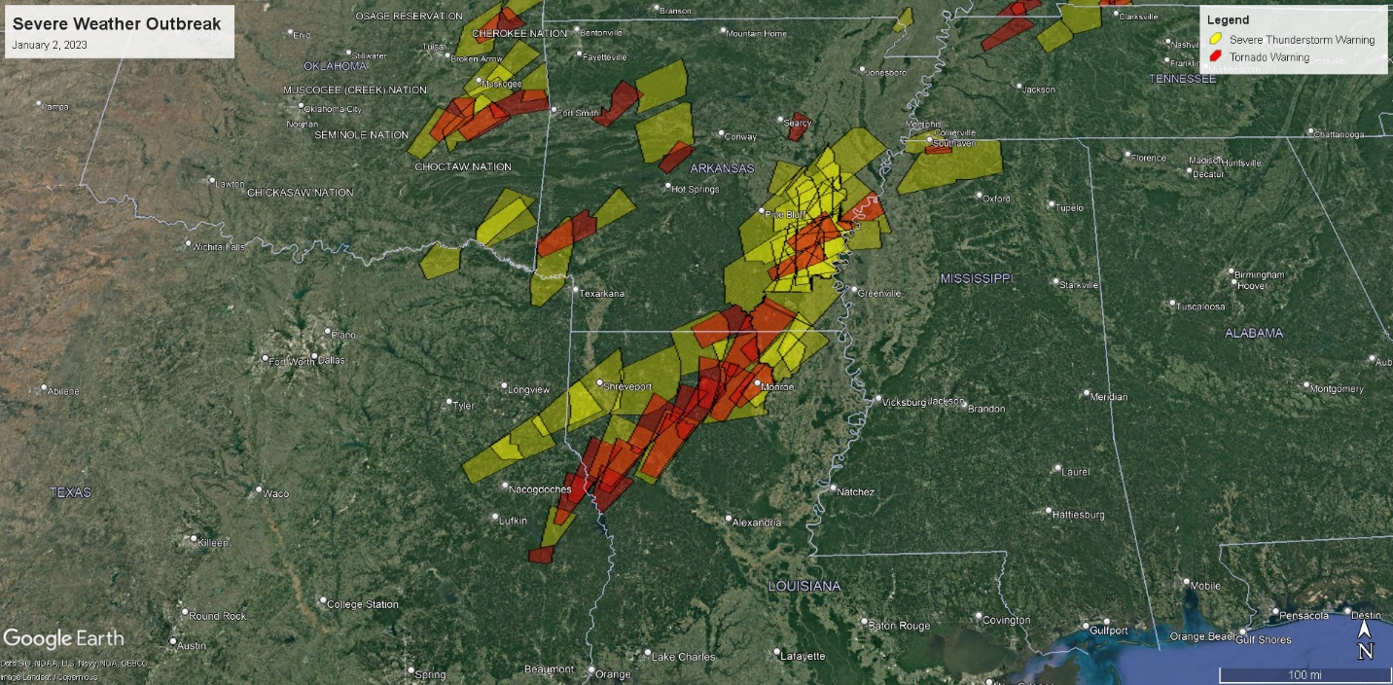
Figure 2 - Tornado (Red) and Severe Thunderstorm (Yellow) Warnings Issued
Synopsis and Overview

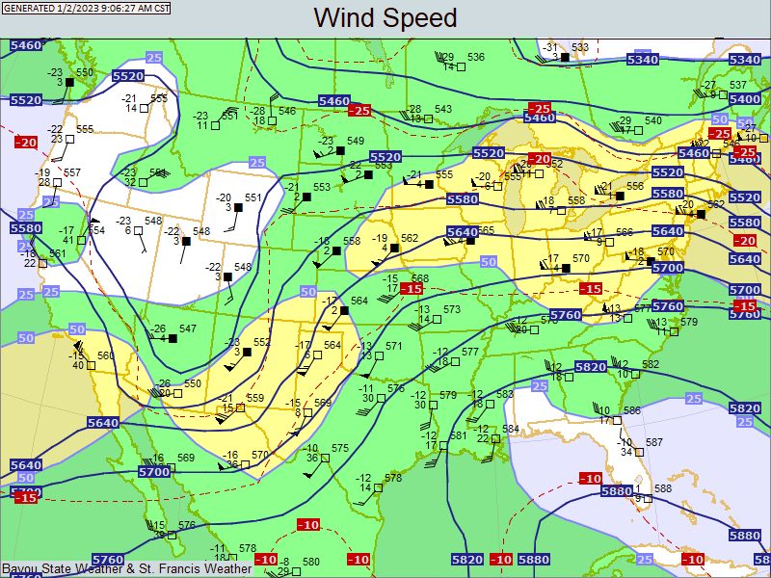
The severe weather outbreak of January 2, 2023 began with a setup similar to prior severe weather outbreaks this fall and winter season. A large-scale upper-level trough was digging southward across the western U.S. with strong jet stream winds along the base of the trough and points southeast. Moisture in the upper levels was streaming in along and just ahead of the advancing upper trough across Texas and Louisiana. At the surface, strong warm-air advection was occurring across the eastern half of Texas, Louisiana, and Mississippi into eastern Oklahoma and Arkansas. Visible satellite imagery verified the northward streaming moisture in the form of cloud streets across Louisiana.
Figure 3 - 500mb Chart 12Z 01/02/2023 Showing Large-Scale Trough to Our West

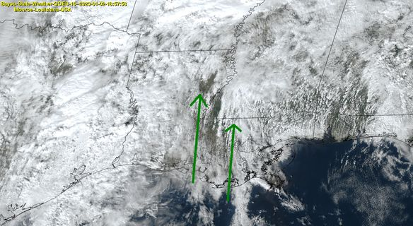
Figure 4 - Warm Air Advection off of the Gulf with Cloud Streets – Bayou State Weather GOES Receiving Station

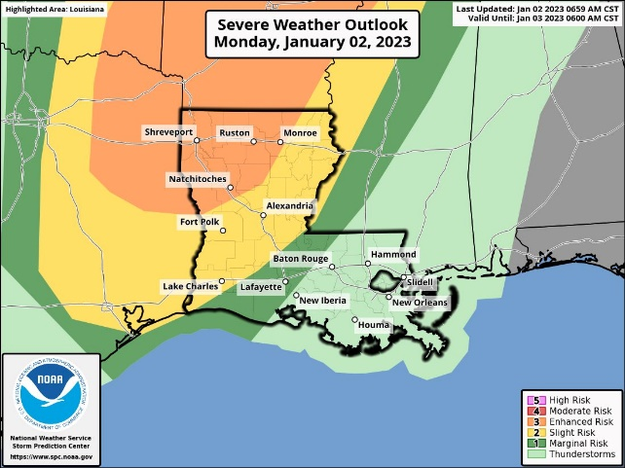
The Storm Prediction Center as of the 7 AM CST Severe Weather Outlook on January 2, placed all of northwest Louisiana as well as adjacent areas of northeast Texas, southeast Oklahoma, and much of Arkansas in an “Enhanced Risk” area for severe storms. This area was bounded by a zone of a “Slight Risk” for severe storms.
Figure 5 - Day 1 Severe Weather Outlook – Storm Prediction Center

The Enhanced Risk area was also highlighted for the possibility of significant tornadoes (EF2 or higher) with a probability of 10-14% within 25 miles of a given point.

The first tornado watch of the day, as well as for the year (Tornado Watch Number 1), was issued at 1:20 PM for portions of central and southwest Arkansas, northwest Louisiana, southeast Oklahoma, and northeast Texas through 9 PM CST. By 2:00 PM an organizing line of showers and a few strong thunderstorms had developed arching from northeast Texas near Ore City and Longview to near San Augustine then back southwest to near Woodville. A lone storm was just ahead of the line in Louisiana just west of Many in Sabine Parish.

The first tornado warning went up for Sabine Parish at 2:30 PM CST for a possible tornado seven miles east of Milam. A second tornado warning was issued shortly afterwards at 2:35 PM for counties of east Texas and a small portion of west-central Sabine Parish for a possible tornado seven miles southwest of Rosevine, Texas. At 2:45 PM, the first circulation over central Sabine Parish intensified between Zwolle and Many and was showing strong rotation. The circulation continued northeast producing the first tornado of the day over northeastern Sabine Parish southeast of Pleasant Hill. The tornado was rated as an EF1 with a path length of just over five miles.

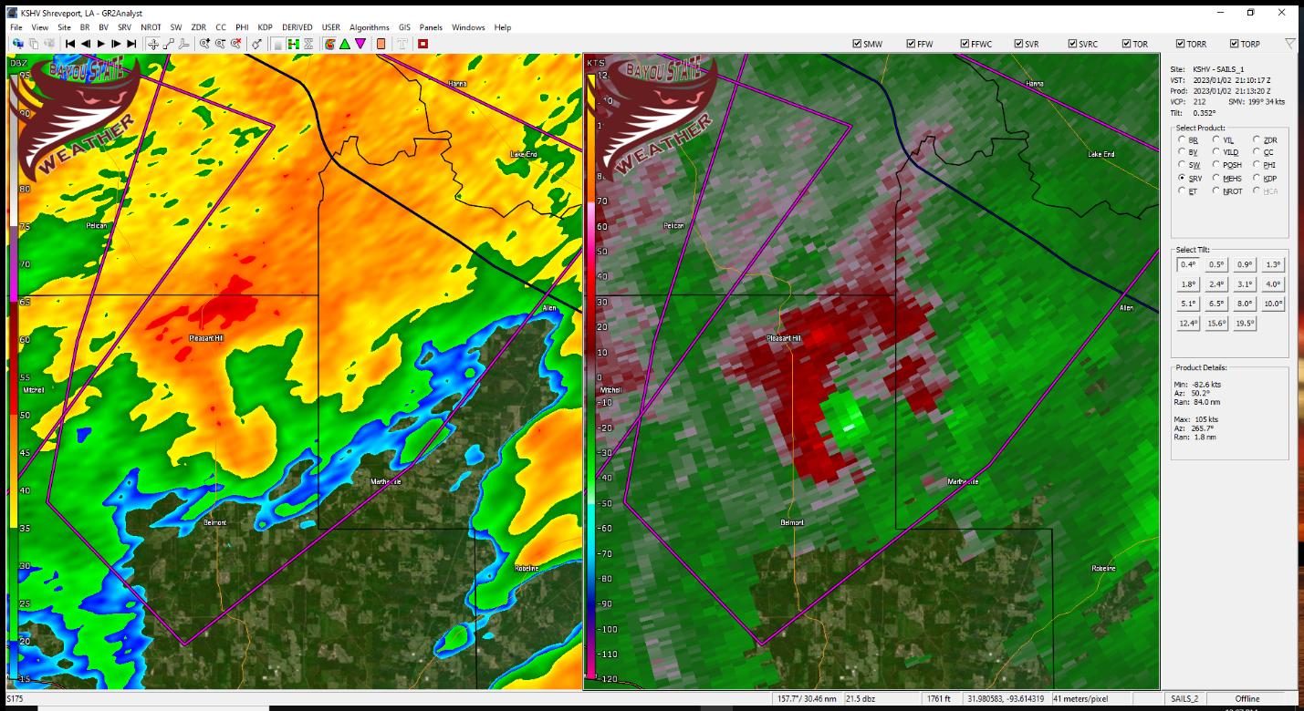
Figure 6 - First Tornado Warning of the Event in Sabine Parish
The tornado lifted approximately four miles east of Pleasant Hill while the parent storm continued northeast into Red River Parish maintaining its circulation. A new tornado warning was issued for Red River Parish as well as for northwestern Natchitoches and southeastern Bienville Parishes at 3:36 PM CST. This storm eventually produced a second tornado of EF0 intensity four miles east-northeast of Edgefield in Red River Parish.

At around 3:20 PM CST a strong thunderstorm near Natchitoches began to show signs of a weak circulation in western Natchitoches Parish and eastern Sabine Parish approximately 18 miles southwest of Natchitoches. This storm would be the most impressive and long-lived storm of the event. At 3:47 PM the developing circulation had moved northeast approximately 2.5 miles west of Natchitoches. At 3:48 PM, a tornado warning was issued for northwestern Natchitoches, southeastern Bienville, and northwestern Winn Parishes.

As the circulation pushed into extreme northwest Winn Parish at 4:18 PM, the circulation quickly intensified. A PDS (Particularly Dangerous Situation) tornado warning was issued for the storm at 4:28 PM for western Jackson, southeastern Bienville, southeastern Lincoln, and northwestern Winn Parishes when a debris signature became visible on radar 10 miles southwest of Jonesboro.

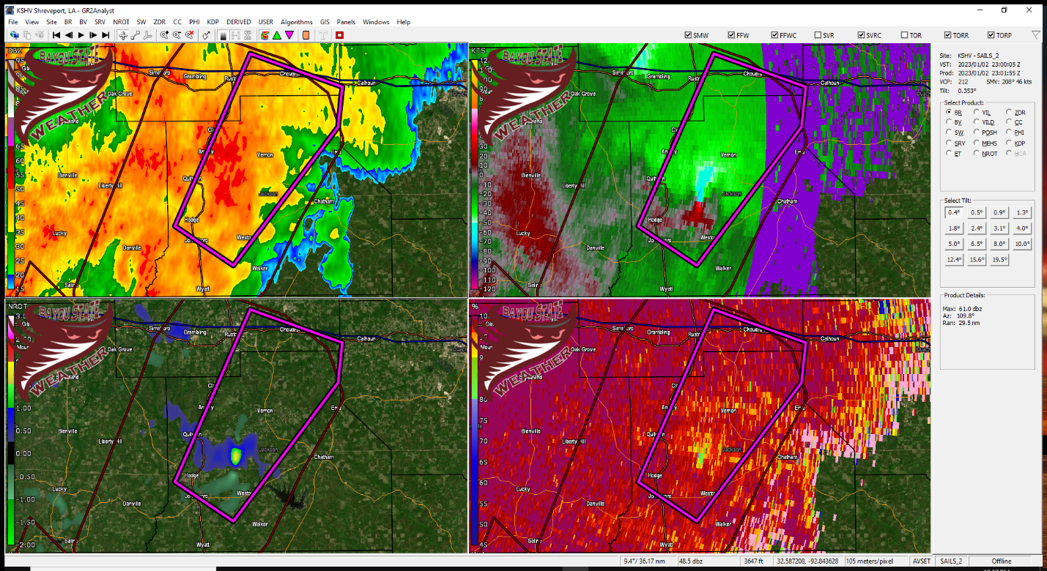
Figure 7 - PDS Tornado Warning in Jackson Parish Showing Debris Signature (lower right frame)

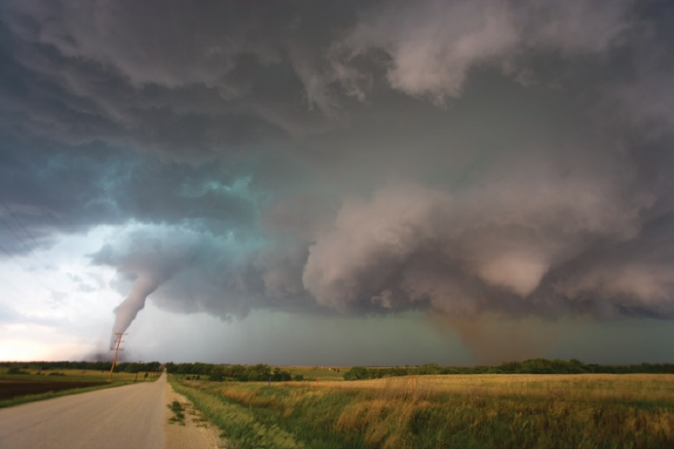
This storm began to show signs of repetitive cycling where a circulation would strengthen, weaken, and then reform while intensifying a short distance away from the original circulation – usually to the east or east-northeast of the original circulation. This cycling happened several times throughout the long path of this storm, even as it moved into southeast Arkansas.
Figure 8 - Photo of a Cyclic Supercell with Two Tornadoes. Courtesy of the Storm Prediction Center

Cycling occurs when the original updraft of a supercell and its associated tornado weakens and is replaced by a new updraft with a new tornado. Sometimes as the original tornado weakens and the new tornado forms, one can have two tornadoes at the same time. Radar imagery during this event supported evidence of cycling on several occasions.

At 4:40 PM the circulation weakened 5.5 miles southwest of Jonesboro only to cycle and strengthen again two miles east-southeast of Jonesboro along with a new debris signature. At 5:29 PM another cycle began with weakening 2.25 miles south of Choudrant and a new area of circulation two miles east of Choudrant. The new circulation intensified as it moved into southwest sections of Union Parish 2.4 miles south of Downsville at 5:42 PM. At 6:05 PM the circulation weakened seven miles east-southeast of Farmerville near Highway 2.

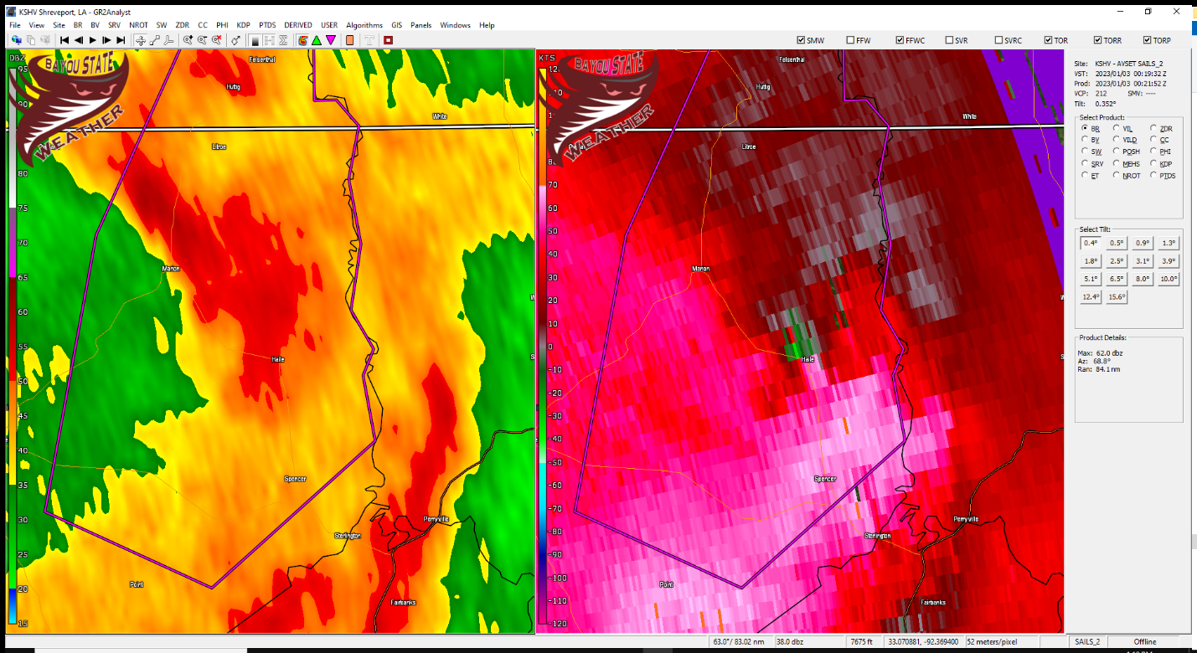
Figure 9 - Radar Indicated Circulation Producing an EF2 Tornado near Haile, Louisiana
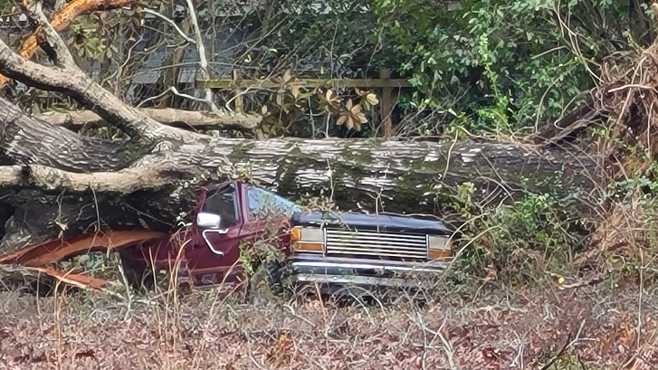
At 6:10 PM a new circulation formed 2.6 miles east of the old circulation 3.5 miles west of the Spencer community. This circulation intensified 3.8 miles south-southwest of the Haile community producing an EF2 tornado that destroyed three large electric transmission towers and produced a large swath of tree damage.
Figure 10 - Large Tree Uprooted on an Old Truck near Haile, Louisiana

It appears the track of this tornado could possibly have extended to the Ouachita River along the Union and Morehouse Parish border but survey teams could not reach that area due to limited access. The storm, however, continued into Morehouse parish producing two additional EF1 tornadoes – one near Bussey Brake and the other near the Beekman community.

The parent thunderstorm finally crossed into southeast Arkansas approximately 10 miles northwest of Bonita in Morehouse Parish. At this point it dropped another tornado that produced a path 42.7 miles long ending six miles east of Dermott, Arkansas.

The parent storm that produced these tornadoes originated southwest of Natchitoches, Louisiana and travelled some 232 miles finally dissipating as a non-severe storm approximately 13.25 miles west of Clarksdale, Mississippi at around 7:48 PM.

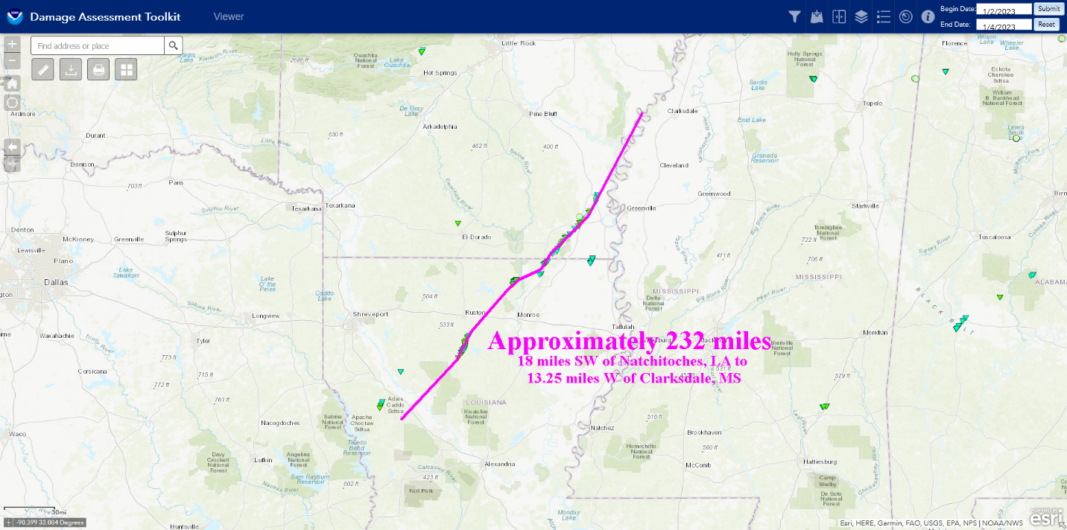
Figure 11 - Map Showing the 232 Mile Path of the Supercell that Produced Multiple Tornadoes across North Louisiana and Southeast Arkansas

Around 6:30 PM a small cluster of strong to severe thunderstorms had developed over Jackson and Ouachita Parishes initially prompting a severe thunderstorm warning. A circulation developed over southern Jackson Parish south of Chatham prompting a tornado warning for Jackson and Ouachita Parishes. The circulation moved into southwest Ouachita Parish moving south of Monroe and northeast across the Lakeshore/Swartz community. Fortunately, the storm did not produce a tornado; however, this storm did continue to the northeast across Morehouse and into West Carroll Parish where it produced one final tornado in Louisiana. It was a brief EF0 tornado that occurred around 9:02 PM just west of the Kilbourne community in extreme northern West Carroll Parish with a 3.9-mile-long path. Interestingly, no tornado warning was issued for this storm.
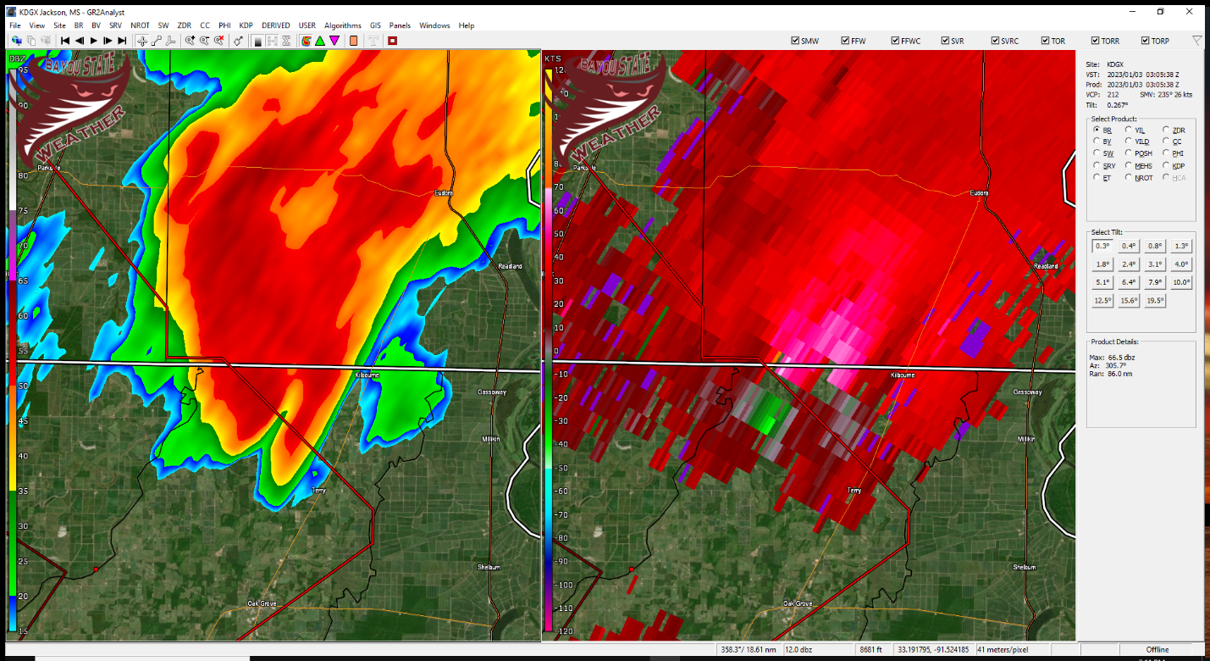
Figure 12 - Final Louisiana Tornado of the Event Just West of Kilbourne in West Carroll Parish
Cycling

As previously mentioned, the long-tracked storm that produced a series of tornadoes along its approximately 232 mile path had a history of cycling. Here is a radar sequence showing velocities and the cycling process. The original circulation shown here is approximately seven miles south-southwest of Choudrant. This circulation weakened rapidly south of Choudrant only to reform and re-strengthen approximately 1.5 miles east-southeast of Choudrant. The new circulation continues to the northeast into Union Parish.

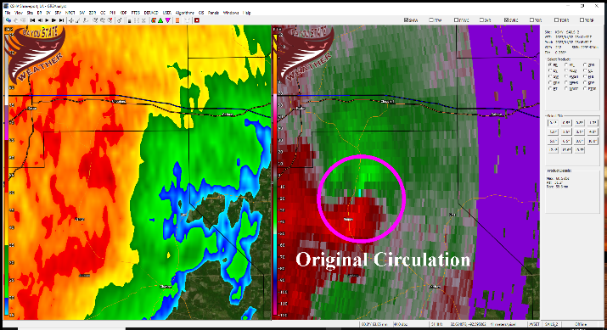 | 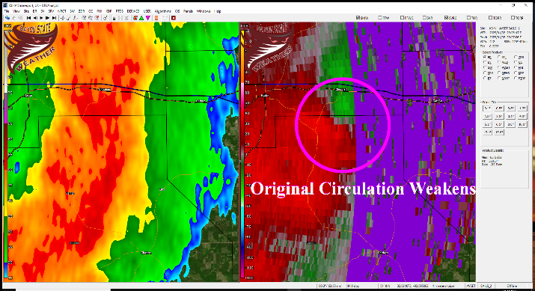
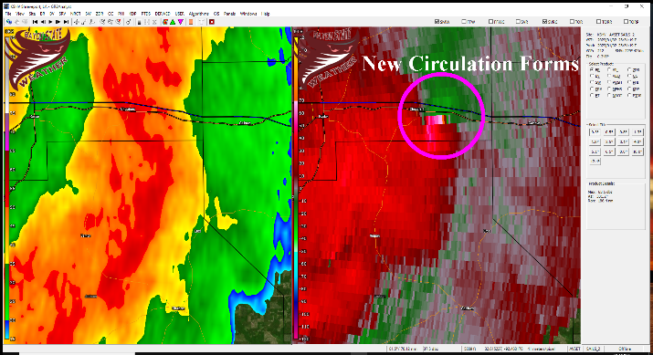 | 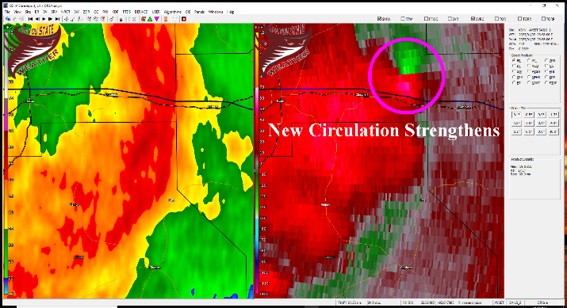

Sabine Parish Tornado

Figure 13 - Courtesy of National Weather Service - Shreveport

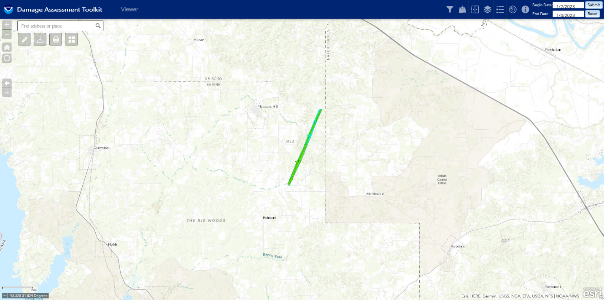

NWS Survey
Rating: EF1
Estimated Peak Wind: 90 mph
Path Length /statute/: 5.1957 miles
Path Width /maximum/: 70 yards
Fatalities: 0
Injuries: 0

Start Date: 01/02/2023
Start Time: 03:11 PM CST
Start Location: 5 SSE Pleasant Hill / Sabine Parish / LA
Start Lat/Lon: 31.7499 / -93.4807

End Date: 01/02/2023
End Time: 03:19 PM CST
End Location: 4 E Pleasant Hill / Sabine Parish / LA
End Lat/Lon: 31.8192 / -93.446

Summary: The tornado was initially spotted off of Little Egypt Road
as it touched down near Terrell Road and Emanuel Church Road. There,
it ripped some metal panels off of a home, flipped a swing set, and
uprooted several trees. As the tornado continued on, it
intermittently touched down several times, uprooting and snapping
trees as it crossed Boline Road. At this location, it also damaged a
small metal outbuilding. The tornado went on to uproot trees and down
branches as it crossed Scourgout Road and then lifted after crossing
Thyra Johnson Road.

Red River Parish Tornado

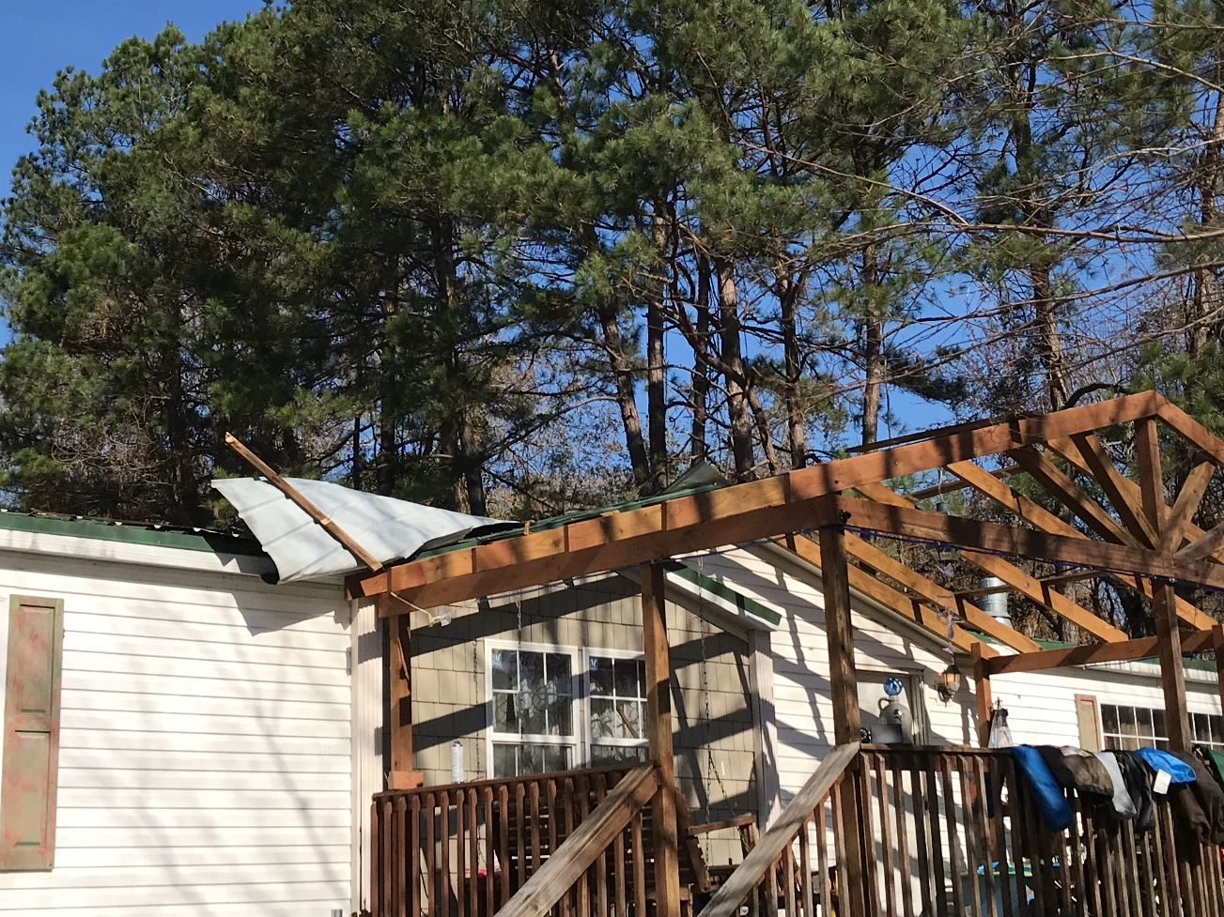
Figure 14 - Courtesy of National Weather Service – Shreveport, Louisiana
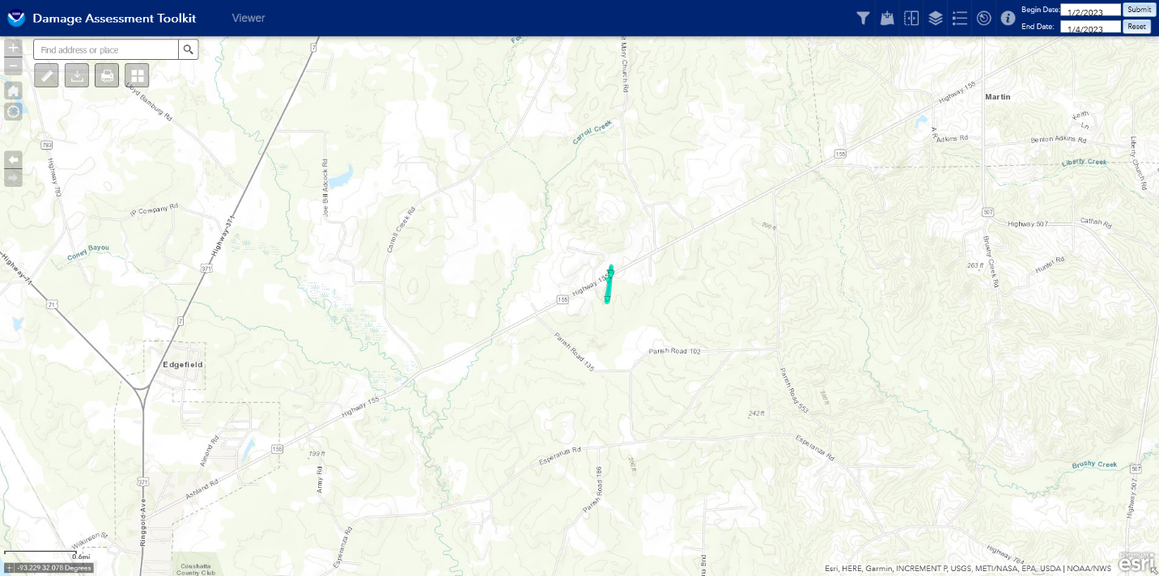

Rating: EF0
Estimated Peak Wind: 70 mph
Path Length /statute/: 0.3041 miles
Path Width /maximum/: 50 yards
Fatalities: 0
Injuries: 0

Start Date: 01/02/2023
Start Time: 03:43 PM CST
Start Location: 4 ENE Edgefield / Red River Parish / LA
Start Lat/Lon: 32.0582 / -93.2735

End Date: 01/02/2023
End Time: 03:44 PM CST
End Location: 4 ENE Edgefield / Red River Parish / LA
End Lat/Lon: 32.0626 / -93.2729

Summary: The tornado briefly touched down near Ashland Road,
downing large branches and peeling shingles off of a roof of a
gazebo. After crossing Ashland Road, the tornado peeled a metal
covering off of a porch of a double wide manufactured home and
damaged the metal skirting around the home before it lifted.

Jackson Parish Tornado

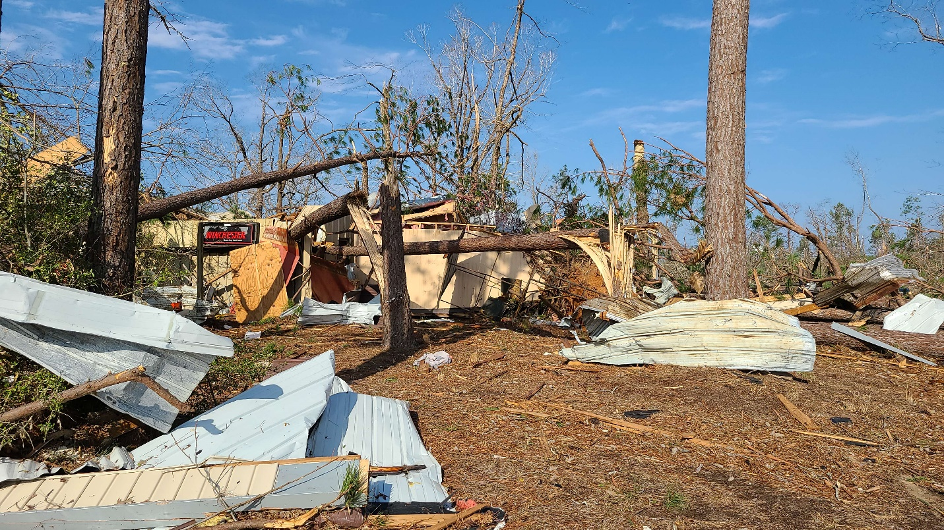
Figure 15 - Courtesy of National Weather Service - Shreveport
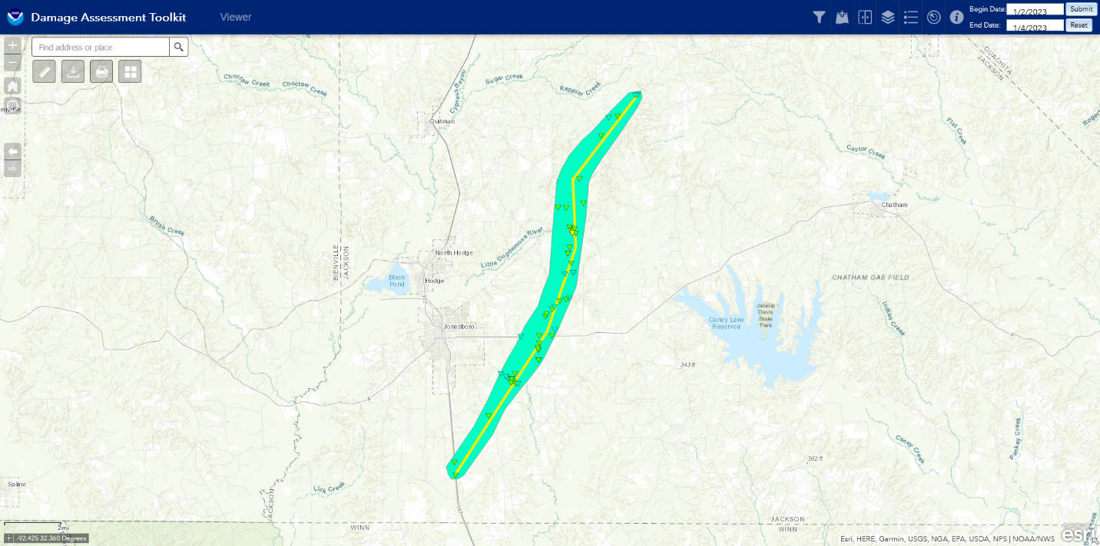

Rating: EF2
Estimated Peak Wind: 122 mph
Path Length /statute/: 15.1583 miles
Path Width /maximum/: 1928.0 yards
Fatalities: 0
Injuries: 3

Start Date: 01/02/2023
Start Time: 04:46 PM CST
Start Location: 4 S Jonesboro / Jackson Parish / LA
Start Lat/Lon: 32.172 / -92.7048

End Date: 01/02/2023
End Time: 05:09 PM CST
End Location: 7 E Quitman / Jackson Parish / LA
End Lat/Lon: 32.3646 / -92.5957

Summary: This tornado began just north of the Jackson/Winn Parish
Line along US Hwy 167 and traveled northeast cross Firetower
Section Road and LA Hwy 147/Walker Road snapping numerous trees.
On Walker Road, the tornado caused roof damage to a chicken house
and some manufactured homes. The most significant damage on
Walker Road occurred just north of its intersection with Whitman
Road where a single-wide manufactured home, which was anchored
into the soil, was flipped and rolled off its foundation
destroying most of the roof and walls, but leaving the
undercarriage attached. The tornado snapped and uprooted more
trees and broke a wooden electrical pole as it crossed Rome Road,
LA Hwy 4, and Strain Allen Road. On Strain Allen Road, a very
large hardwood tree was snapped and a home suffered the partial
loss of its metal roof. More broken tree limbs and snapped trunks
were observed as the tornado crossed Halfway Creek Road and
traveled north-northeast along Kelley Road.

The most significant damage along the entire track occurred as
the tornado cross LA Hwy 811/Gladway Road near its intersection
with Kelley Road. Here, a brick single-family home lost most of
its roof. This caused the partial failure of the walls of the
garage of the home, but the majority of the walls of the home
remained standing and intact. This damage was rated as EF2. A
metal garage building on this property suffered complete loss of
its walls, but most of its roof and the metal frame poles remained
standing. About 150 yards to the northwest, another brick single-
family home suffered almost total loss of its roof covering. The
damage in this area was rated as EF2 based mainly on the roof lose
to the two homes. On the north side of Gladeway Road, a double-
wide manufactured home suffered the loss of most of its roof, but
the walls remained standing. An attached car port on another brick
single-family residence was destroyed as the tornado continued
north of Gladway Road and west of Kelley Road. This tornado
continued to snapped numerous trees on Kelley Road as it continued
northward crossing Slash Pine Road and again crossing Kelley
Road, then, Parish Barn Road. More tree damage was observed along
Lucy-Leonard Road and LA Hwy 155. Two brick single-family homes
on LA-155 just west of Sugar Creek Road suffered some loss of
shingles from the roof.

The tornado began to weaken rapidly and caused more minor roof
damage to a single-family home and snapped some large tree
branches along Stonewall Road before finally lifting. Three minor
injuries were reported from this tornado, but their exact
locations were not available to the survey team. The team spoke
was almost a half dozen residents that were at home in the path of
the tornado. All of them mentioned receiving the Tornado Warning
via Wireless Emergency Alerts well before the tornado struck.

Union Parish Tornado

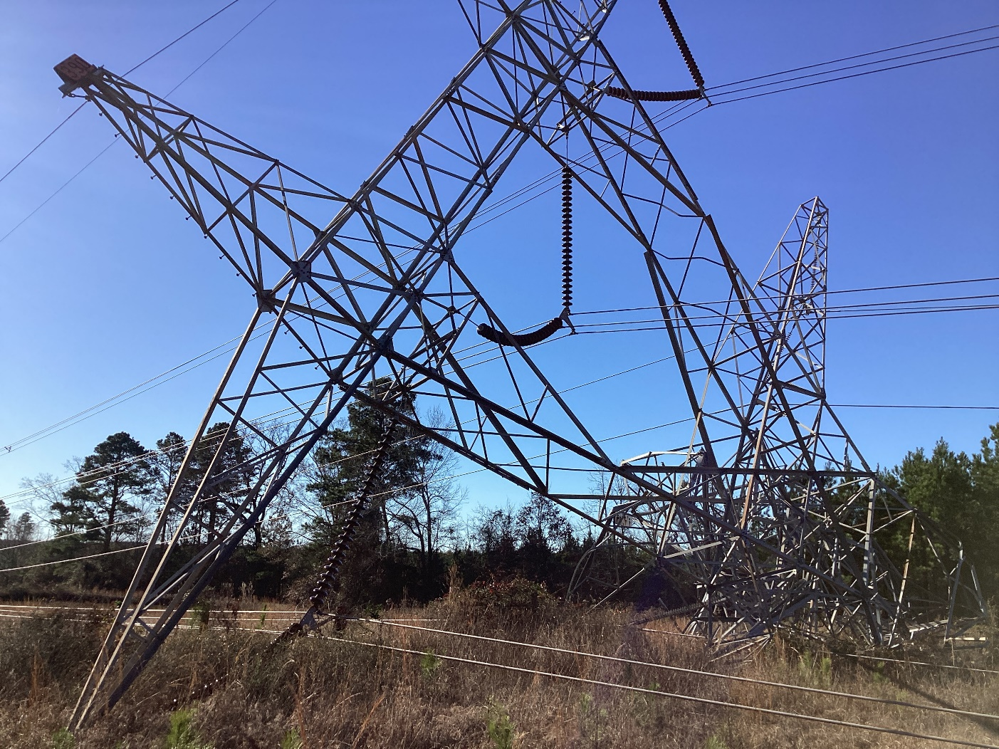
Figure 16 - Courtesy of National Weather Service - Shreveport

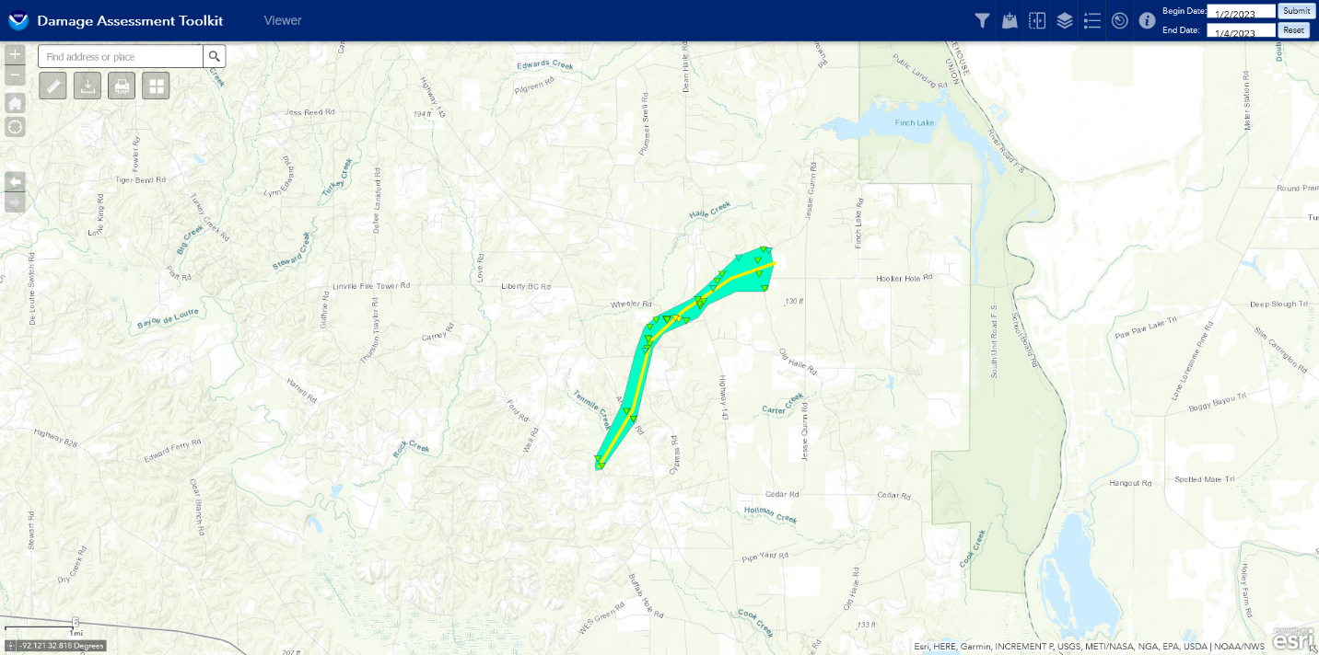

Rating: EF2
Estimated Peak Wind: 130 mph
Path Length /statute/: 4.19 miles
Path Width /maximum/: 900 yards
Fatalities: 0
Injuries: 0

Start Date: 01/02/2023
Start Time: 06:19 PM CST
Start Location: 8 NW Sterlington / Union Parish / LA
Start Lat/Lon: 32.784 / -92.1695

End Date: 01/02/2023
End Time: 06:25 PM CST
End Location: 8 SE Marion / Union Parish / LA
End Lat/Lon: 32.8271 / -92.1251

Survey Summary: This tornado originated from a quasi-linear
convective system developing and migrating across northeast
Louisiana during the evening hours. The tornado affected areas
well east of Farmerville and closer to the southern vicinity
of the Haile Community. It first touched down west southwest of
the Haile Community, crossing Ford and Arkansas Roads in a very
rural area where the only evidence was downed hardwood and
softwood trees. The tornado continued on to the east northeast,
producing mostly tree damage as it crossed Cypress Road and
Albert Barr Road. In addition, falling trees downed many
powerlines in this area and continued to the northeast for 2 to
3 miles. The most significant damage occurred a little farther
to the northeast as the tornado crossed Wheeler Road. Here
there were a few collapsed electrical transmission towers which
easily rated in the EF-2 category. From here, the last few
miles of the tornado tracked closer to the Haile Community,
crossing Highway 143, Jordan Taunton Road, Sunset Road, Haile
Baptist Church Road, and Jessie Guinn Road. In these
areas the damage was again confined to mainly uprooted and
snapped trees, with several homes and outbuildings heavily
damaged, but mainly due to downed trees.

The tornado was unique in a few different ways. First, the path
width was up to half a mile in the latter portion of the track,
which is very wide for a tornado which was mostly weak
throughout a majority of its path. Secondly, the collapsing
of the large electrical transmission towers garnered a rating
up to 130 mph, but there was no other surveyed damage
indicators which warranted an EF-2 rating. The survey team
believes there could be other significant indicators near the
downed transmission towers, although potentially live downed
high voltage lines in the vicinity of the towers did not
allow the survey team to survey to get in close in proximity.
Fortunately, no injuries or fatalities were reported in
association with this tornado.

A special thanks to the Union Parish Office of Homeland Security
and Emergency Preparedness and the Union Parish Sheriff`s Office
for assistance locating damage.

Morehouse Parish Tornadoes

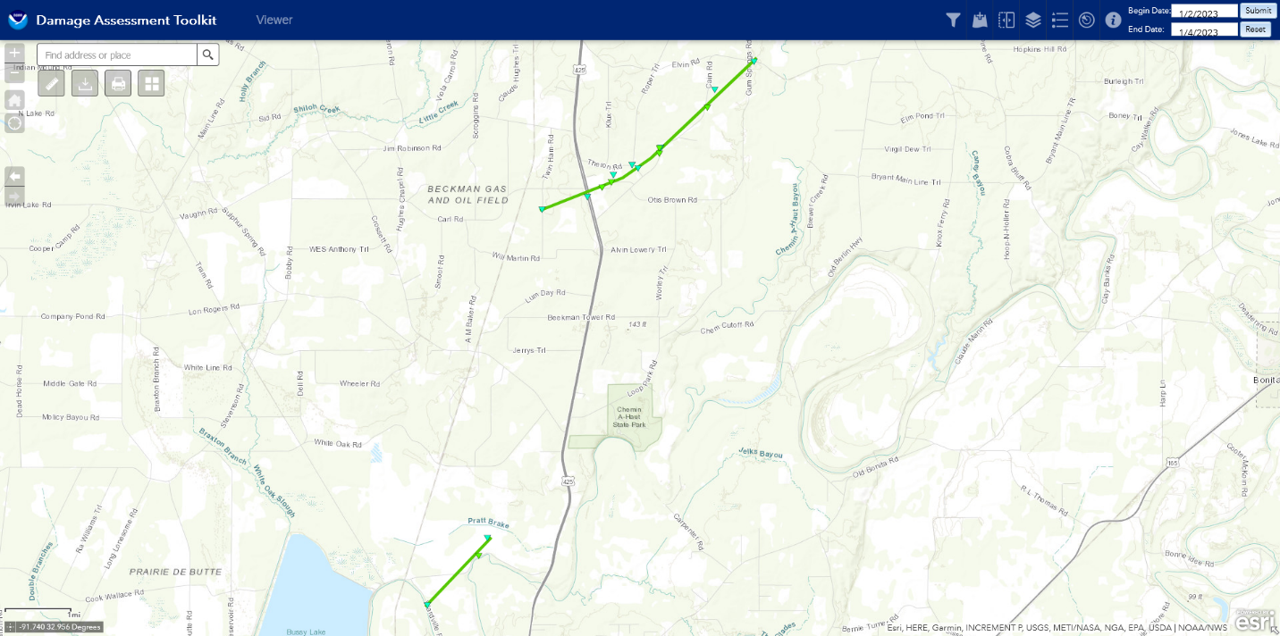

.Bussey Brake Tornado...

Rating: EF1
Estimated Peak Wind: 90 mph
Path Length /statute/: 1.4 miles
Path Width /maximum/: 75 yards
Fatalities: 0
Injuries: 0

Start Date: 01/02/2023
Start Time: 06:36 PM CST
Start Location: 6 N Bastrop / Morehouse Parish / LA
Start Lat/Lon: 32.8681 / -91.8982

End Date: 01/02/2023
End Time: 06:37 PM CST
End Location: 7 N Bastrop / Morehouse Parish / LA
End Lat/Lon: 32.8831 / -91.8813

Survey Summary:
This tornado touched down along Wardville Road on the east side
of Bussey Brake and moved northeast across Louisiana Highway
593 Bonner Ferry Road, where some trees were snapped. The tornado
quickly dissipated after crossing the road.

.Beekman Tornado...

Rating: EF1
Estimated Peak Wind: 100 mph
Path Length /statute/: 4.0 miles
Path Width /maximum/: 200 yards
Fatalities: 0
Injuries: 0

Start Date: 01/02/2023
Start Time: 06:40 PM CST
Start Location: 11 W Bonita / Morehouse Parish / LA
Start Lat/Lon: 32.9539 / -91.8686

End Date: 01/02/2023
End Time: 06:49 PM CST
End Location: 9 WNW Bonita / Morehouse Parish / LA
End Lat/Lon: 32.9869 / -91.8129

Survey Summary:
The tornado began on Twin Ham Rd initially producing some damage
to pine trees before moving northeastwards toward Highway 425. As
the tornado crossed the highway, it produced additional tree
damage and damaged a gas production facility along Texas Gas Rd.
This damage combined with additional tree damage, suggests that
the tornado reached maximum intensity in this area with maximum
estimated winds of 100 mph. The EF-1 tornado continued to track
northeastward producing damage to mixed forest. As the tornado
moved along Cain Rd, some farm out buildings were damaged with
primarily tin peeling noted on the roofs. As the tornado
paralleled the roadway, a few residents also suffered damage to
tin and shingled roofs. The tornado dissipated near the
intersection of Cain Rd and Gum Springs Rd with a few large
branches downed.

West Carroll Parish Tornado

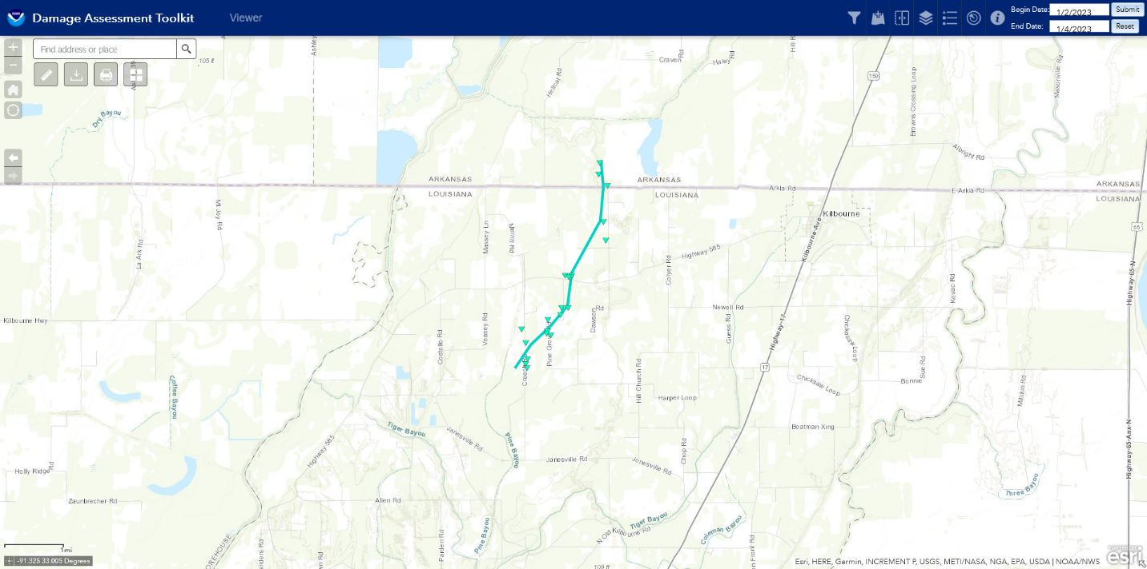

Concord/Kilbourne Tornado...

Rating: EF0
Estimated Peak Wind: 85 mph
Path Length /statute/: 3.9 miles
Path Width /maximum/: 250 yards
Fatalities: 0
Injuries: 0

Start Date: 01/02/2023
Start Time: 09:02 PM CST
Start Location: 5 WSW Kilbourne / West Carroll Parish / LA
Start Lat/Lon: 32.9621 / -91.4023

End Date: 01/02/2023
End Time: 09:08 PM CST
End Location: 4 WNW Kilbourne / Chicot County / AR
End Lat/Lon: 33.0123 / -91.3775

Survey Summary:
This tornado developed along Creech Rd, where minor roof damage
occurred to a home and a trampoline was tossed, some small trees
were snapped, and several large limbs were downed. It continued
northeastward, crossing Pine Grove Rd where multiple sheds and a
small trailer were damaged, additional trees were downed, and a
home experienced shingle damage. Two more homes received minor
roof damage and two more sheds were damaged as the tornado
crossed LA Hwy 585. One small shed was demolished and another was
damaged along Dawson Rd before the tornado turned more northward.
As the tornado crossed Arkla Rd at the Arkansas state line, a
home sustained shingle damage and a trampoline was tossed, then a
barn was blown down and a shed was tossed before the tornado
dissipated shortly thereafter.

Summary

Another in a series of severe weather outbreaks this fall and winter season struck portions of north Louisiana and adjacent areas of northeast Texas, eastern Oklahoma, and south Arkansas on January 2, 2023. The synoptics leading up to this event were similar to past events such as the November 29, 2022 and December 13, 2022 outbreaks. A large-scale trough of low pressure developed over the western U.S. and migrated east. The trough induced a strong cold front and associated low pressure to our west over Colorado and New Mexico that pushed east throughout the day. Ahead of the front, strong warm-air advection developed providing ample fuel for the storms. Strong winds aloft along with directional wind shear created an environment ripe for severe storms and tornadoes.

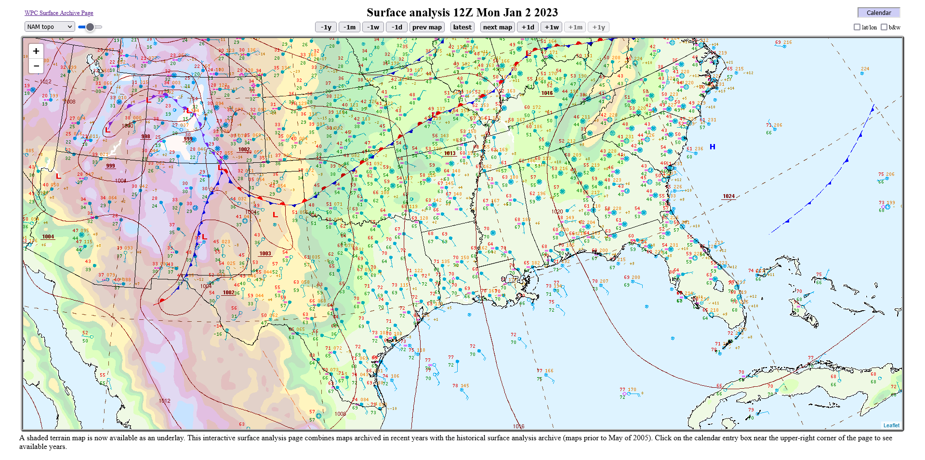
Figure 17 – 12Z January 2, 2023, Surface Map Depicting Developing Low Pressure over New Mexico and Colorado with a Trailing Cold Front into New Mexico. Warm-Air Advection was Noted Over East Texas, Southeast Oklahoma, Louisiana, Arkansas, and Mississippi.

Supporting Photos

Sabine Parish Tornado

 | 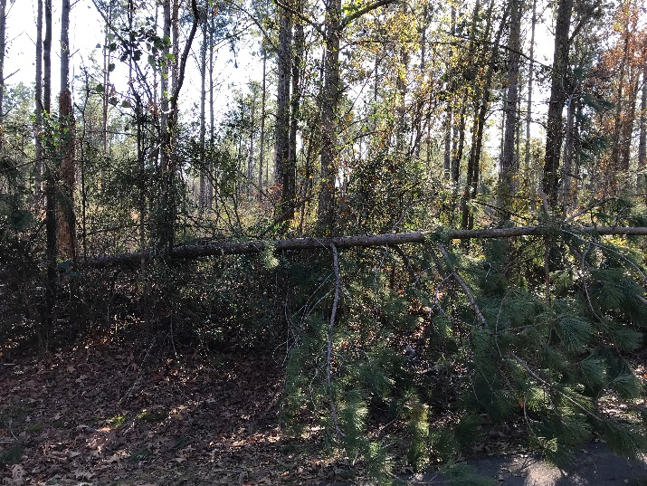
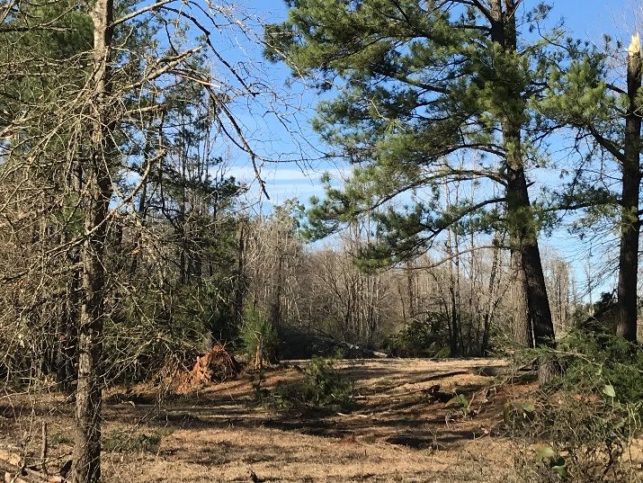 | 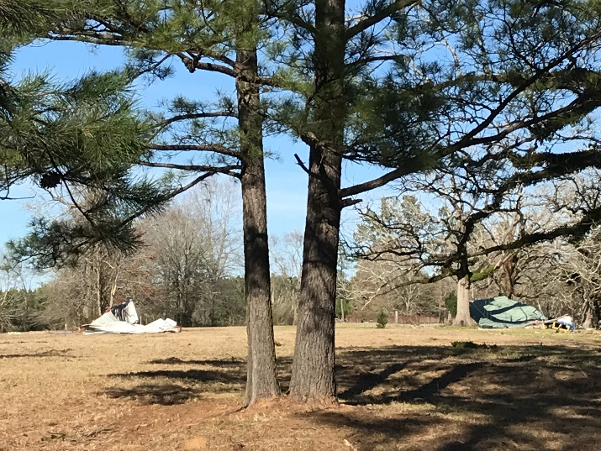

Red River Parish Tornado

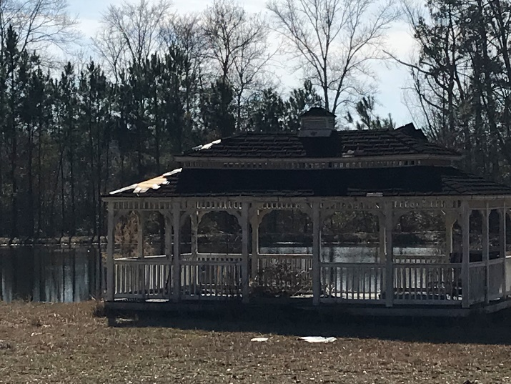 | 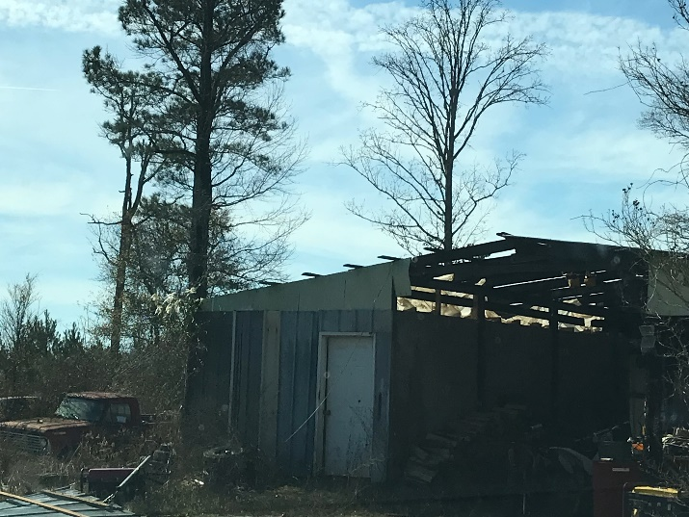
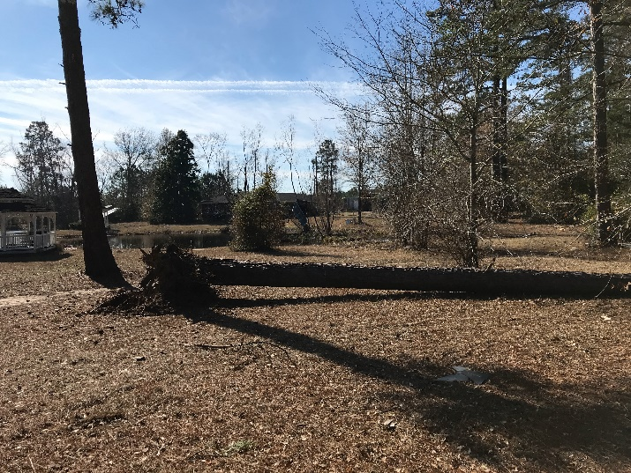 | 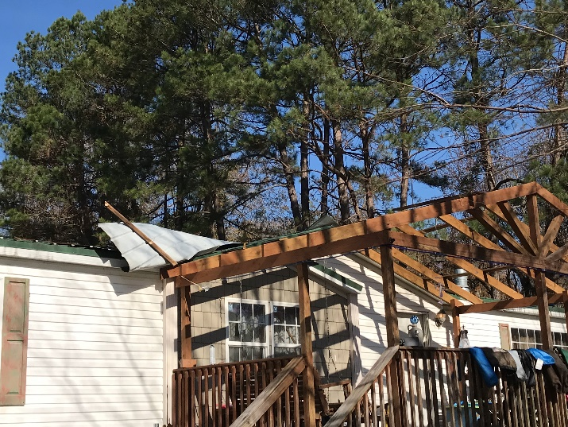

Jackson Parish Tornado

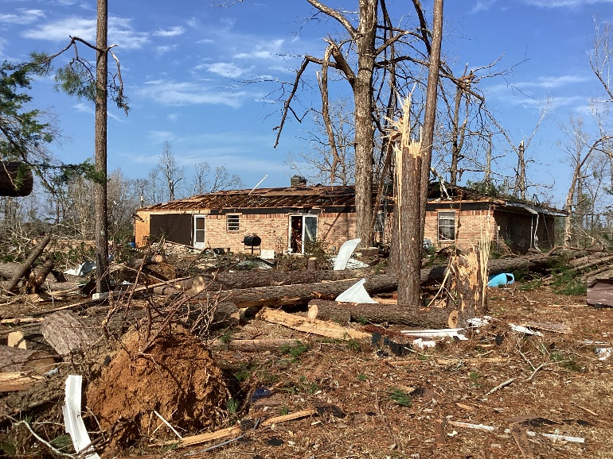 | 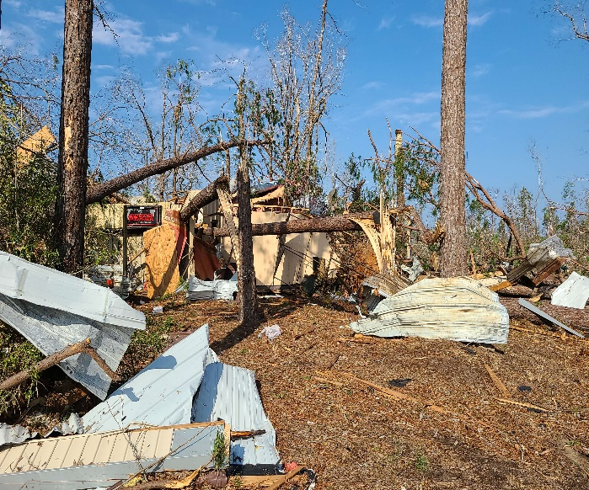
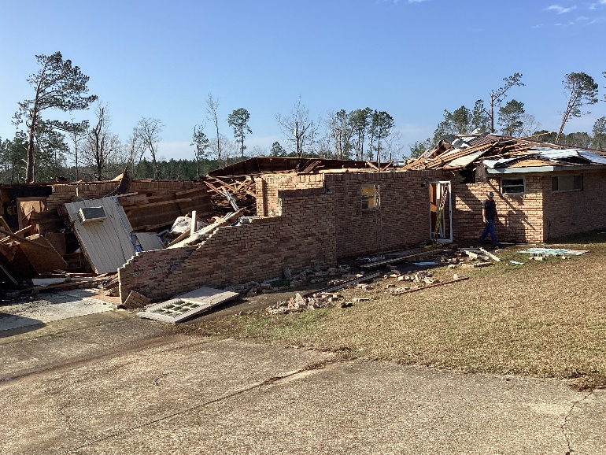 | 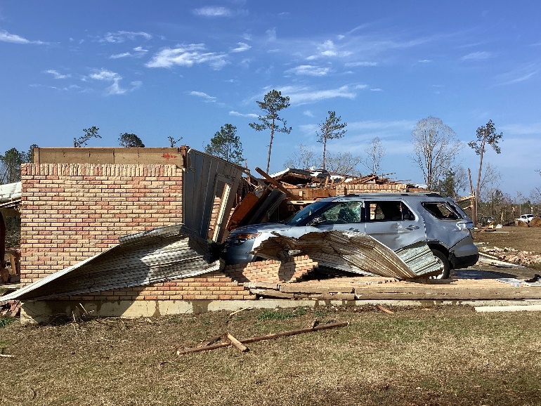
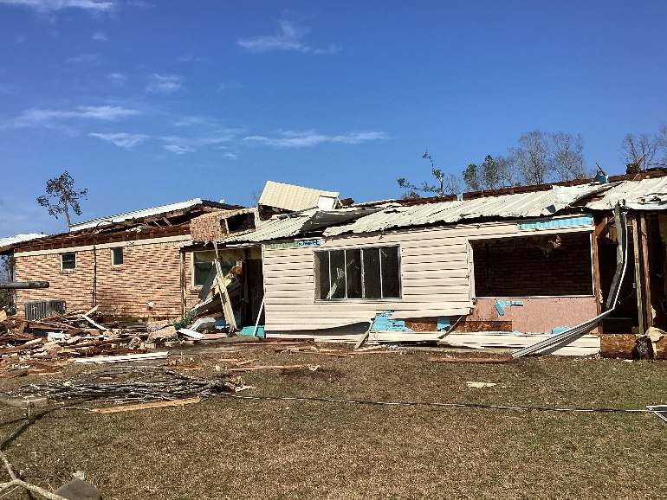 | 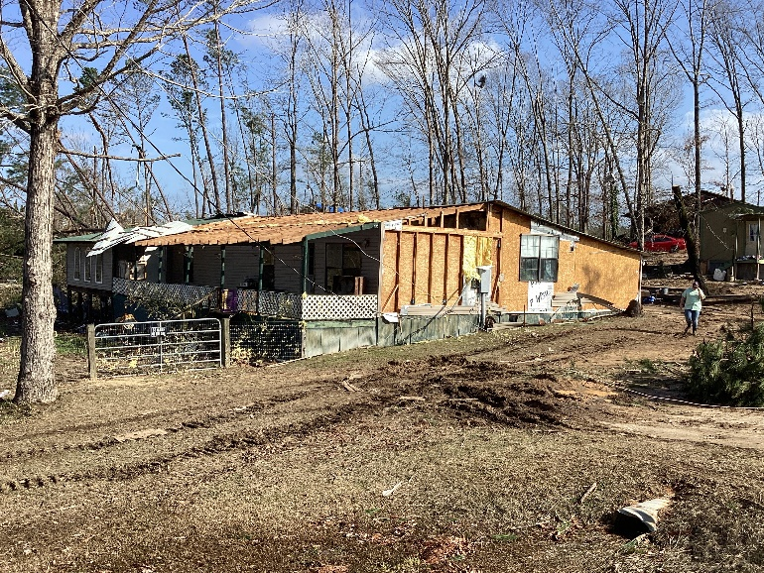

Union Parish Tornado

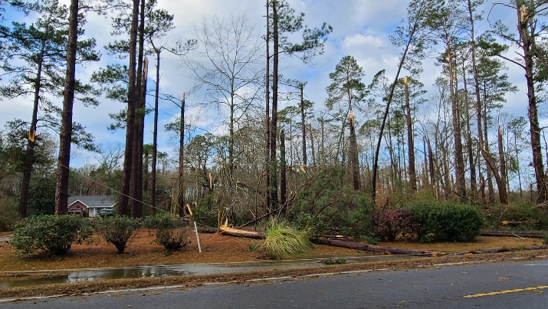 | 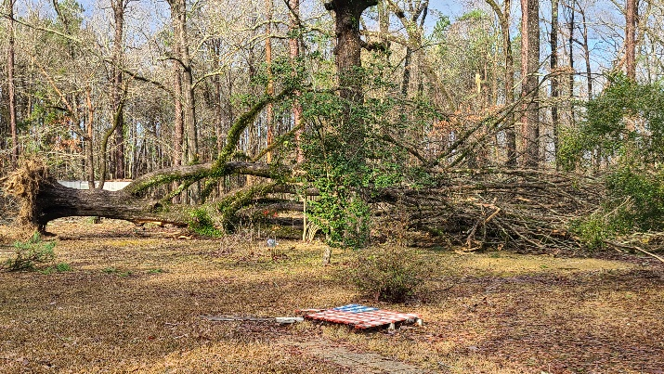
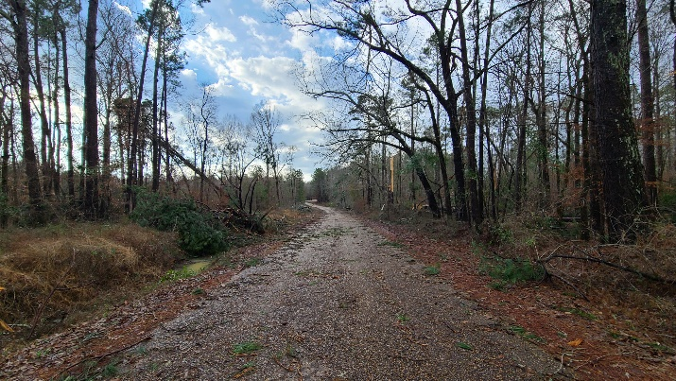 | 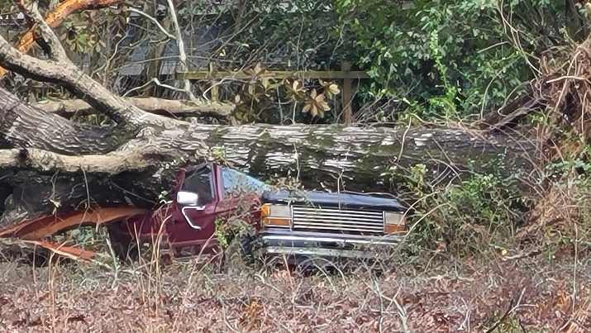
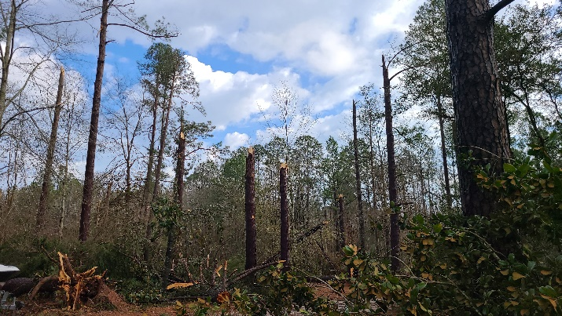 | 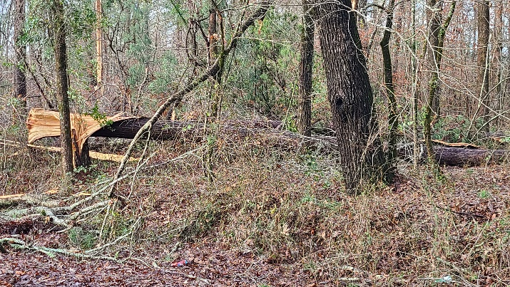
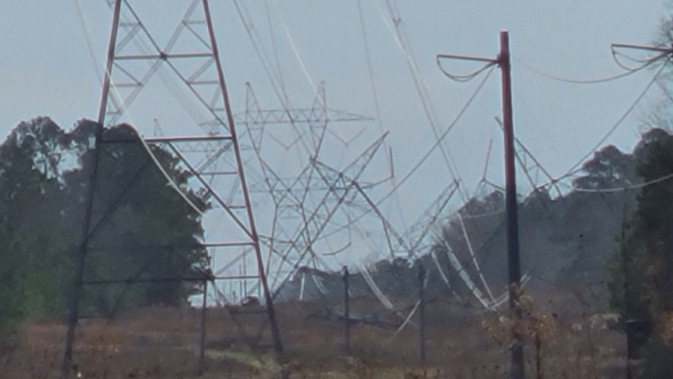 | 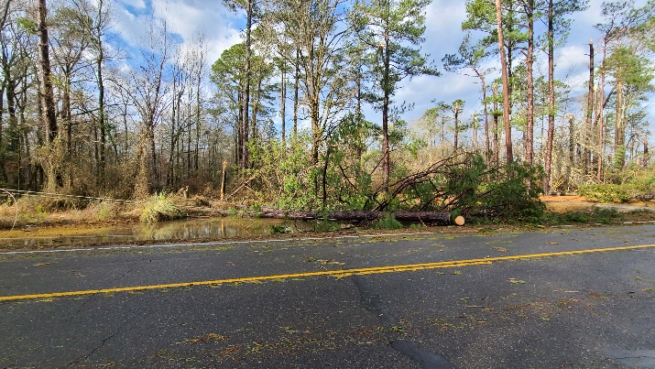

Drone Footage near Haile, Louisiana
Courtesy of Burt Green/WeatherUP

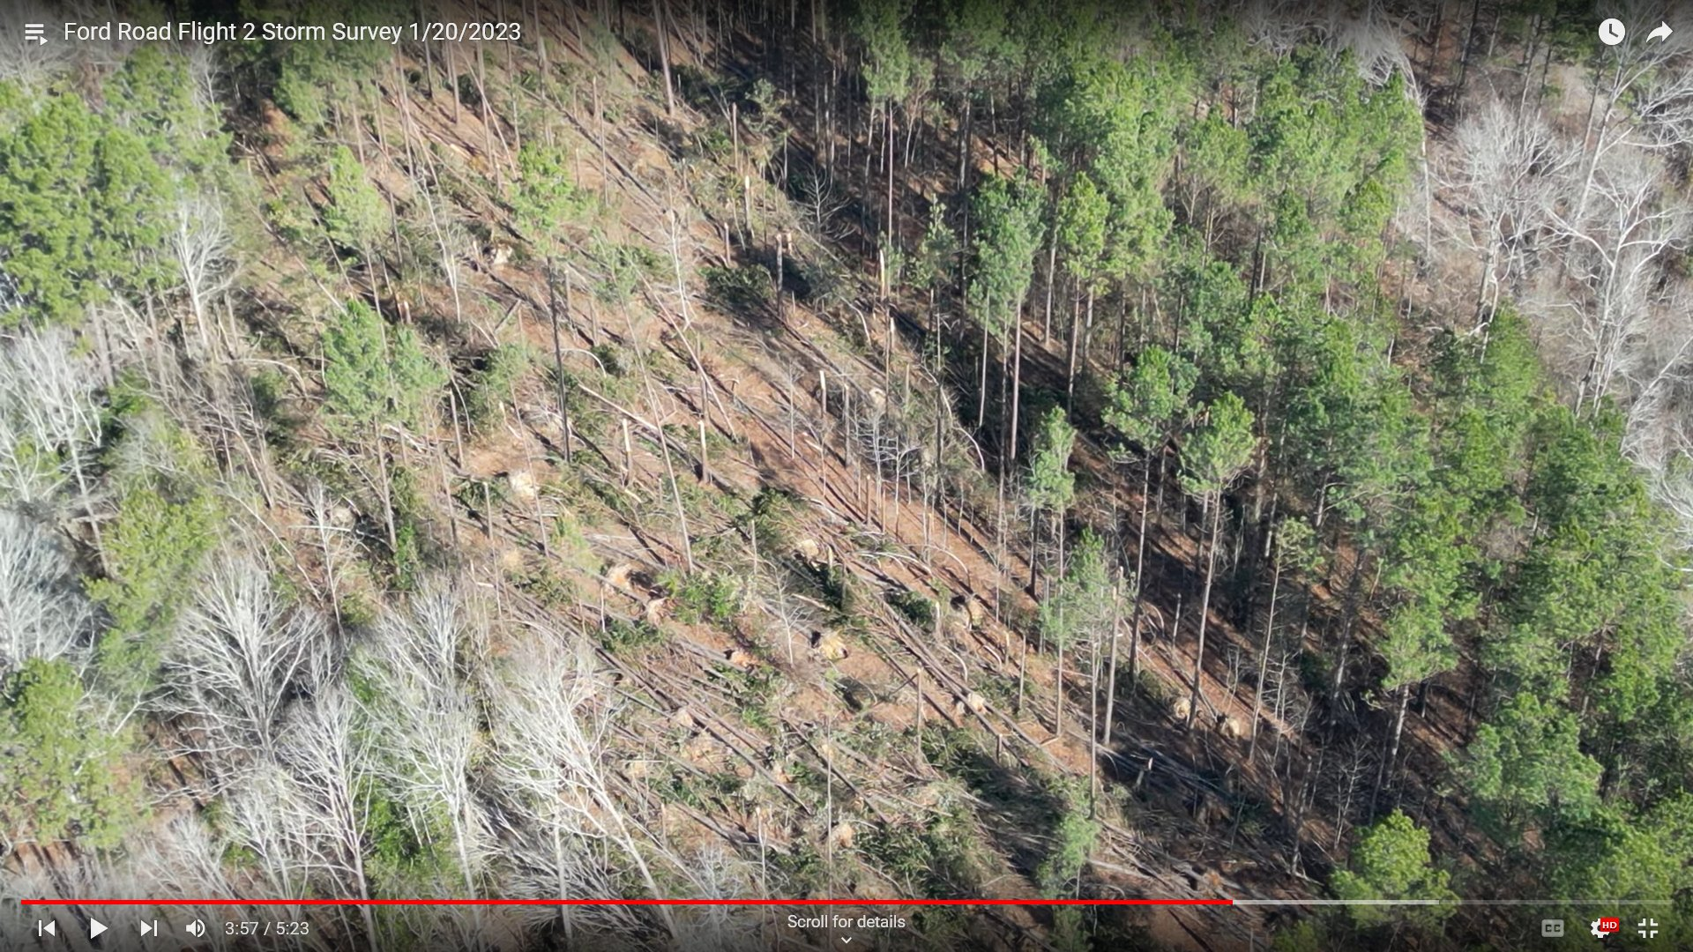

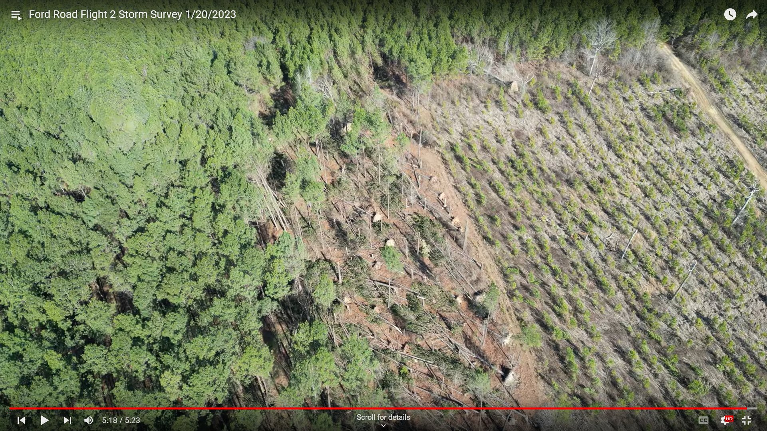

Acknowledgements

Bayou State Weather, LLC – https://www.bayoustateweather.com

Burt Green/WeatherUP - https://www.facebook.com/BurtGreenWX

Iowa State University - https://mesonet.agron.iastate.edu

National Weather Service – Jackson, Mississippi

National Weather Service – Shreveport Louisiana

