Easter Sunday Tornado Outbreak 4/12/2020
Report by: Don Wheeler, Meteorologist

...TORNADO EMERGENCY FOR MONROE LOUISIANA AND NORTHEAST OUACHITA
PARISH...

...A TORNADO WARNING REMAINS IN EFFECT UNTIL 1215 PM CDT FOR
NORTHEASTERN OUACHITA PARISH...

At 1142 AM CDT, a confirmed large and destructive tornado was located
over Monroe, moving northeast at 45 mph.

TORNADO EMERGENCY for Monroe and Northeast Ouachita Parish!

This is a PARTICULARLY DANGEROUS SITUATION. TAKE COVER NOW!

These are the words that are rarely put out by the National Weather Service during a tornado warning situation. They are dire and express the need for urgent and immediate action for citizens affected. These words were issued by the National Weather Service in Shreveport on Easter Sunday, at 11:44AM on April 12, 2020.

A “Tornado Emergency” is issued when:
- Severe threat to human life is imminent or ongoing.
- Catastrophic damage is imminent or ongoing.
- Reliable sources confirm tornado
- Visually
- Radar imagery strongly suggests the existence of a damaging tornado (a debris ball signature, for example).

All of the above criteria were met when the tornado emergency was issued for Monroe and northeastern Ouachita Parish: 1. Hook feature on reflectivity and debris ball; 2. Strong couplet on velocity; 3. Strong rotation on Normalized Rotation (NROT); and 4. Strong Correlation Coefficient signature indicating debris in the air.

Three tornadoes touched down in Ouachita Parish. One struck a portion of West Monroe and Monroe, one at Sterlington, and the other in Fairbanks. The West Monroe/Monroe tornado was rated at EF3, the Sterlington tornado rated at EF2, and the Fairbanks tornado rated at EF1.
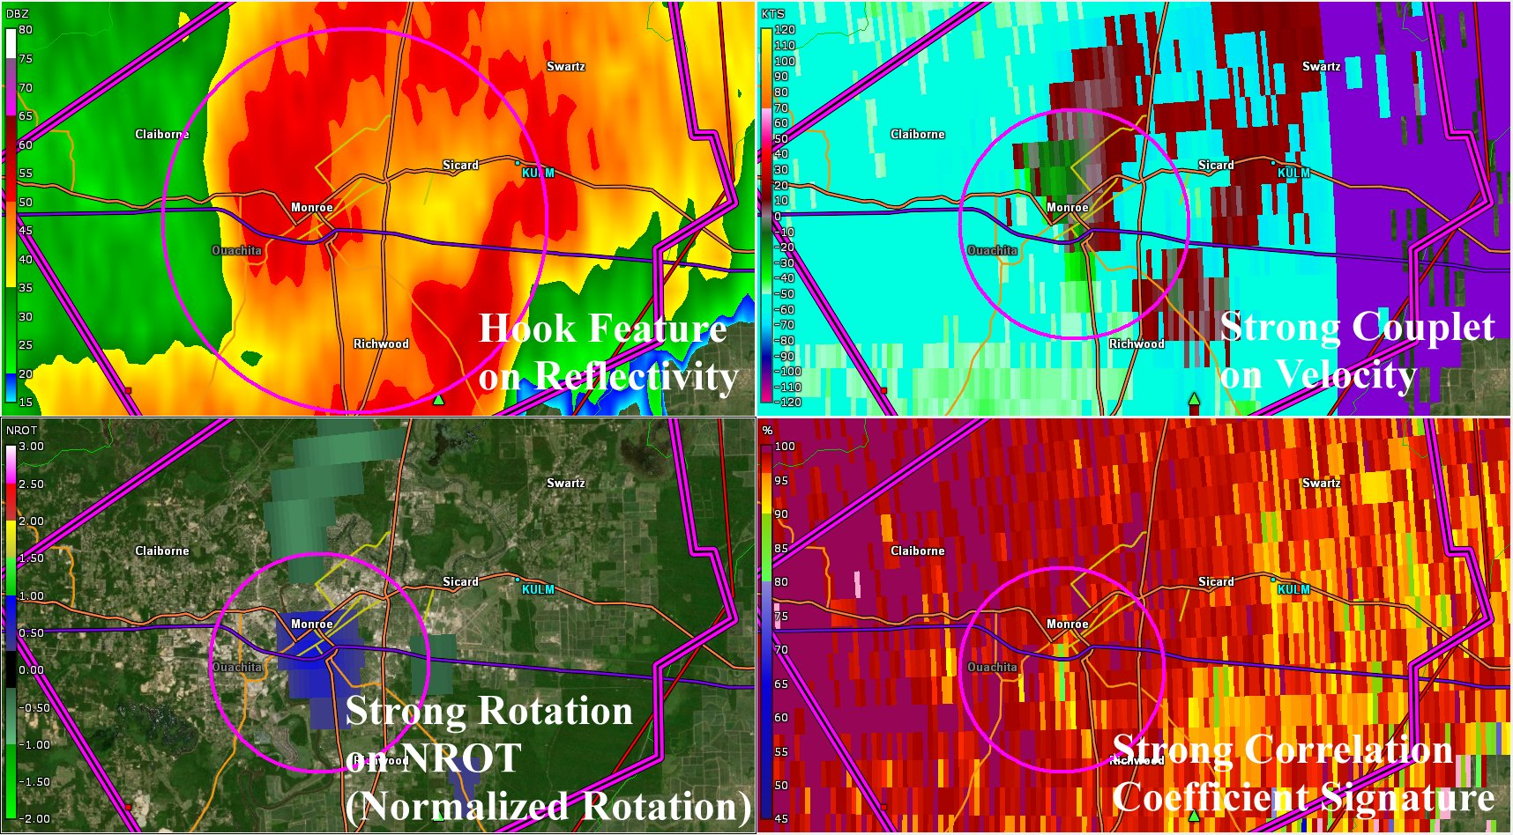
Figure 1 Radar Image from KSHV of Monroe Tornado
While some of the aforementioned indicators did not show up on the National Weather Service radar in Shreveport until the tornado had become stronger due to distance from the radar, these strong indicators of a tornado-on-the-ground were prevalent much sooner when viewed from the KULM radar and KTVE-TV’s radar as they were much closer to the storm. These valuable relatively new radars to our area proved what many have known for a long time in that northeast Louisiana was located at such a distance between the Shreveport and Jackson radars that lead-time for warning issuance could be somewhat delayed.

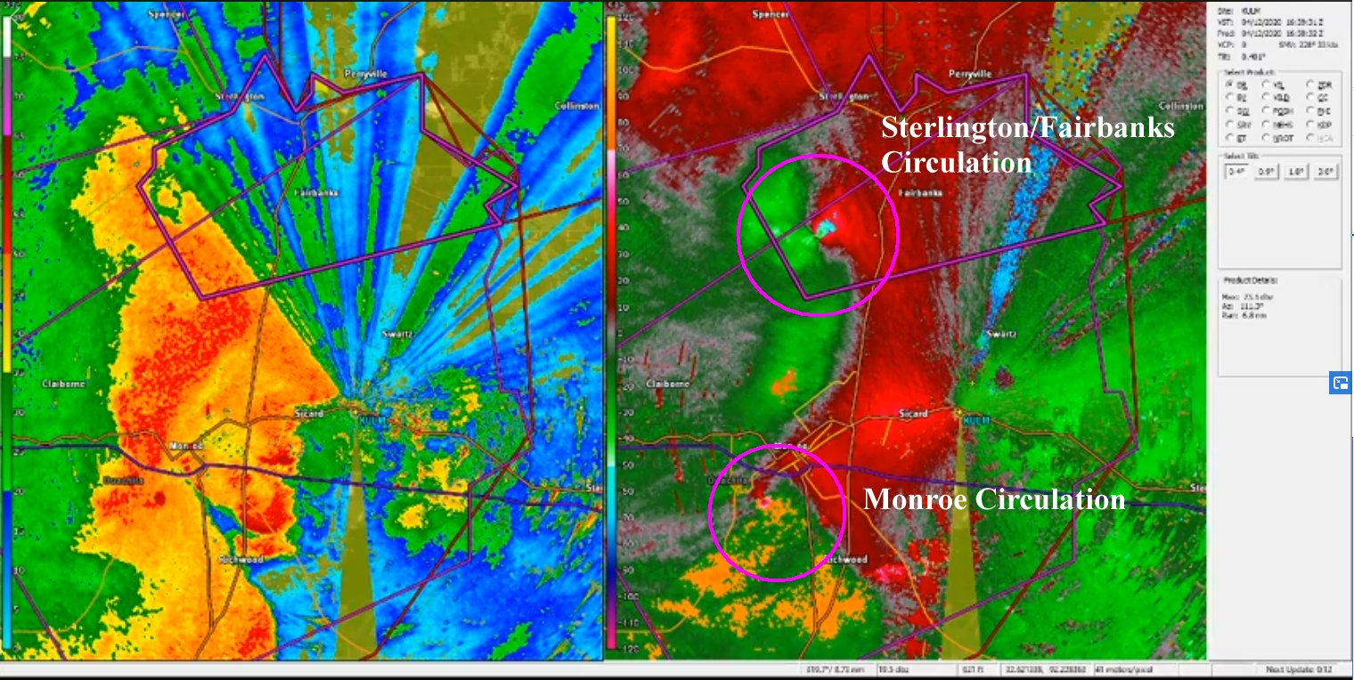
Figure 2 Video Capture of KULM Radar Showing Two Tornadic Storms over Ouachita Parish

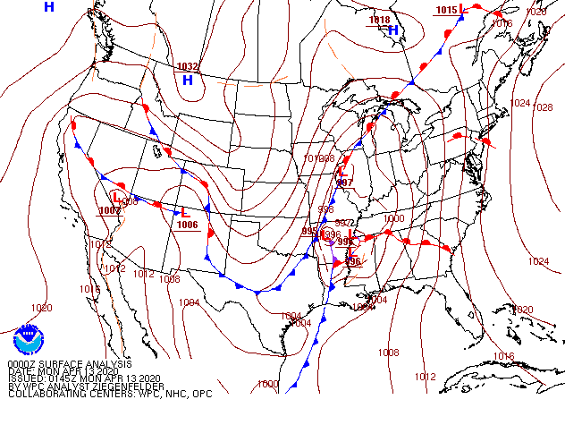
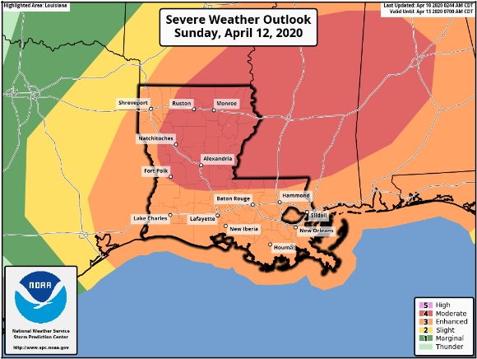
Several days before the event, the Storm Prediction Center had already tagged north Louisiana and adjacent Mississippi for a potential significant severe weather event. In the days that followed, computer model guidance only solidified the threat for the event. It is not very common for a Day Three Outlook to have a “Moderate Risk.”

At 1200Z (7AM CDT) a warm front had begun to lift north out of south Louisiana with a developing area of low pressure over Oklahoma. A cold front trailed south of the low into north and central Texas. Thunderstorms began to develop across northeast Texas producing damaging winds along with isolated tornadoes. Thunderstorms continued to organized into a squall line with numerous bow segments throughout the line. This trend continued through the morning and early afternoon as the line progressed across north Louisiana. Numerous tornado warnings were issued with the line. The image below shows how portions of the line would push out into bow segments. Typically, it is at the top of the bow where a cyclonic circulation is found. In the radar image, one can easily see the bowing feature on the velocity signatures indicated by the arrows. The top of each bow segment (circled) represents cyclonic circulation and where a tornado can form.
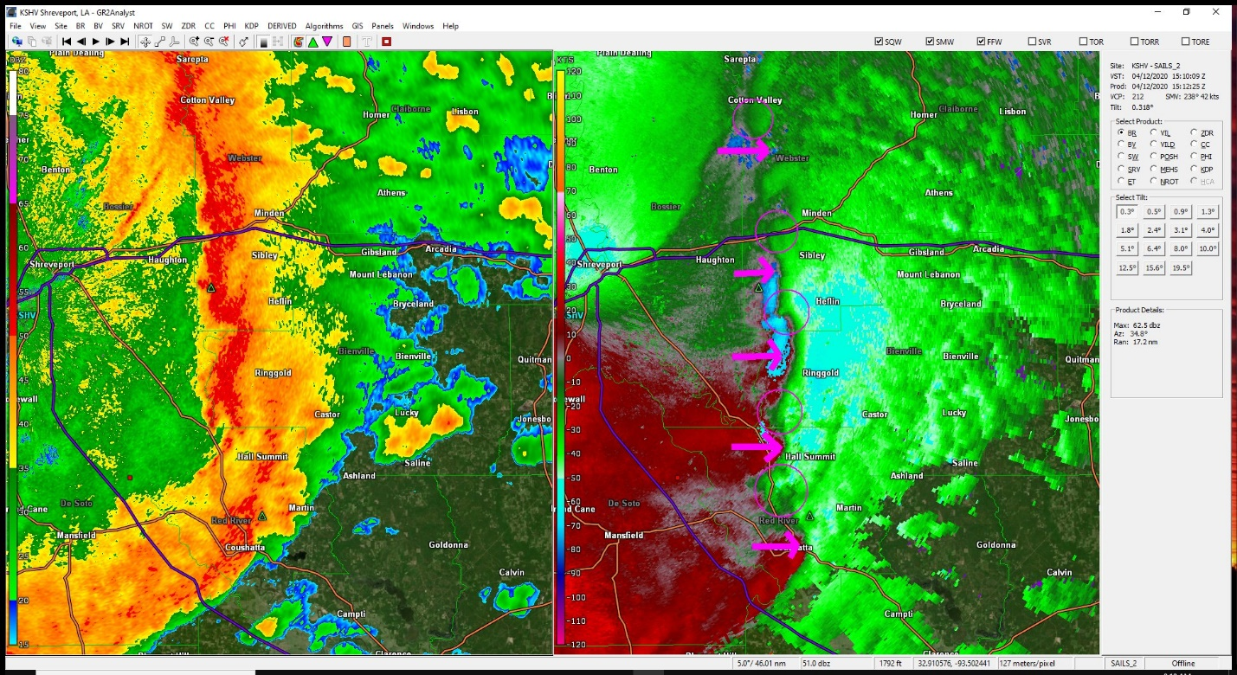
Figure 3 KSHV Radar Showing Bow Features
The line of storms began to approach Ouachita Parish at approximately 11AM CDT. Two circulations began to develop at 11:15 AM near and just to the south of Calhoun in western Ouachita Parish. The northern circulation would track northeast toward Sterlington and Fairbanks while the southern circulation weakened and/or reformed about nine miles southwest of Monroe at 11:20 AM.

The National Weather Service issued a tornado warning for the southern circulation at 11:33 AM for eastern Ouachita Parish for the southern circulation that eventually produced the EF3 tornado over West Monroe and Monroe. A tornado warning for the northern circulation was issued at 11:42 AM for northeastern Ouachita Parish for the Sterlington and Fairbanks area. This circulation produced two tornadoes – one in Sterlington (EF2) and the other in Fairbanks (EF1). Both storms had radar signatures indicating that debris was being lofted into the air.

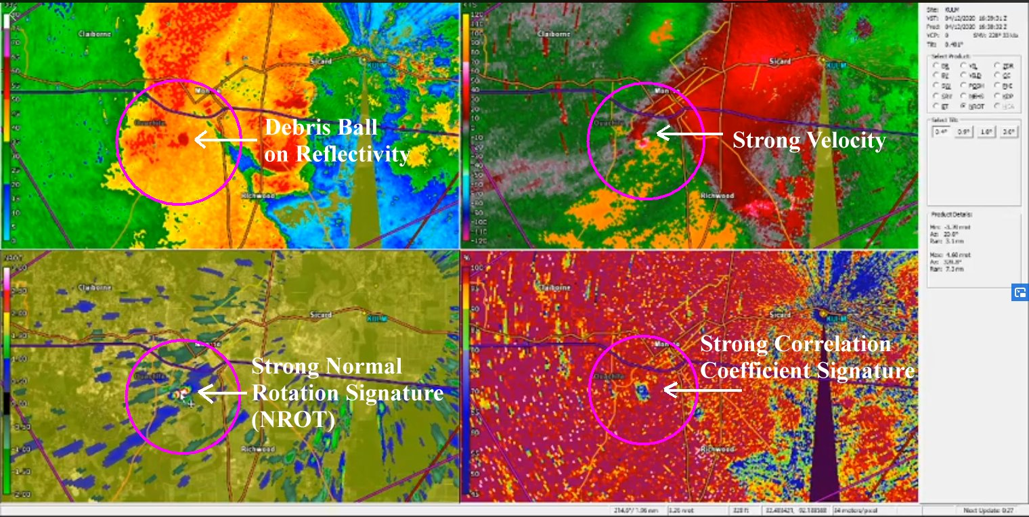
Figure 4 Video Capture of KULM Radar of Storm near Monroe
The storm that struck West Monroe/Monroe touched down in Bawcomville producing EF1 damage. It quickly moved northeast causing further damage at Lazarre Point in West Monroe before crossing the river in south Monroe near Jackson Street. The tornado continued to cause considerable damage to homes and businesses. The tornado moved across I-20 and U.S. 165 where it produced EF3 damage to homes near Powell Avenue just northwest of Pecanland Mall. It is possible that here an intense suction vortex (mesovortex) formed that caused a small area of EF3 damage. Roofs were completely removed from several homes with partial collapse of exterior walls.

The tornado continued northeast crossing Kansas Lane and entered the northern section of the Monroe Regional Airport. Here it destroyed a hangar and damaged several corporate jets. The tornado dissipated as it moved over one of the north runways at the airport. Three weather observation sites near or at the airport recorded significant pressure drops/spikes as the storm passed over or near them: KULM Radar Site (north of the airport), KMLU Airport, and KLAMONRO6 (Swartz)
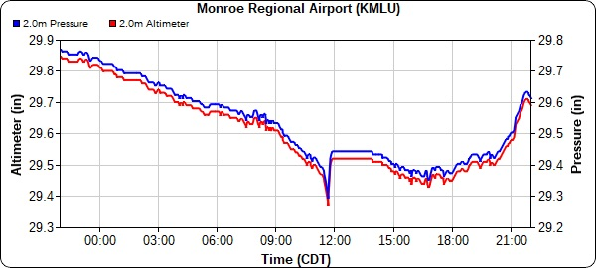 | 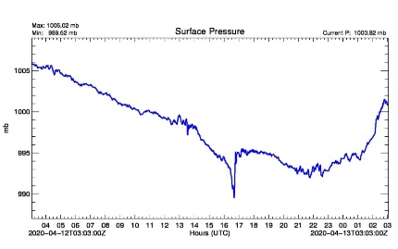 | 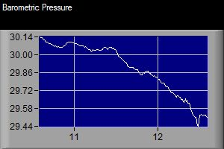
Figure 5 Pressure Drops/Spikes at KULM Radar Site, KMLU Airport, and KLAMONRO6 (Swartz)
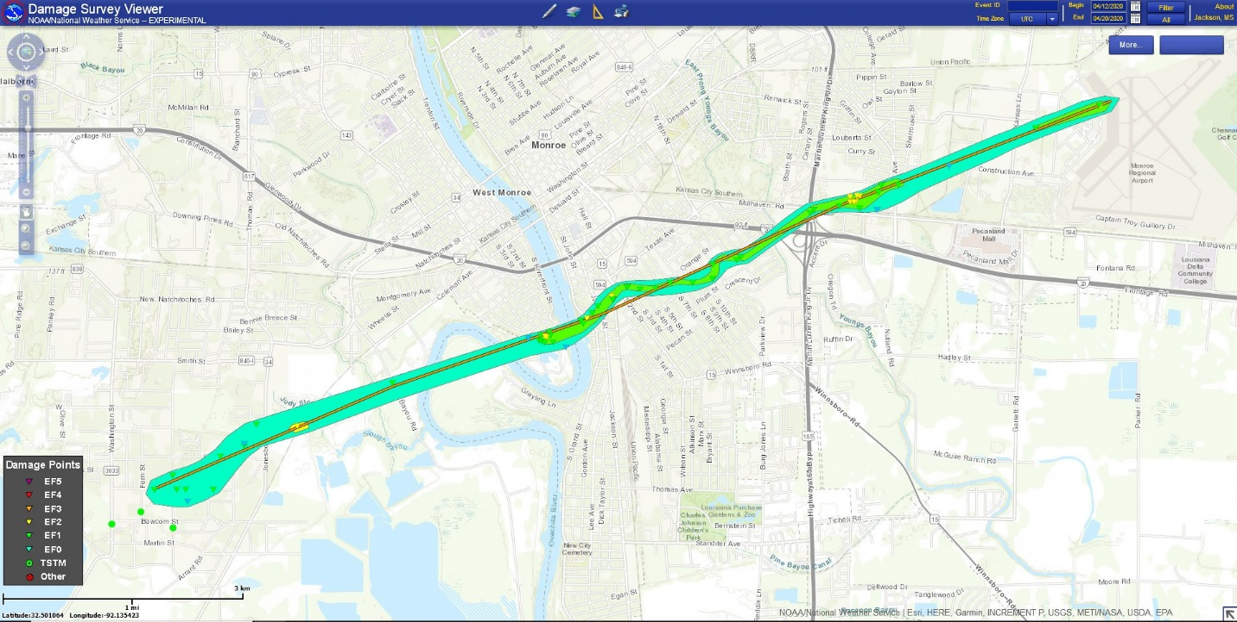
Figure 6 Damage Path from National Weather Service Survey
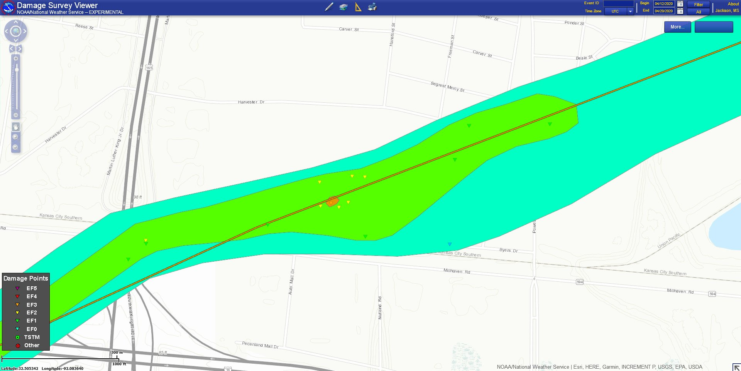
Figure 7 Isolated Area of EF3 Damage in Monroe
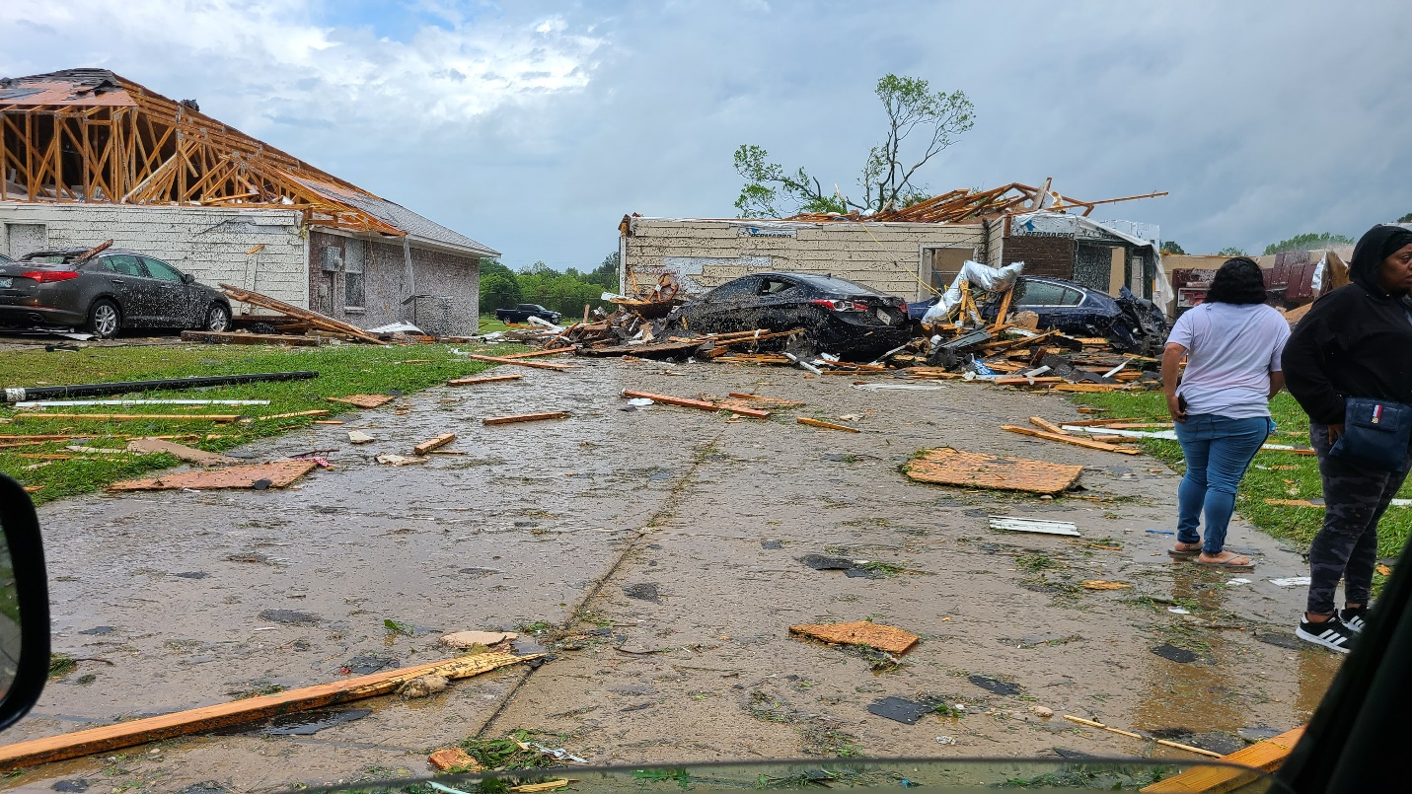
Figure 8 EF3 Damage in Monroe Subdivision. Photo by Keith Brooks
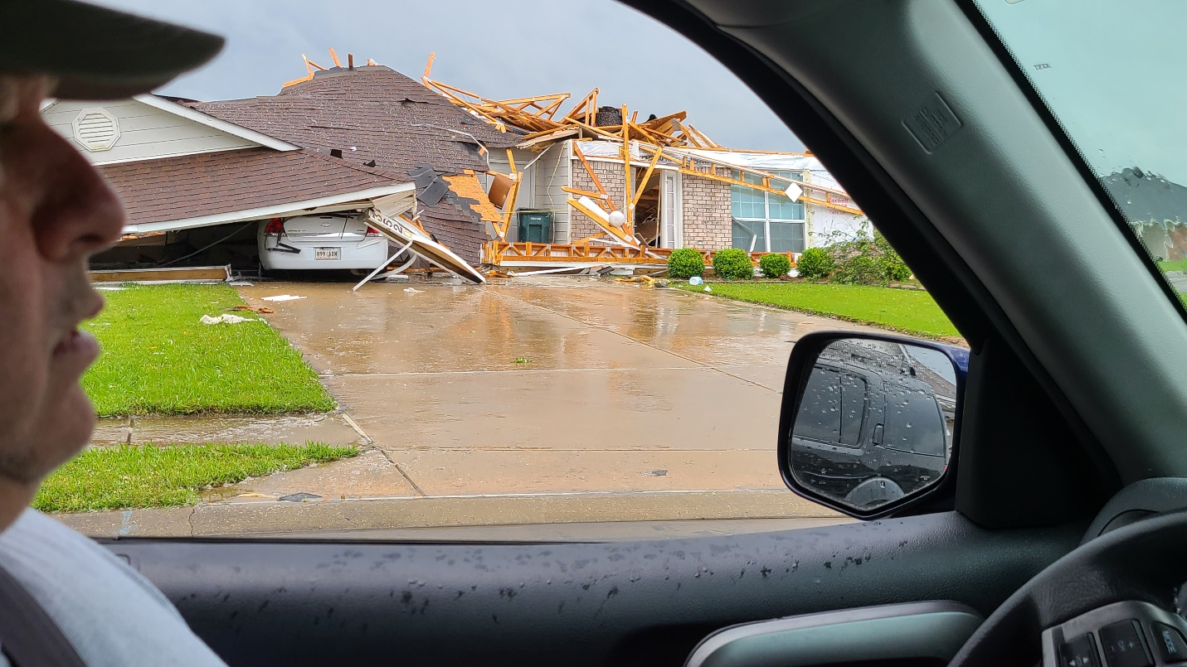
Figure 9 EF3 Damage in Monroe Subdivision. Photo by Keith Brooks
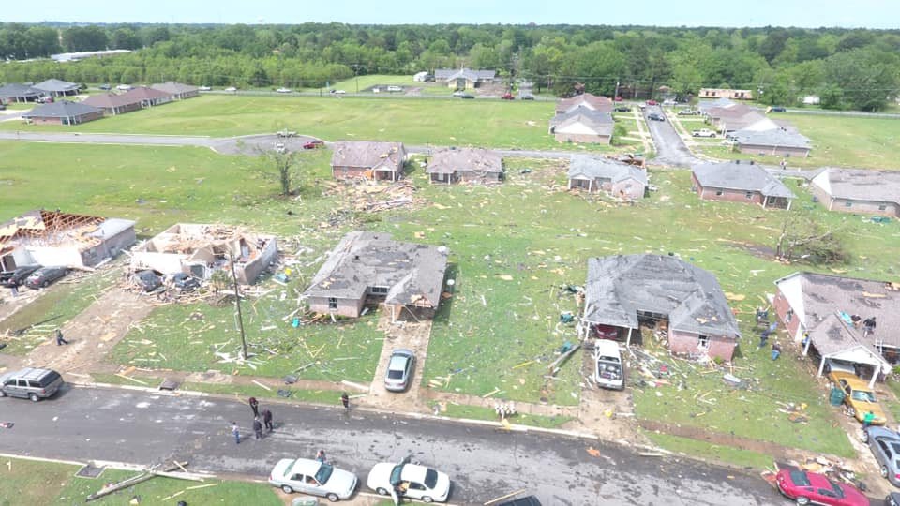
Figure 10 Aerial Image of Monroe Damage Courtesy of Kita Wright/ProWorks Productions LLC
Given the nature of the advancing squall line with multiple bow segments, two active and confirmed tornadoes were ongoing in Ouachita Parish simultaneously. A second storm was raking the northern portion of the parish in the Sterlington/Fairbanks area. This circulation produced two tornadoes – one in Sterlington which damaged homes and Sterlington High School and the other produced tree and home damage in the community of Fairbanks just to the east-northeast of Sterlington. It appears that the first Sterlington tornado cycled out and lifted while another formed downstream to strike Fairbanks. The Sterlington tornado produced EF2 damage while the Fairbanks tornado produced EF1 damage.
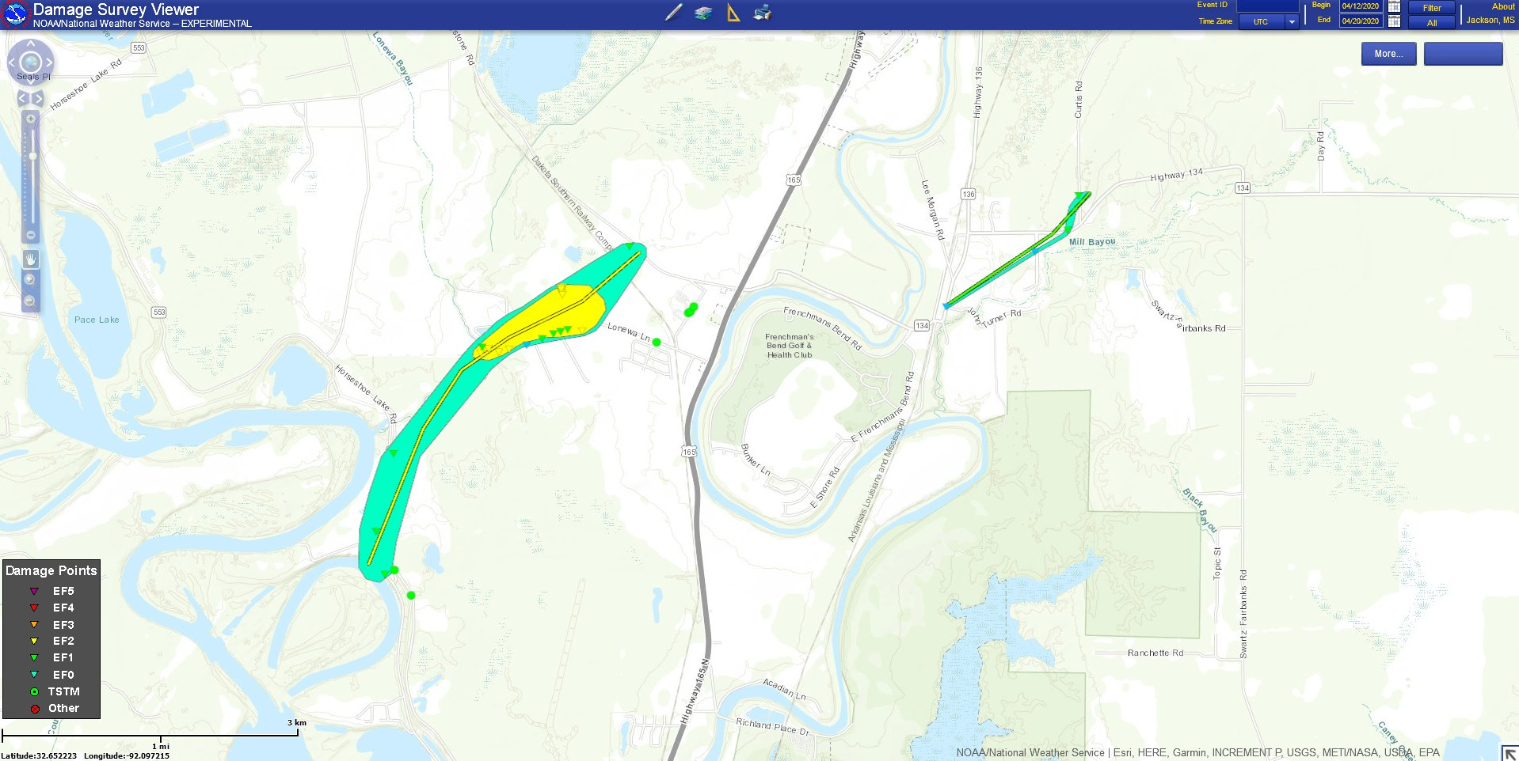
Figure 11 Sterlington/Fairbanks Tornado Damage Paths from National Weather Service Surveys
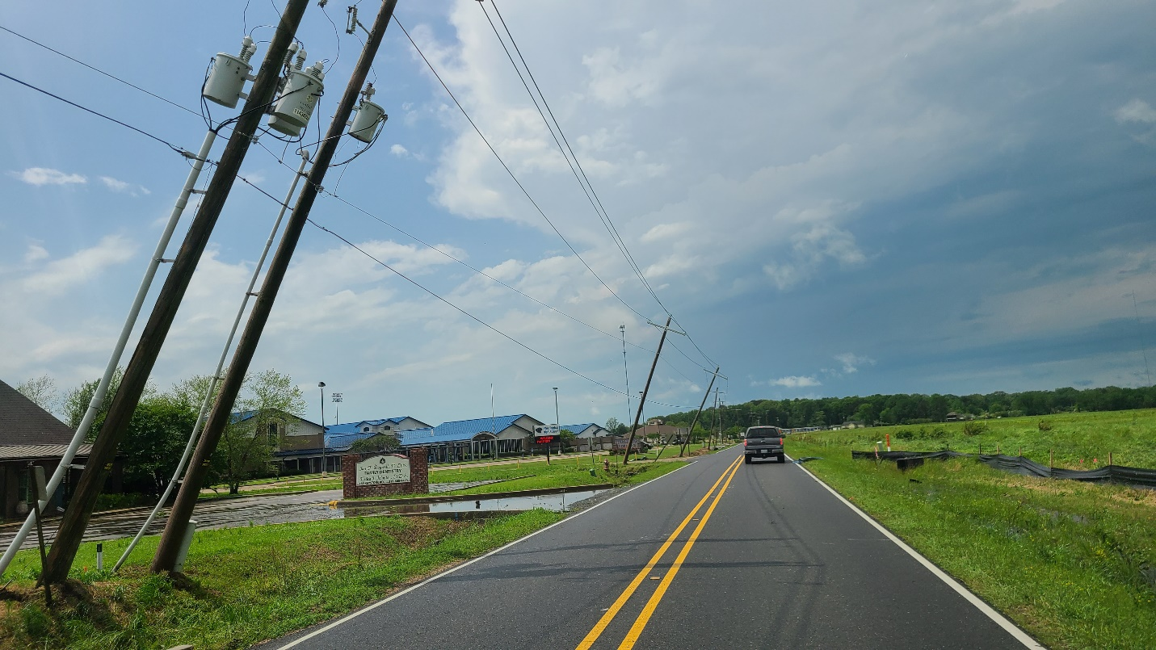
Figure 12 Light Pole Damage and Damage to Sterlington High School (left of image. Photo by Keith Brooks

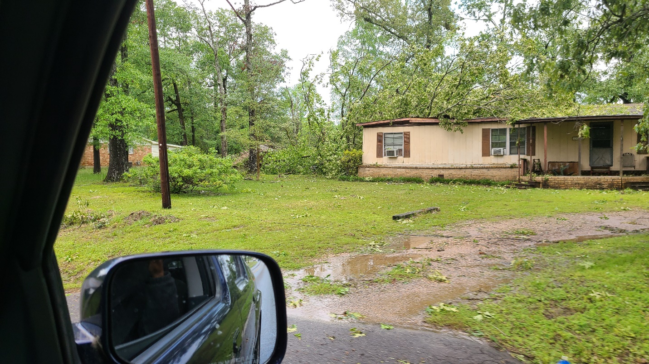
Figure 13 Tree Damage in Fairbanks. Photo by Keith Brooks

The Easter 2020 tornado outbreak was part of a larger outbreak that struck the Deep South. One hundred fifty-six reports of tornadoes were documented by the Storm Prediction Center with 14 (at the time of this report) documented across north Louisiana.
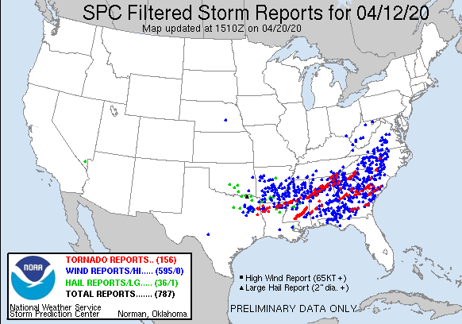
Figure 14 SPC Reports for April 12, 2020

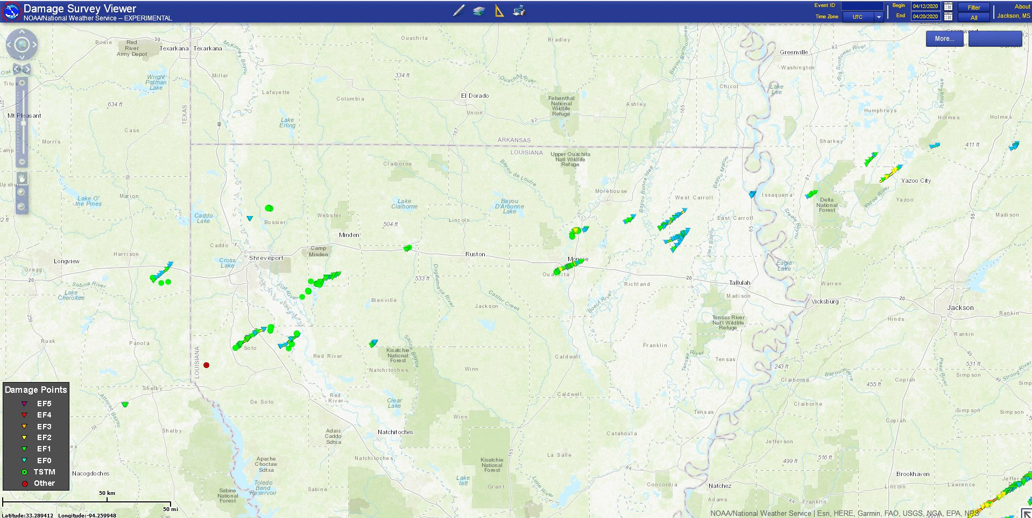
Figure 15 North Louisiana Tornado Tracks for April 12, 2020
Survey Report from the National Weather Service

.TORNADO #9 - MONROE IN OUACHITA PARISH, LA

RATING: EF3
ESTIMATED PEAK WIND: 140 MPH
PATH LENGTH /STATUTE/: 8.03 MILES
PATH WIDTH /MAXIMUM/: 300.0 YARDS
FATALITIES: 0
INJURIES: 0

START DATE: 04/12/2020
START TIME: 11:36 AM CDT
START LOCATION: 1 SSW BROWNSVILLE-BAWCOM / OUACHITA
PARISH / LA
START LAT/LON: 32.4706 / -92.1699

END DATE: 04/12/2020
END TIME: 11:45 AM CDT
END LOCATION: 2 E MONROE / OUACHITA PARISH / LA
END LAT/LON: 32.5142 / -92.0425

SUMMARY: THE TORNADO FIRST TOUCHED DOWN ON THE CORNER OF FERN ST
AND BROWN ST IN THE BROWNSVILLE-BAWCOMVILLE COMMUNITY. AS IT
MOVED THROUGH NEIGHBORHOODS, IT DOWNED AND SNAPPED HUNDREDS OF
TREES, MANY OF WHICH FELL ONTO HOMES. AS THE TORNADO CROSSED
SANDAL ST, IT DID MINOR STRUCTURE DAMAGE TO SEVERAL SINGLE WIDE
MANUFACTURED HOMES BEFORE TIPPING OVER A TRAILER AS IT CROSSED
JONESBORO RD. THE TORNADO THEN PROCEEDED ONWARD TO BREAK THE
METAL TRUSSES AND BRING DOWN A WOOD CHIP CONVEYOR BELT ONTO A
TRAIN AT A PAPER MILL. AS THE TORNADO CONTINUED, IT CROSSED THE
OUACHITA RIVER TWICE WHERE IT BENDS SHARPLY BEFORE INCREASING
INTENSITY ALONG RIVERBEND DR. THIS INCREASE IN INTENSITY WAS MOST
NOTABLE FROM MANY TREE TRUNKS SNAPPED, THE ROOF RIPPED OFF OF A
SINGLE FAMILY HOME AND A COLLAPSED WALL ON ANOTHER SINGLE FAMILY
HOME.

THE TORNADO THEN CROSSED THE OUACHITA RIVER AGAIN AND
PARTIALLY DAMAGED THE ROOF OF THE MASUR MUSEUM OF ART, MISSING
DOWNTOWN MONROE BY ROUGHLY A MILE. AS IT CROSSED SOUTH GRAND ST,
IT THEN RIPPED THE ROOF OFF OF A TWO STORY HOME AND CONTINUED ON
TO DAMAGE THE ROOFS OF SEVERAL HOMES AND DOWNED TREES UNTIL IT
CROSSED NEAR THE INTERSECTION OF HIGHWAY 165 AND INTERSTATE 20.
THERE IT DAMAGED A METAL BUILDING STRUCTURE AND SNAPPED A WOODEN
POWER POLE AND STEEL STREET LIGHT ASSEMBLY AS IT CROSSED MILHAVEN
RD.

THE WORST DAMAGE FROM THE TORNADO THEN OCCURRED ALONG ORCHID
DR WHERE IT RIPPED THE ROOF OFF OF 3 HOMES AND COLLAPSED MUCH OF
THE EXTERIOR WALLS OF ONE OF THE HOMES. THE WORST DAMAGE WAS
ALONG A VERY NARROW CORRIDOR IN THIS SUBDIVISION AND IS BELIEVED
THAT A MESOVORTEX WITHIN THE TORNADO LED TO THIS NARROW CORRIDOR
OF MORE INTENSE DAMAGE. AFTER THE TORNADO MOVED OUT OF THIS
SUBDIVISION, DAMAGE BECAME MORE SPORADIC AND THE TORNADO TOUCHED
SEVERAL TIMES BEFORE IT DESTROYED A METAL HANGAR HOUSING SEVERAL
AIRPLANES AT THE MONROE REGIONAL AIRPORT. THE TORNADO THEN
LIFTED AS IT CROSSED A RUNWAY OF THE AIRPORT.

A SPECIAL THANKS GOES OUT TO THE OUACHITA PARISH OFFICE OF
HOMELAND SECURITY AND EMERGENCY PREPAREDNESS (OHSEP) FOR THEIR
ASSISTANCE IN THE SURVEY. INITIAL ESTIMATES FROM OUACHITA OHSEP
INDICATE THAT THAT A TOTAL OF 458 HOMES ACROSS THE PARISH WERE
IMPACTED BY THE THREE TORNADOES. 23 HOMES WERE DESTROYED,
108 HAD MAJOR DAMAGE, 243 WITH MINOR DAMAGE, AND ANOTHER 84 HOMES
WERE AFFECTED ACROSS THE PARISH.

MUCH APPRECIATION GOES OUT TO THE UNIVERSITY OF LOUISIANA-MONROE
ATMOSPHERIC SCIENCE PROGRAM FOR MAKING ADJUSTMENTS TO THE ULM
RADAR SCANNING STRATEGY IN COORDINATION WITH OUR OFFICE PRIOR TO
STORMS HITTING NORTH-CENTRAL AND NORTHEAST LOUISIANA. THIS
ACTION PRIOR TO THE TORNADOES HITTING OUACHITA PARISH ALLOWED FOR
WARNING FORECASTERS TO HAVE CRITICAL INFORMATION WHICH LED TO
ADDITIONAL LEAD-TIME ON THE MONROE TORNADO.

.TORNADO #10 - SOUTHWEST OF STERLINGTON IN OUACHITA PARISH, LA...

RATING: EF2
ESTIMATED PEAK WIND: 130 MPH
PATH LENGTH /STATUTE/: 2.71 MILES
PATH WIDTH /MAXIMUM/: 400.0 YARDS
FATALITIES: 0
INJURIES: 0

START DATE: 04/12/2020
START TIME: 11:39 AM CDT
START LOCATION: 5 SSW STERLINGTON / OUACHITA PARISH / LA
START LAT/LON: 32.6215 / -92.0977

END DATE: 04/12/2020
END TIME: 11:43 AM CDT
END LOCATION: 3 S STERLINGTON / OUACHITA PARISH / LA
END LAT/LON: 32.65 / -92.0684

SUMMARY: THE TORNADO FIRST TOUCHED DOWN IN A FORESTED AREA NEAR
HORSESHOE LAKE RD, UPROOTING HUNDREDS OF TREES. WINDS INCREASED
AND TREE DAMAGE BECAME MORE WIDESPREAD AS TREES WERE UPROOTED,
SNAPPED, AND EVEN A TREE PARTIALLY DEBARKED OFF OF END OF LINE
RD. THE TORNADO TOOK THE ROOF OFF OF TWO SINGLE FAMILY HOMES AND
DESTROYED AN OUTBUILDING ALONG END OF LINE RD. IT THEN DAMAGED
SHINGLES AS APPROXIMATELY TEN HOUSES AS IT TRACKED ALONG LONEWA
LANE AND ROSE PLANTATION LANE. ALONG LONEWA LANE, THE TORNADO
SNAPPED FOUR CONCRETE POLES BEFORE LIFTING JUST BEFORE IT CROSSED
KEYSTONE RD.

.TORNADO #11 - SOUTHEAST OF STERLINGTON IN OUACHITA PARISH, LA

RATING: EF1
ESTIMATED PEAK WIND: 105 MPH
PATH LENGTH /STATUTE/: 1.15 MILES
PATH WIDTH /MAXIMUM/: 50.0 YARDS
FATALITIES: 0
INJURIES: 0

START DATE: 04/12/2020
START TIME: 11:46 AM CDT
START LOCATION: 3 SSE STERLINGTON / OUACHITA PARISH / LA
START LAT/LON: 32.6452 / -92.035

END DATE: 04/12/2020
END TIME: 11:48 AM CDT
END LOCATION: 3 SE STERLINGTON / OUACHITA PARISH / LA
END LAT/LON: 32.6554 / -92.0196

SUMMARY: A TORNADO BRIEFLY TOUCHED DOWN IN FAIRBANKS ALONG THE
CORNER OF JOHN TURNER RD AND HIGHWAY 134. IT CONTINUED ON TO
CROSS HIGHWAY 134 AGAIN AND CURTIS RD. BEFORE LIFTING.
APPROXIMATELY 30 TREES WERE UPROOTED AND SNAPPED IN A CONVERGENT
PATTERN ALONG THE PATH.

EF SCALE: THE ENHANCED FUJITA SCALE CLASSIFIES TORNADOES INTO
THE FOLLOWING CATEGORIES.

EF0...WEAK......65 TO 85 MPH
EF1...WEAK......86 TO 110 MPH
EF2...STRONG....111 TO 135 MPH
EF3...STRONG....136 TO 165 MPH
EF4...VIOLENT...166 TO 200MPH
EF5...VIOLENT...>200MPH

*This report along with a gallery of images can be found at: http://www.bayoustateweather.com/eastertornadoes2020

