December 9, 2023 North Louisiana Hail Event

By: Don Wheeler, Meteorologist

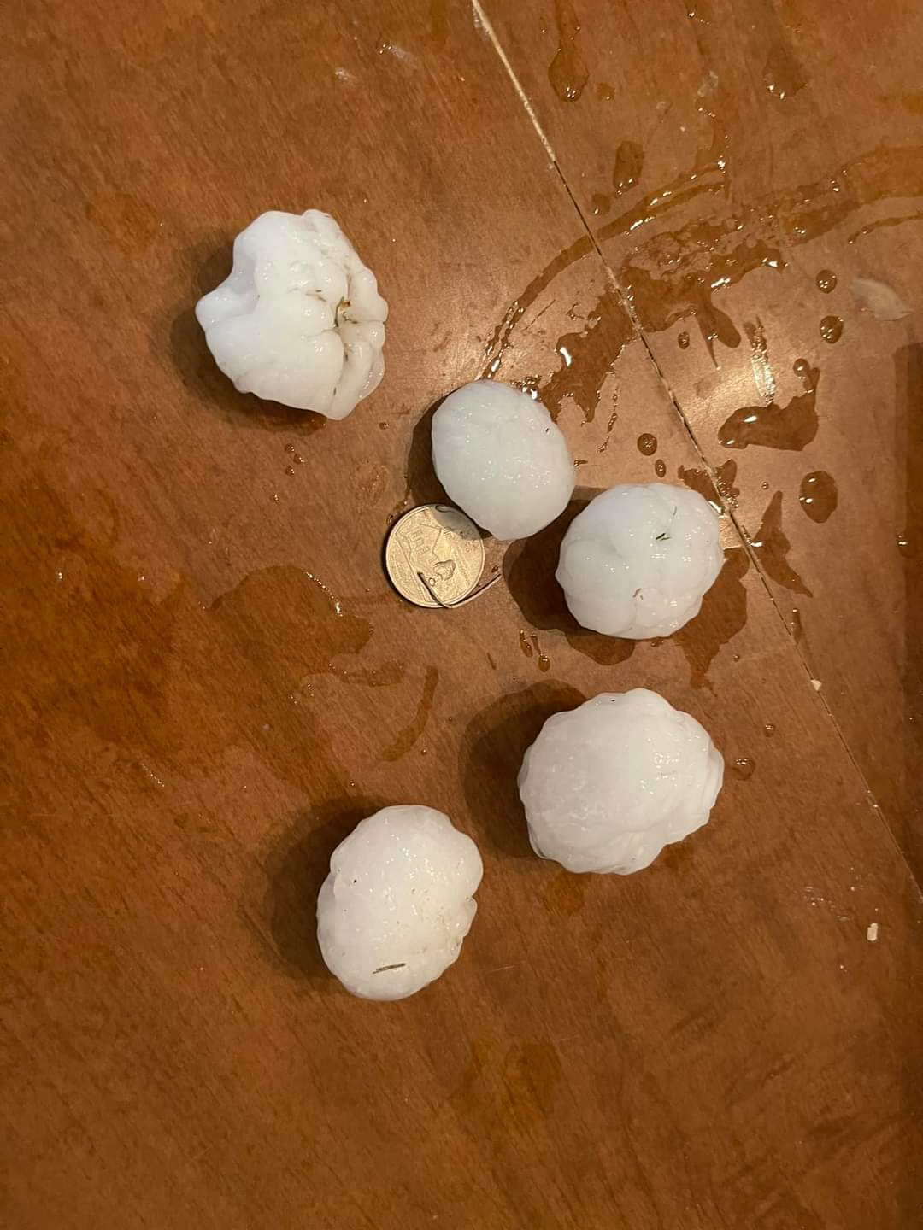
Large Hail near Sterlington, Louisiana
Left Image Courtesy of Burt Green/Weather UP – Right Image Courtesy of Mike Hammett
Introduction

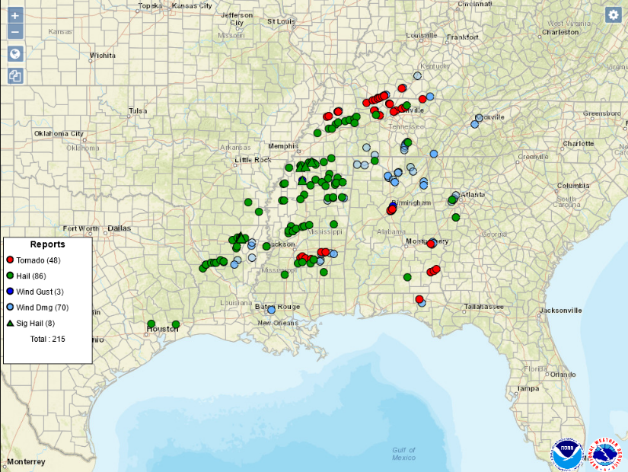
During the late afternoon and early evening hours of December 9, severe thunderstorms marched across north Louisiana dropping large, damaging hail and a few reports of wind damage. These storms were a part of a larger storm system that spawned severe weather across a significant portion of the southeastern U.S. known as Dixie Alley.
Figure 1 - Severe Weather Reports from December 9, 2023 - Dixie Alley

Across the Deep South, the storm system generated a total of 43 tornado reports, 68 reports of damaging wind, 79 reports of large hail, and 8 reports of very large hail (2-inches in diameter or greater). Most of the tornado reports were in Tennessee, Mississippi, and Alabama including the deadly EF-3 Clarksville, Tennessee tornado.
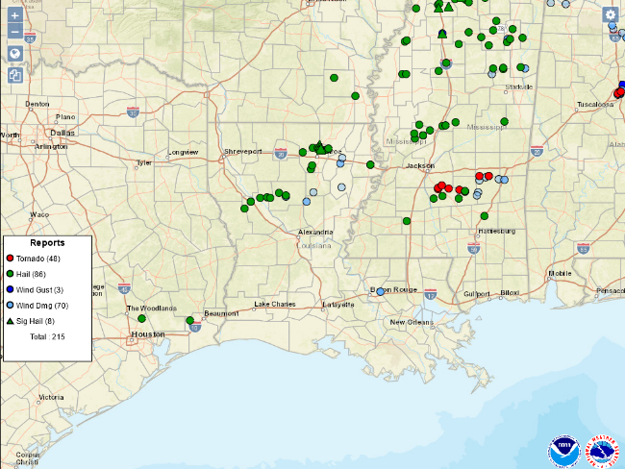
Figure 2 - Louisiana Severe Weather Reports
Louisiana was spared any tornado activity with this system but did experience very large hail and damaging wind gusts. Overall, the state saw six reports of damaging wind (50 knots/58 mph or greater), 16 reports of large hail (1-inch diameter or greater), and four reports of significant large hail (2-inches in diameter or greater).

Ouachita Parish saw perhaps the highest proportion of severe weather with this event tallying eight reports of large hail (two of these were on or near the Ouachita/Union line) and all four of the significant hail reports in the state.

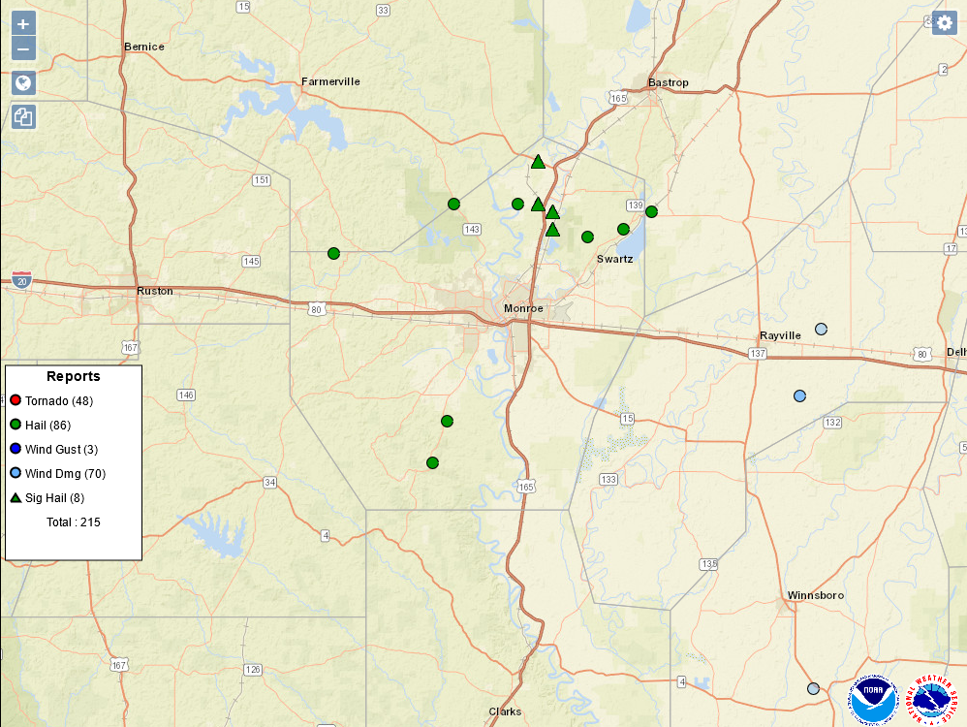
Figure 3 - Ouachita Parish Severe Reports

Synopsis

The morning of December 9, showed a large-scale, positively tilted upper-level trough across the central part of the U.S. with an upper low over Minnesota. The trough extended southwest into New Mexico. At the surface, an elongated cold front extended from a surface low over the Great Lakes region south through Illinois and then southwest across central Arkansas into northeast and central Texas. Several areas of low pressure were noted along the frontal boundary.

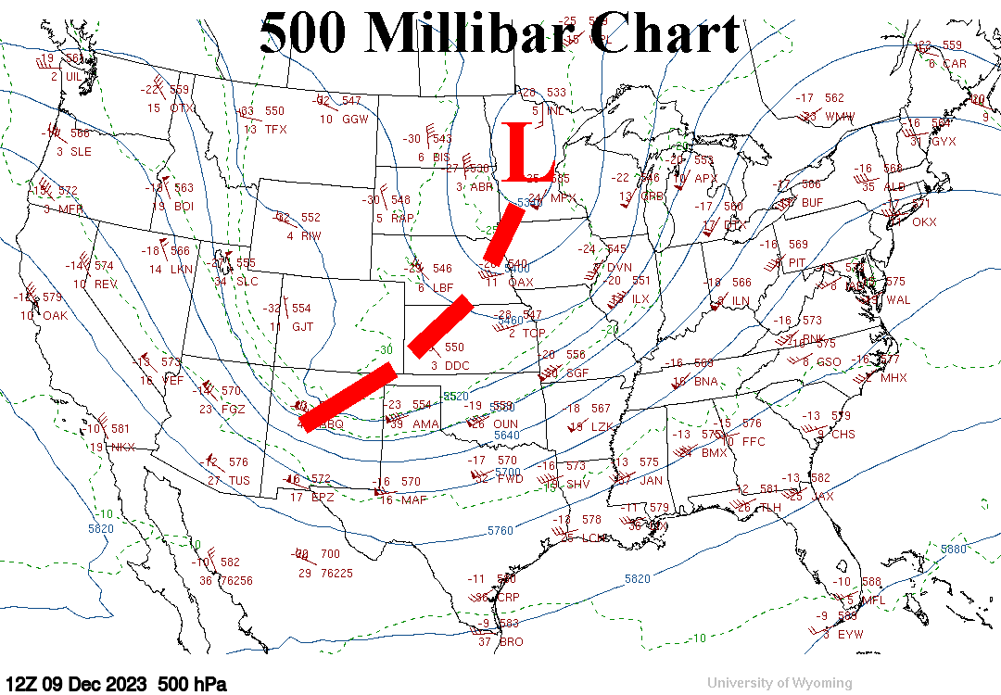
Figure 4 - 500 Millibar Chart - 12Z 12/9/23

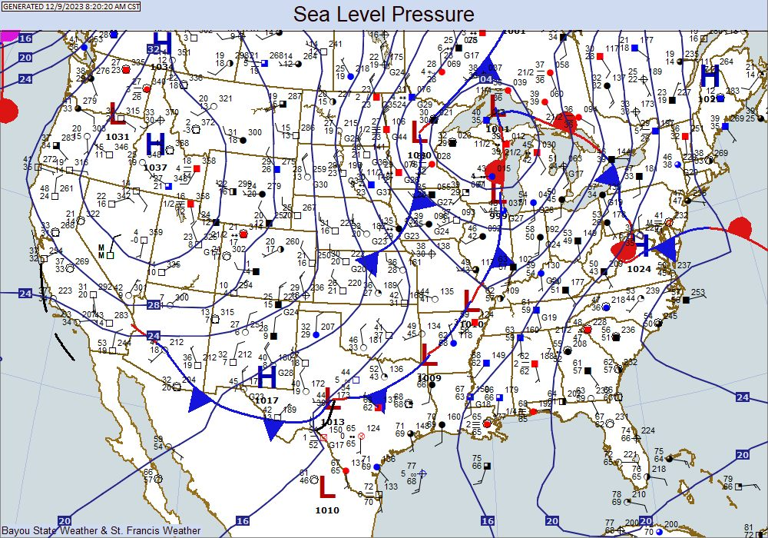
Figure 5- Surface Chart 12/9/23 14Z 12/9/23
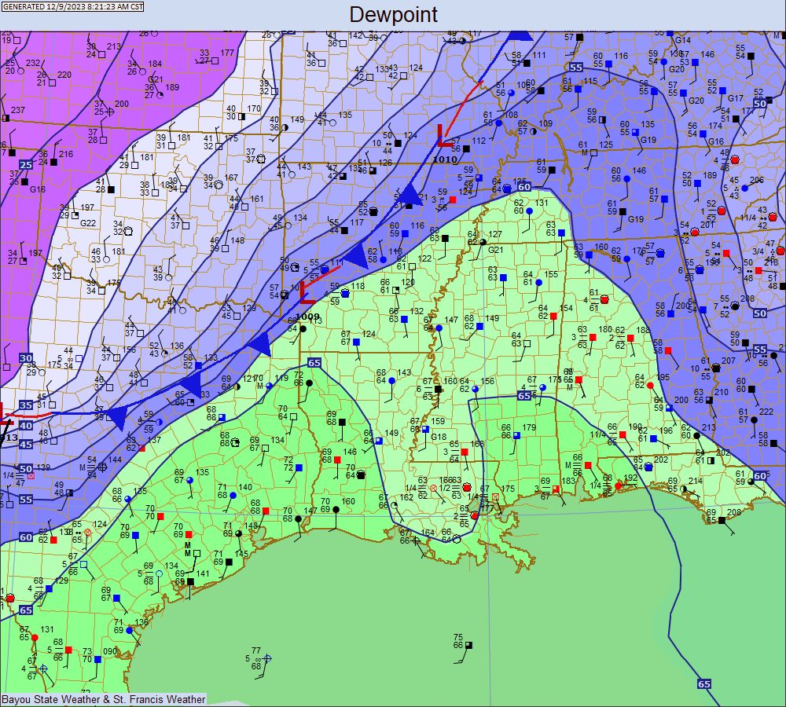
Moisture return during the morning was evident on the dewpoint charts with isodrosotherms (lines of equal dewpoint values) surging north ahead of the slowly advancing cold front. Dewpoint values across Louisiana were well into the 60s with sharply lower values along and behind the front across northern Arkansas, northeast Texas, and Oklahoma.

The morning balloon sounding from Shreveport National Weather Service showed ample moisture in the lower levels with dry air above 900 millibars. The freezing level was relatively low at around 650 millibars. Directional wind shear was low, thus minimizing the tornado threat across our state. These parameters, along with ample instability, allowed for the formation of hail-producing thunderstorms.
Figure 6 - Dewpoints 14Z 12/9/23

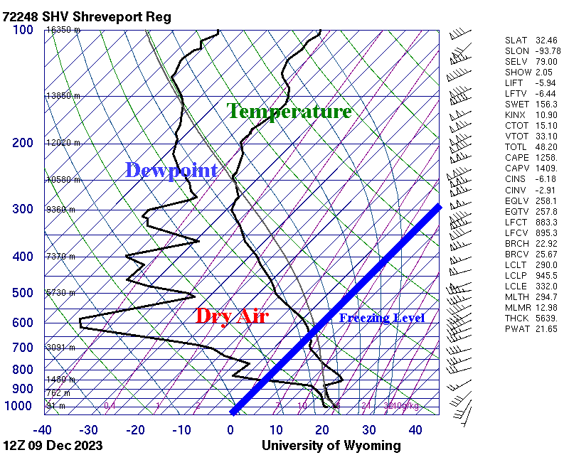
Figure 7 - 12Z Sounding from Shreveport NWS

The Storm Prediction Center had all of northeast Louisiana under a “Slight Risk” for severe storms for Saturday afternoon and evening. This area extended northeast into southeast Arkansas, much of Mississippi, and into Tennessee and northern Alabama. The tornado outlook was relatively low for Louisiana showing only a 2-4% chance of a tornado within 25 miles of a given point across most of north Louisiana and a 5-9% chance for a small portion of northeast Louisiana that extended northeastward into adjacent states. The severe wind threat showed much of northeast Louisiana with a 15-29% chance for damaging winds within 25 miles of a given point. The severe hail threat showed a 15-29% chance for severe hail with 25 miles of a given point but only for a small area of northeast Louisiana. Lesser chances of 5-14% were found south of the higher percentage area extending into southwest Louisiana.

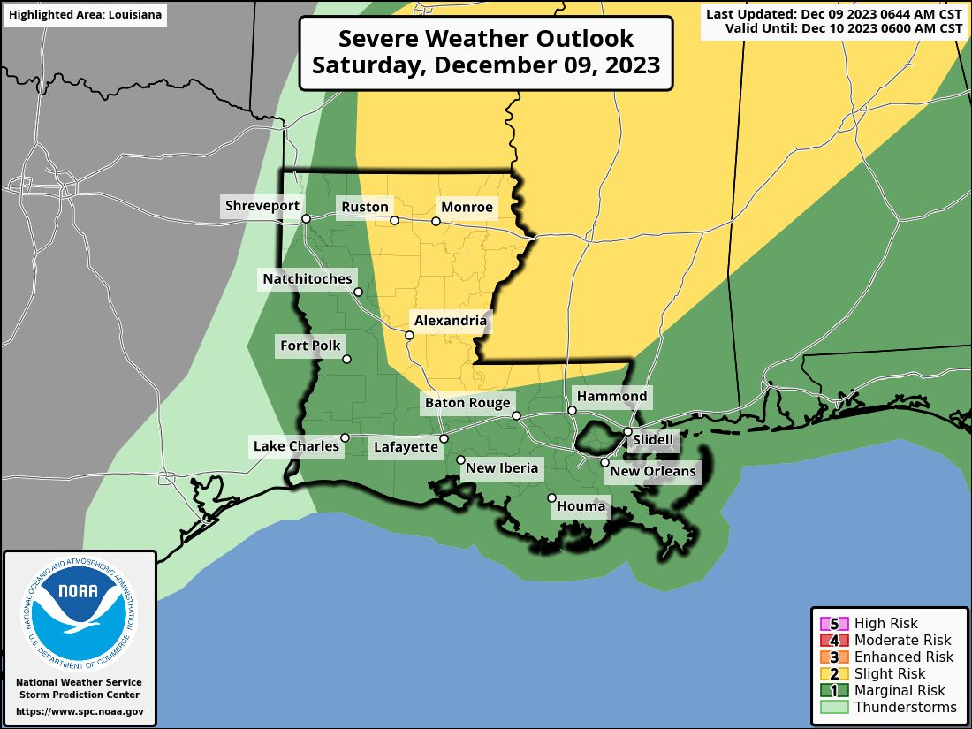
Figure 8 - Severe Weather Outlook from Storm Prediction Center

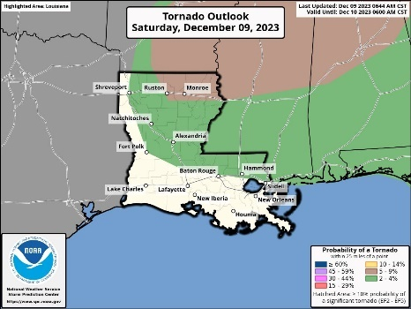  Figure 9 - Tornado Outlook | 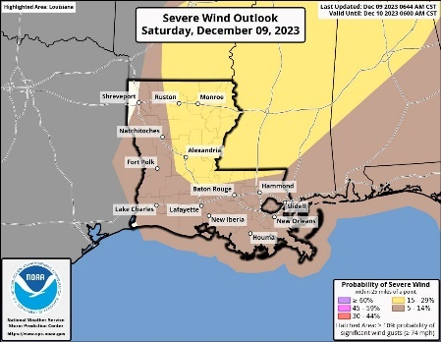  Figure 10 - Damaging Wind Outlook | 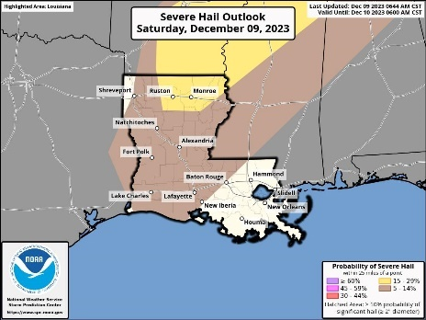  Figure 11 - Severe Hail Outlook

Storm initiation across Louisiana began around 21Z/3PM CST with sub-severe storms developing in a broken line from near Arcadia southwest into east Texas just west of the Toledo Bend Reservoir. Additional storms were in a broken line from near Lake Providence in northeast Louisiana to near Olla in LaSalle Parish. The storms were moving to the east-northeast within the broken lines. A tornado watch had been issued north of Louisiana across portions of eastern Arkansas and northern Mississippi and by 4PM CST was later extended to include the eastern tier of Louisiana parishes.

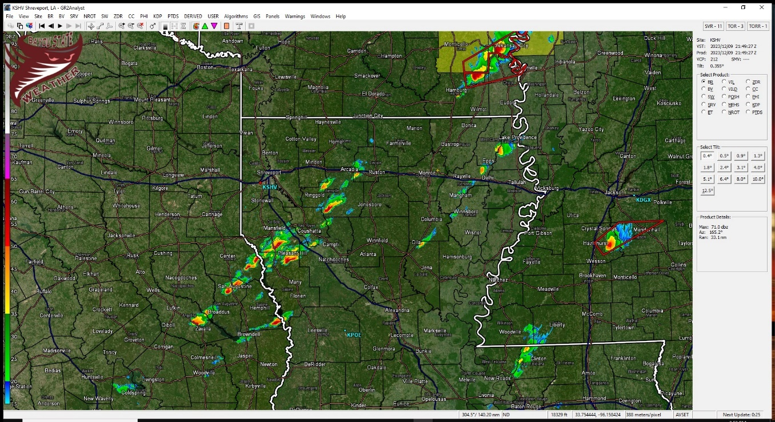
Figure 12 - KSHV Radar Image 2149Z

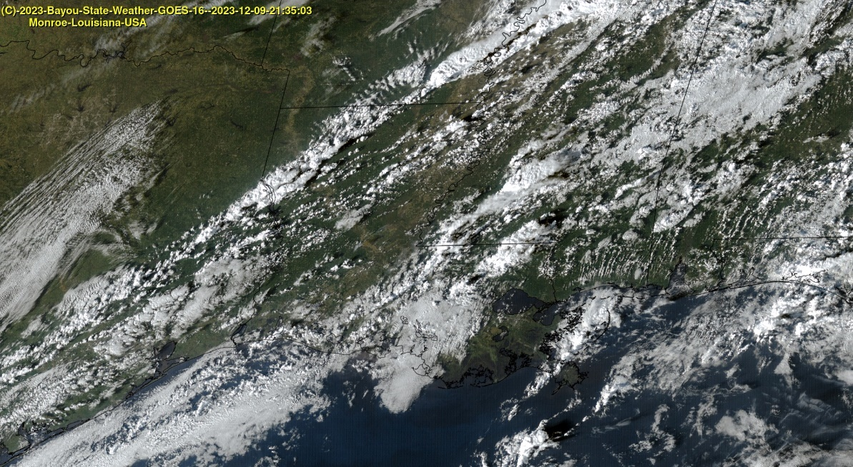
Figure 13 - GOES Satellite Imagery 2135Z

The 21Z/3PM surface map showed the front had begun to advance southeast and extended from extreme western Tennessee, across southeast Arkansas, and into extreme northwest Louisiana. Satellite imagery clearly showed the position of the front and the developing thunderstorms just ahead of it.

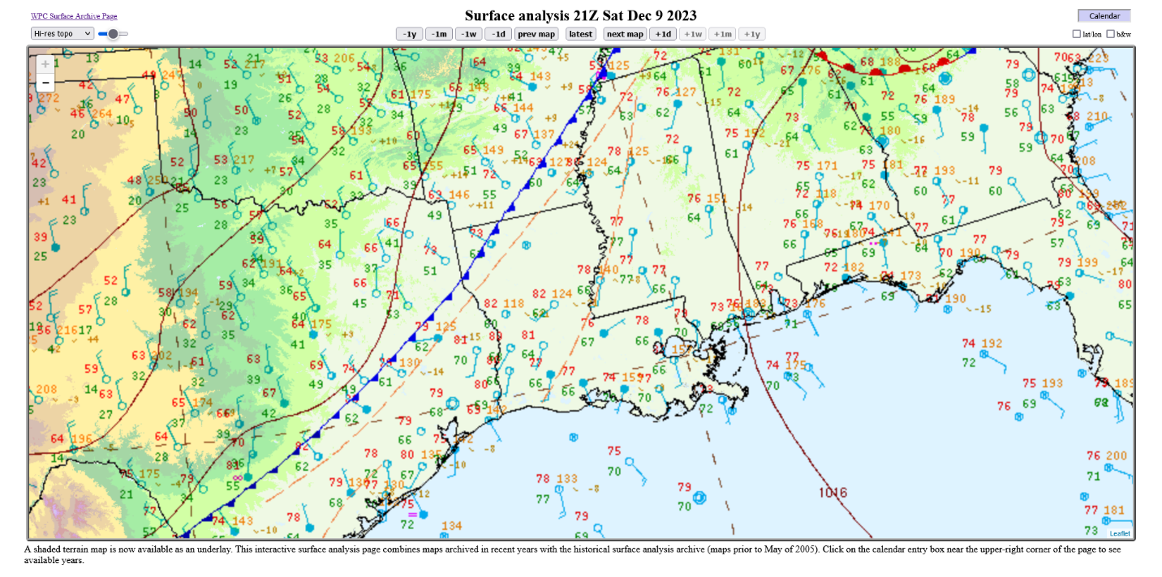
Figure 14 - Surface Map 21Z
The first severe thunderstorm warning was issued at 4:02 PM by the National Weather Service in Shreveport for southern DeSoto, southeastern Red River, northwestern Natchitoches, and northern Sabine for a storm capable of producing damaging winds and quarter to golf ball sized hail. This warning was later extended to include northern Natchitoches and western Winn as the storm progressed to the east-northeast. The storm produced large hail along its path. This storm waxed and waned across central portions of northeast Louisiana and produced three damaging wind reports in northern LaSalle, southern Caldwell, and Franklin Parishes.

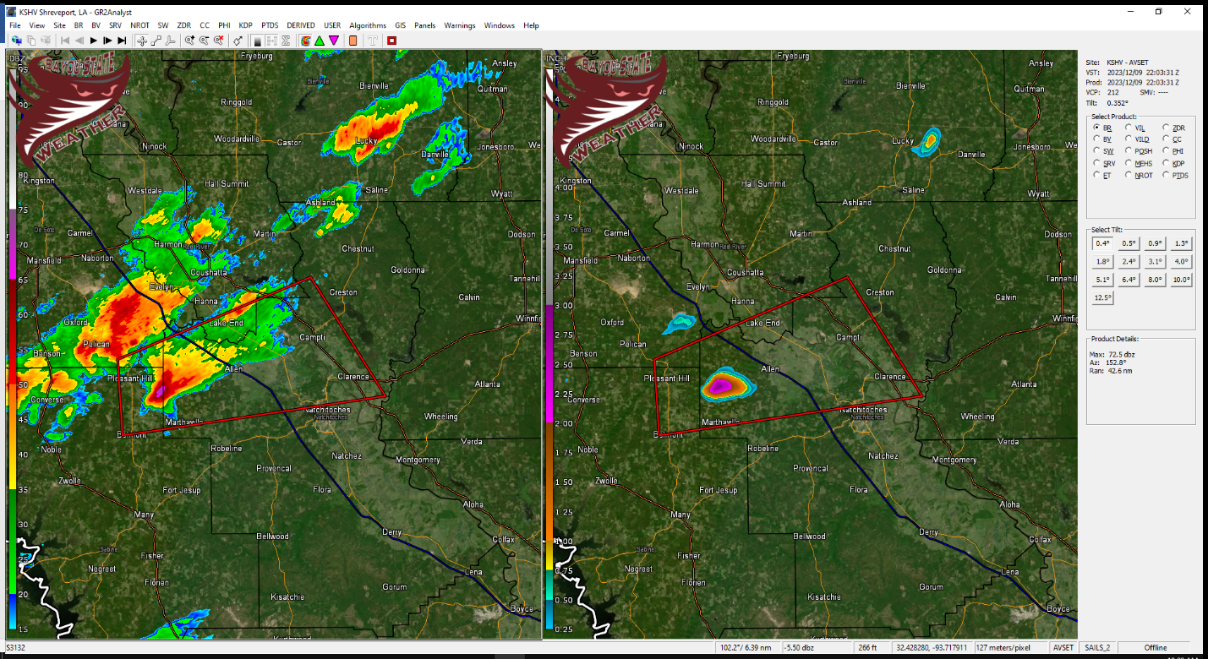
Figure 15 - KSHV Radar 2203Z with Estimated Hail Size
At 2230Z/4:30 PM CST, an intensifying thunderstorm was located over eastern Lincoln Parish between Downsville and Choudrant moving east to slightly east-northeast. The storm had a small hail signature on radar about three miles southwest of Downsville. The storm continued to intensify along with an increasing hail signature as it moved along the southern Union and northwestern Ouachita Parish line.

At 2257Z/4:57 PM CST, the storm began to push in the northern portion of Ouachita Parish along with an impressive hail core just over 5.5 miles southwest of Sterlington. Hail size was radar estimated to be between 1 and 1.5-inches. At 23:03Z, the central hail core was 2.6 miles west-southwest of Fairbanks, near the new Sterlington area along U.S. 165. It was here that large, confirmed hail of over 2-inches was reported in the Thatcher Point and Frenchman’s Bend subdivisions. Radar also indicated maximum hail size of 2.5 inches. Two-inch hail was also reported at the Black Bayou Wildlife Refuge.

The National Weather Service in Jackson issued a severe thunderstorm warning for central Morehouse at 5:07PM CST as the storm was about to cross into Morehouse Parish. Oddly, the National Weather Service in Shreveport did not issue a severe thunderstorm warning for extreme northern Ouachita and extreme southeastern Union Parishes until 5:10 PM CST.

The storm continued across southern Morehouse Parish producing large hail, but less than the very large hail sizes produced across northern Ouachita Parish. The storm weakened as it moved into southern West Carroll Parish.

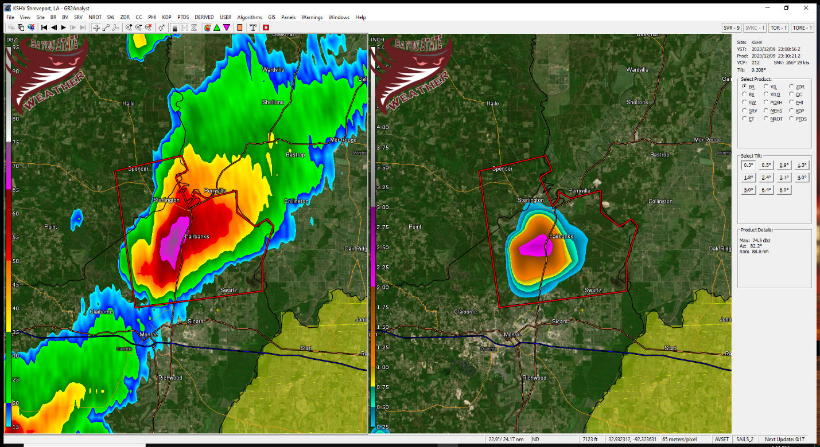
Figure 16 - KSHV Radar Showing Estimated Hail Size of 2.5" over Northern Ouachita Parish
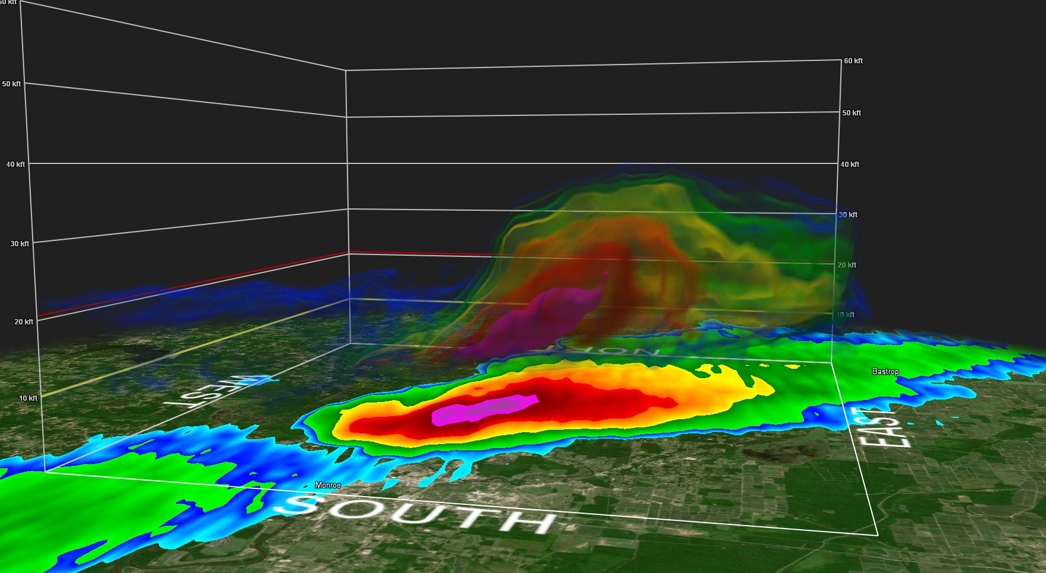
Figure 17 - 3D Volumetric Scan of Northern Ouachita Parish Storm Showing Hail Core
One additional storm moved out of central Jackson Parish crossing into southern Ouachita Parish. A severe thunderstorm warning was issued for this storm at 5:15 PM CST while the storm was 12 miles southwest of Bawcomville. This storm produced confirmed quarter-sized hail 11 miles SSW of Bawcomville and 7 miles SSW of Bawcomville. This storm weakened as it moved just south of Richwood.
Radar analysis showed three primary tracks of hail-producing storms along with a few other scattered locations. The first extended from just south of Pleasant Hill (Sabine Parish), Louisiana to near Campti, to Winnfield, to between Clarks and Olla, and to west of Wisner. The second track, that produced the largest hail, extended from just southwest of Downsville (Lincoln Parish) east along the Union/Ouachita line to near Sterlington to Oak Ridge to near Epps. The third primary track extended from just east of Chatham (Jackson Parish) across southern Ouachita, weakened as it moved into western Richland Parish, and then re-intensified south of Rayville before weakening once again south of Delhi.

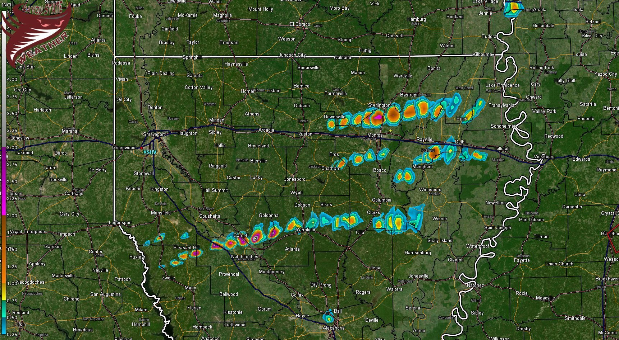
Figure 18 - Primary Hail Tracks from Radar Data

Summary

Conditions across north Louisiana during the late afternoon and early evening hours were conducive for severe storm formation, especially for large hail and damaging wind gusts. Tornadic conditions were marginal at best across Louisiana and no reports of tornadoes were found. Tornado likelihoods were, however, more prevalent across Mississippi, Alabama, and Tennessee where conditions were more favorable. A large-scale, positively tilted upper trough was digging across the central U.S. with a surface cold front stretching from the Great Lakes region south and southwest into Texas. These two features created a severe weather outbreak across western and central portions of Dixie Alley.

Given an unstable atmosphere, dry air aloft, and a low freezing level across north Louisiana, conditions were favorable for hail development. Three primary hail-producing storm tracks were noted across north Louisiana. The largest hail reported was across northern Ouachita Parish in the Sterlington/Fairbanks area where hail in excess of 2-inches fell and was confirmed. Damage to roofs likely occurred along with damage to vehicles. A few reports of wind damage were also received as the storms began to become more linear. These reports were found across mainly eastern portions of north Louisiana.
Supporting Images

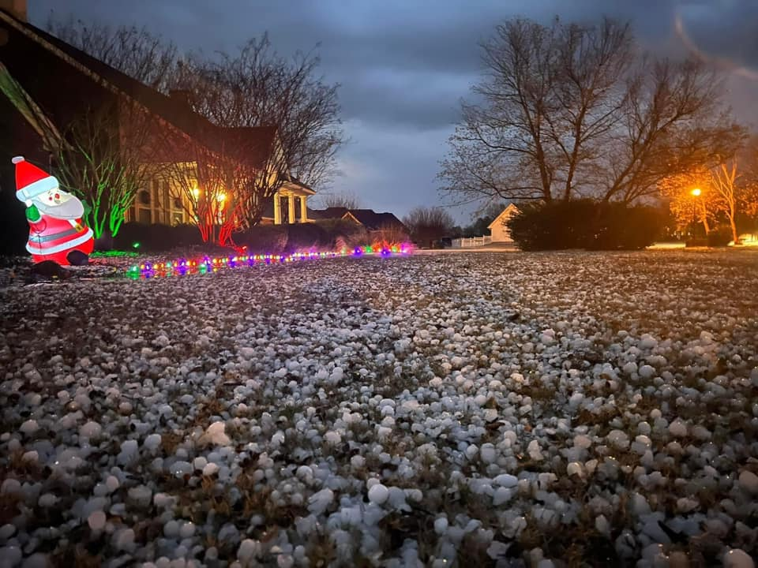
Figure 19 - Frenchman's Bend - Courtesy of Burt Green/Weather UP

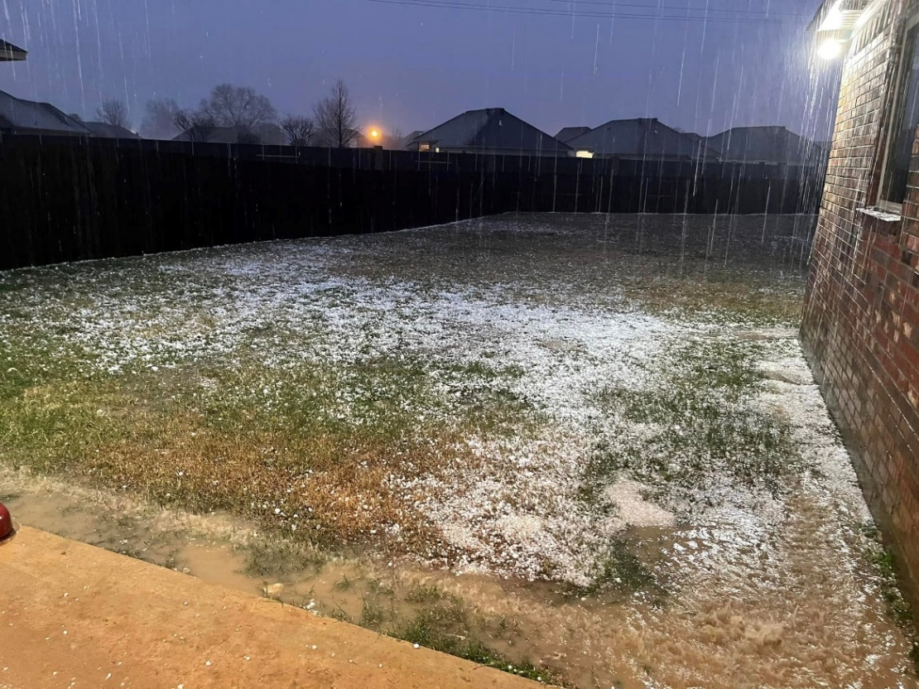
Figure 20 – Thatcher Point Subdivision, Sterlington, LA - Courtesy of Mike Hammett

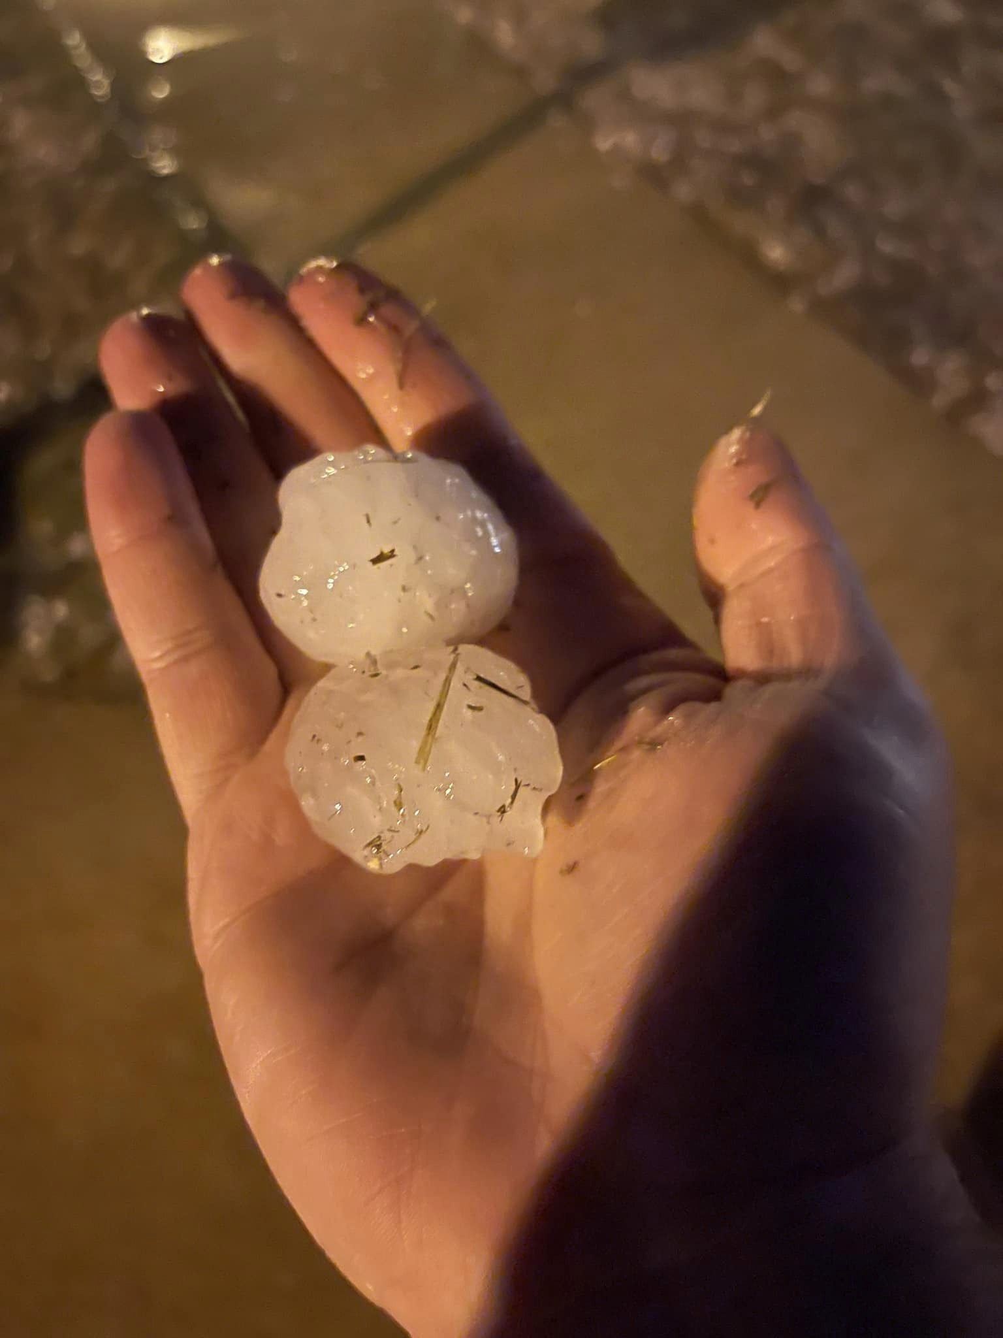
Figure 21 - Hailstones at Thatcher Point Subdivision, Sterlington, Louisiana - Courtesy of Mike Hammett
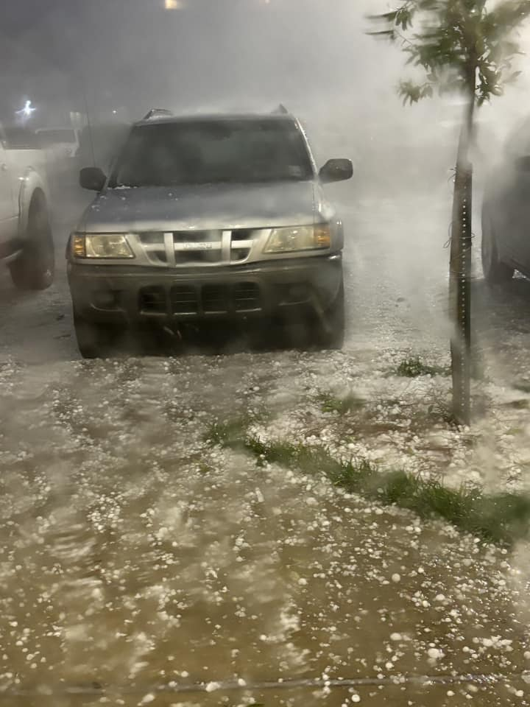
Figure 22 - Hail near Sterlington, Louisiana - Courtesy of Paula Hendricks

Severe Reports from the National Weather Service

Report | Date/Time (GMT) | Magnitude | Location | Parish
Half dollar to ping pong ball size hail reported near Marthaville. [SOURCE: Emergency Mngr; CWA: SHV ] | 2023/12/09 2208 | E1.50 | 6 NW Robeline | Natchitoches
Ping pong ball size hail reported along Interstate 49 at the Powhaten exit. [SOURCE: Emergency Mngr; CWA: SHV ] | 2023/12/09 2218 | E1.50 | 5 WSW Powhatan | Natchitoches
Report from mPING: Ping Pong Ball (1.50 in.). [SOURCE: Public; CWA: SHV ] | 2023/12/09 2234 | E1.50 | 5 W Powhatan | Natchitoches
A picture was posted to social media of golfball size hail that fell in Campti. [SOURCE: Public; CWA: SHV ] | 2023/12/09 2237 | E1.75 | Campti | Natchitoches
A picture of quarter to half dollar size hail was posted to social media that fell along Lenard Road near the Union/Ouachita Parish line several miles southeast of Downsville. [SOURCE: Public; CWA: SHV ] | 2023/12/09 2245 | E1.25 | 4 SE Downsville | Union
A picture was posted to social media of ping pong ball size hail that fell along Black Lake east of Campti. [SOURCE: Public; CWA: SHV ] | 2023/12/09 2248 | E1.50 | 7 NNE Clarence | Natchitoches
A picture was posted to social media of golf ball size hail that fell on Salt Pit Road between Black Lake and Saline Lake. [SOURCE: Public; CWA: SHV ] | 2023/12/09 2259 | E1.75 | 7 NE Clarence | Natchitoches
Quarter size hail reported along Highway 143 near Union Parish and Ouachita Parish line. [SOURCE: Emergency Mngr; CWA: SHV ] | 2023/12/09 2303 | E1.00 | 7 N Claiborne | Union
Ping pong ball size hail reported on Horseshoe Lake Road. [SOURCE: Broadcast Media; CWA: SHV ] | 2023/12/09 2310 | E1.50 | 4 SSW Sterlington | Ouachita
Hen egg size hail reported in Sterlington. [SOURCE: Broadcast Media; CWA: SHV ] | 2023/12/09 2310 | E2.00 | Sterlington | Ouachita
A picture was posted to social media of quarter size hail that fell in Calvin. [SOURCE: Public; CWA: SHV ] | 2023/12/09 2310 | E1.00 | Calvin | Winn
Hen egg to tennis ball size hail reported in the Thatcher Point subdivision south of Sterlington. [SOURCE: Broadcast Media; CWA: SHV ] | 2023/12/09 2312 | E2.50 | 3 S Sterlington | Ouachita
Hen egg size hail reported at Black Bayou National Wildlife Refuge north of Monroe. [SOURCE: Broadcast Media; CWA: SHV ] | 2023/12/09 2312 | E2.00 | 4 NW Swartz | Ouachita
Golf ball size hail reported on Barnes Road near Schwartz. [SOURCE: Broadcast Media; CWA: SHV ] | 2023/12/09 2314 | E1.75 | 2 NNW Swartz | Ouachita
Hen egg to tennis ball size hail in Frenchmans Bend subdivision south of Sterlington. [SOURCE: Broadcast Media; CWA: SHV ] | 2023/12/09 2314 | E2.50 | 4 S Sterlington | Ouachita
Report from mPING: Quarter (1.00 in.). [SOURCE: Public; CWA: SHV ] | 2023/12/09 2316 | E1.00 | 2 NW Winnfield | Winn
Quarter size hail reported near the Luna community. [SOURCE: Public; CWA: SHV ] | 2023/12/09 2320 | E1.00 | 11 SSW Brownsville-Bawc | Ouachita
Trees downed along Highway 84 just west of Winnfield. [SOURCE: 911 Call Center; CWA: SHV ] | 2023/12/09 2320 | UNK | 1 W Winnfield | Winn
A picture was posted to social media of quarter to half dollar size hail that fell in the Wham Brake community near Highway 139 north of Swartz. [SOURCE: Public; CWA: SHV ] | 2023/12/09 2325 | E1.25 | 3 NE Swartz | Ouachita
[SOURCE: Public; CWA: JAN ] | 2023/12/09 2326 | E1.75 | 5 SSW Collinston | Morehouse
A picture of quarter size hail was posted to social media that fell along Highway 557 just south of Ed Rutledge Road. [SOURCE: Public; CWA: SHV ] | 2023/12/09 2328 | E1.00 | 7 SSW Brownsville-Bawco | Ouachita
Local law enforcement reported golf-ball size hail near Richmond. [SOURCE: Law Enforcement; CWA: JAN ] | 2023/12/09 2349 | E1.75 | Richmond | Madison
Tree downed in the Kelly community. [SOURCE: 911 Call Center; CWA: SHV ] | 2023/12/09 2355 | UNK | 4 SSW Clarks | Caldwell
Trees downed along Highway 165 between Tullos and Urania. [SOURCE: 911 Call Center; CWA: SHV ] | 2023/12/10 0000 | UNK | 2 SSW Urania | La Salle
A few trees were blown down. [SOURCE: Public; CWA: JAN ] | 2023/12/10 0006 | UNK | 6 SE Rayville | Richland
Local law enforcement reported a fallen tree on Smalling Rd near Rayville in Richland Parish. [SOURCE: Law Enforcement; CWA: JAN ] | 2023/12/10 0007 | UNK | 3 WNW Holly Ridge | Richland
Tree downed along Hwy 425 just north of Gilbert. [SOURCE: Law Enforcement; CWA: JAN ] | 2023/12/10 0056 | UNK | 2 WNW Gilbert | Franklin
Corrects previous hail report from Richmond. Local law enforcement reported golf-ball size hail near Richmond. [SOURCE: Law Enforcement; CWA: JAN ] | 2023/12/10 0105 | E1.75 | Richmond | Madison
Roof damage to two homes on Frenchtown Rd. in Central... LA. Small portion of a metal roof was peeled back on one home. [SOURCE: Broadcast Media; CWA: LIX ] | 2023/12/10 0450 | UNK | 3 WNW Denham Springs | East Baton Rouge

Sources

Bayou State Weather, LLC/Don Wheeler – www.bayoustateweather.com

Mike Hammett – Monroe/Sterlington, Louisiana

Paula Hendricks – Sterlington, Louisiana

National Weather Service – Shreveport, Louisiana

Storm Prediction Center – Norman, Oklahoma

University of Wyoming

Weather Prediction Center/NOAA

Weather UP/Burt Green - https://www.facebook.com/BurtGreenWX

