December North Louisiana Severe Weather Outbreak
December 13, 2022

By: Don Wheeler, Meteorologist

Synopsis and Overview

A highly advertised severe weather outbreak materialized across portions of Louisiana during the afternoon and evening hours of December 13. All of the state that throughout the day was at least under a “Slight Risk” for severe storms, which eventually extended into the afternoon hours of December 14. A good part of north and central Louisiana was under the higher category of “Elevated Risk.” All of north, central, and northern areas of south Louisiana would see the chance for strong tornadoes of EF-2 or higher during the afternoon and overnight hours of the 13th. Unfortunately, tornadoes did break out resulting in injuries and fatalities.

Oddly, given the numerous tornado warnings and storm rotations indicated by radar, only three confirmed tornadoes touched down: 1) Keachi (Caddo Parish), 2) Farmerville (Union Parish), and 3) Rural Franklin/Madison Parishes. The event was even deemed significant enough to get national coverage when CNN and AccuWeather arrived in Farmerville, Louisiana.

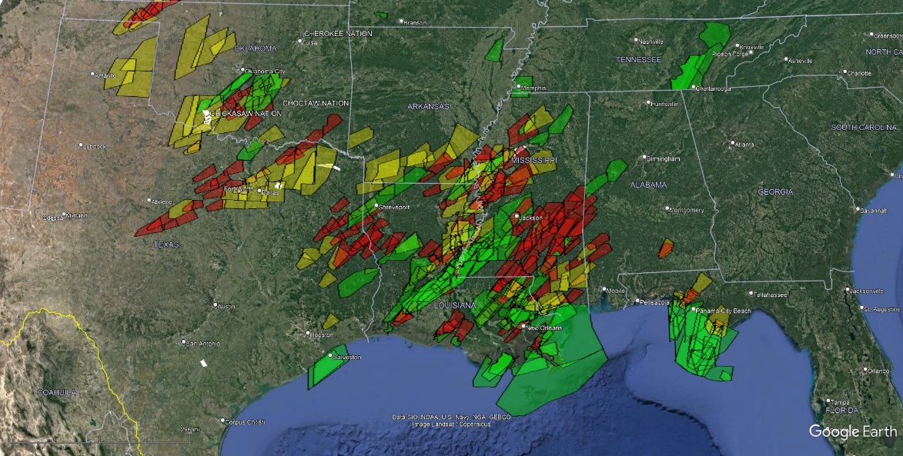
Figure 1 - Tornado Warnings, Severe Thunderstorm Warnings, and Flash Flood Warnings for December 13-14, 2022
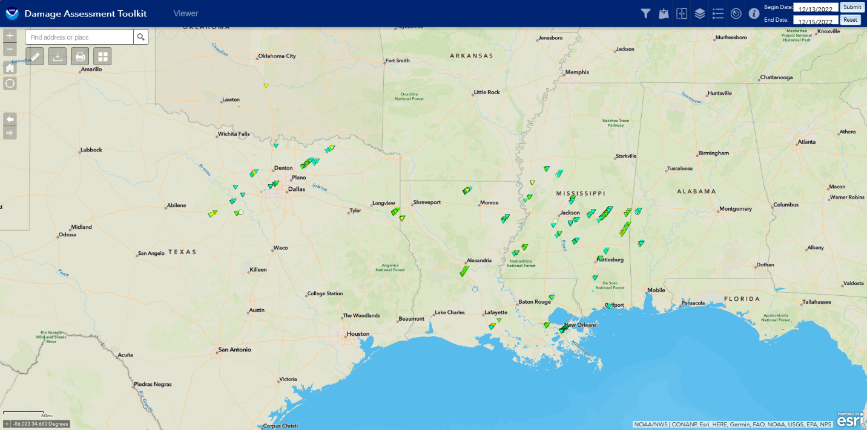
Figure 2 - Confirmed Tornado Map for December 13-14, 2022
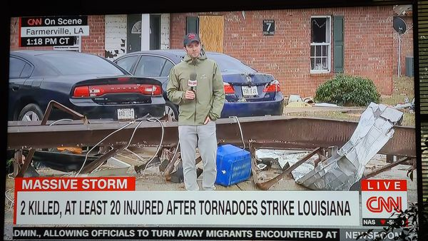
Figure 3 - CNN Coverage in Farmerville, Louisiana
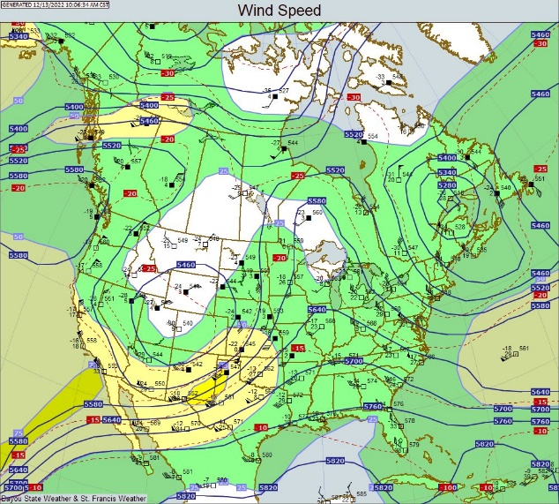
Analysis on the morning of December 13 showed a large upper-level low over northeastern Utah, northwestern Colorado, and southwestern Wyoming. This low was part of a large-scale trough that was digging deep into old Mexico. A strong jet was noted over much of northern old Mexico into west Texas.
Figure 4 - Upper-level Depiction 12Z 12/13/2022

At the surface, a developing area of low pressure was over northwestern Kansas with a trailing occluded front extending into central Kansas into northern Oklahoma where it became a cold front continuing south into north Texas and then southwest Texas. A warm front stretched across Louisiana from the New Orleans area northwest into northeast Texas.

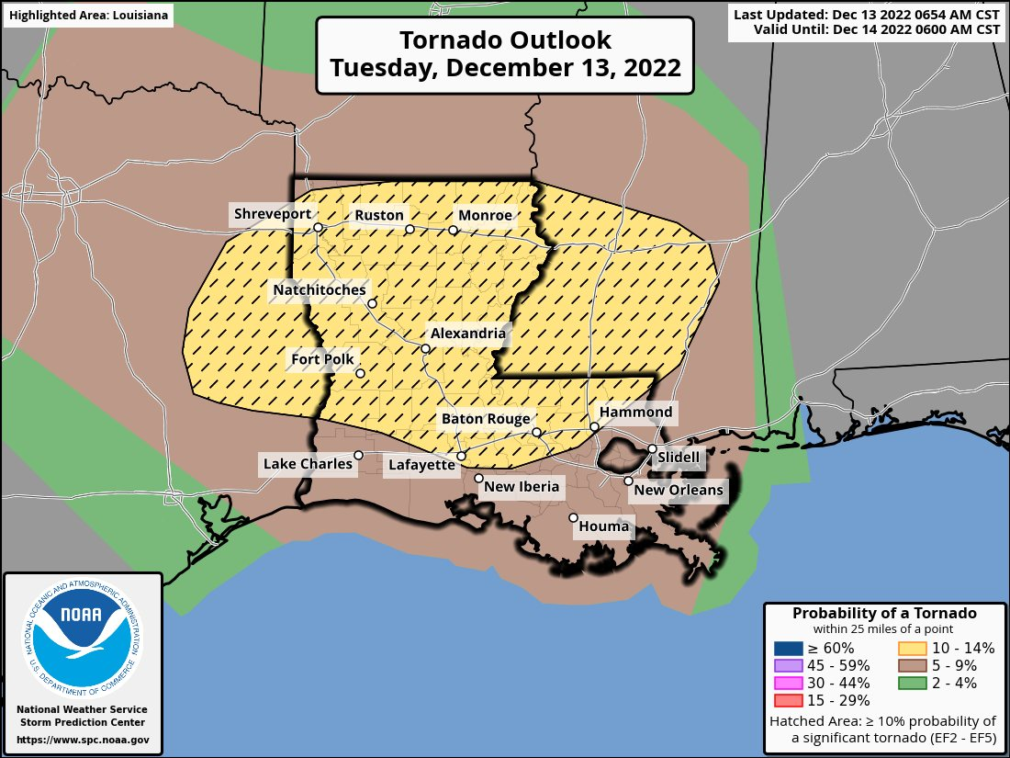
Warm, moist air was flowing into our state behind the advancing warm front. Forecast CAPE values were between 1000 and 1500 J/kg along with strong shear profiles. Strong upper-level winds were present along with a 35 to 50 knot low-level jet.

The Storm Prediction Center in their Tornado Outlook indicated that there was a 10-14% probability of tornadoes with a rating of EF-2 or higher. This prediction did come to fruition.
Figure 5 - Tornado Outlook for December 13 indicating the possibility of EF-2 or higher tornadoes in the hatched area.

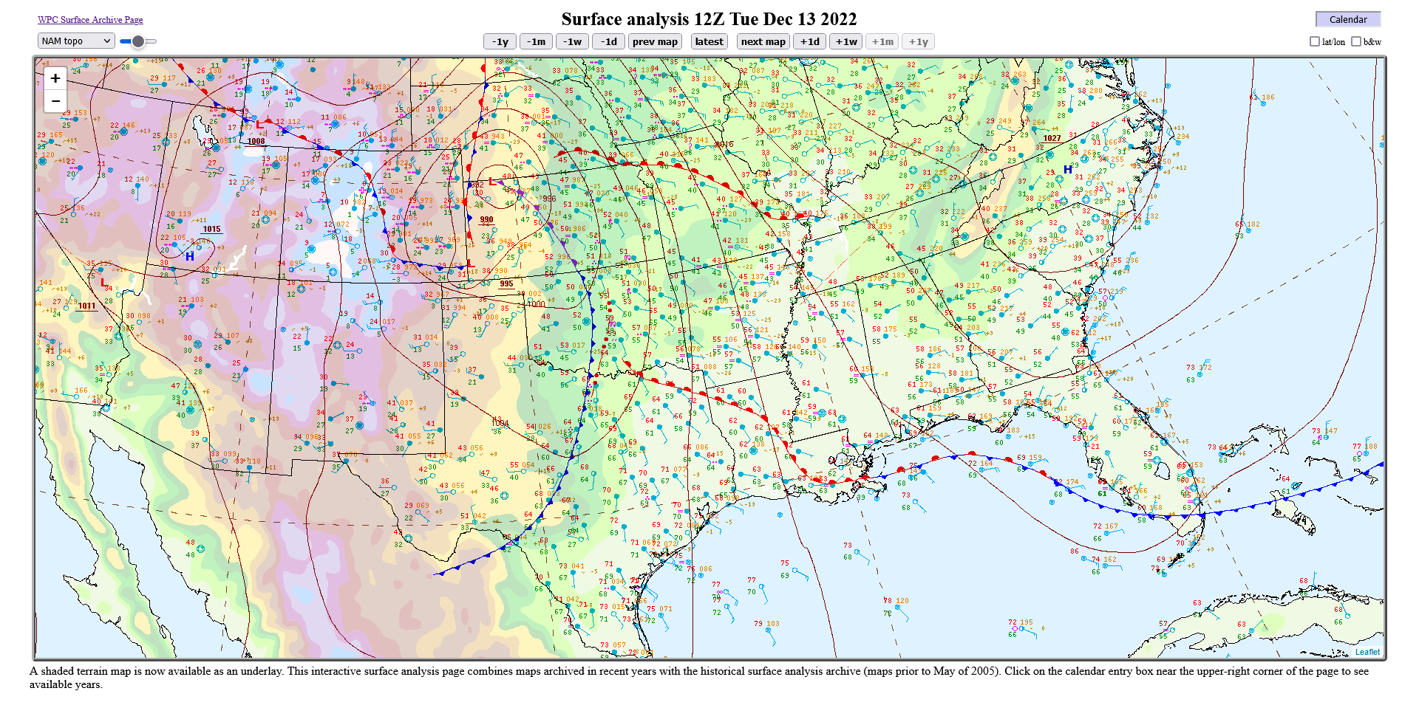
Figure 6 - Surface Map 12Z - 12/13/2022
A tornado watch was issued for portions of southeast Oklahoma, southwest Arkansas, and a good part of east Texas during the morning hours as thunderstorms were quick to develop in the unstable atmosphere. A few tornado warnings were issued north and northeast of the Dallas area. Around 2 PM, the Storm Prediction Center issued a mesoscale discussion for the issuance of a new tornado watch further east into south Arkansas and north Louisiana.

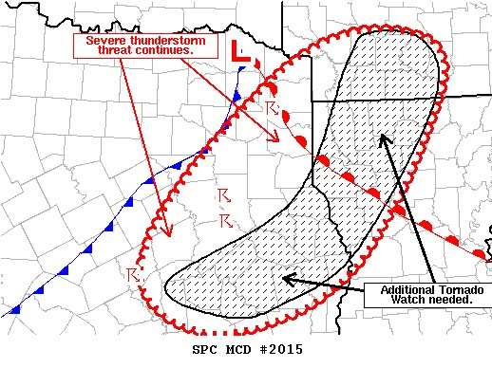
Figure 7 - Mesoscale Discussion Map from Storm Prediction Center
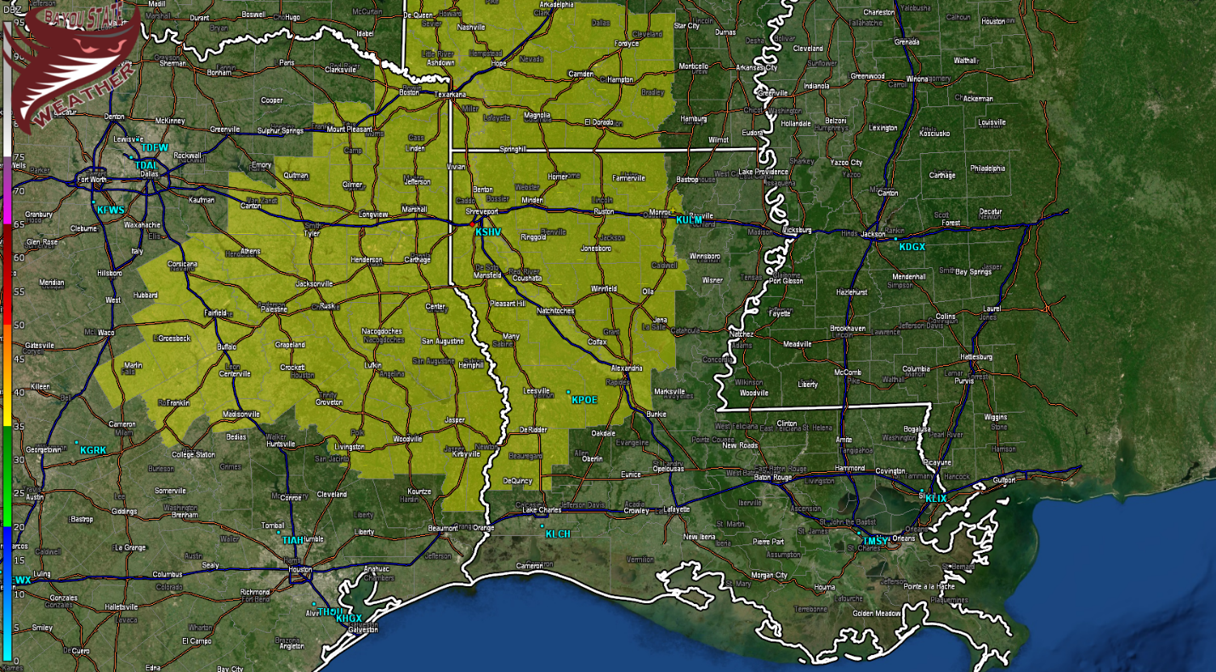
Figure 8 - New Tornado Watch Issued at 2:15 PM
The first tornado warning for the state with this system came at 2PM for a cell moving northeast out of east Texas. Radar was showing a circulation with a storm near Rosevine, Texas or 26 miles southeast of Center, Texas moving rapidly northeast at 40 mph. Louisiana parishes included in the warning were for west-central Sabine Parish. At 2:15, the new tornado watch was issued covering all of northwest Louisiana and western portions of northeast Louisiana.

Numerous thunderstorms, including discrete supercells, developed during the afternoon across northeast and deep east Texas with several tornado warnings issued as many indicated rotation. The first significant tornadic storm formed in extreme northeast Texas west of Shreveport and produced a large tornado near Elysian Fields or 17 miles southeast of Marshall. National Weather Service Radar not only showed strong rotation with this tornado, it also produced a debris signature indicating that large debris was being lofted high into the air. It was rated as an EF-2 with 115 mph maximum winds. The storm began to weaken as is moved into northwest Louisiana and eventually lost its debris signature.

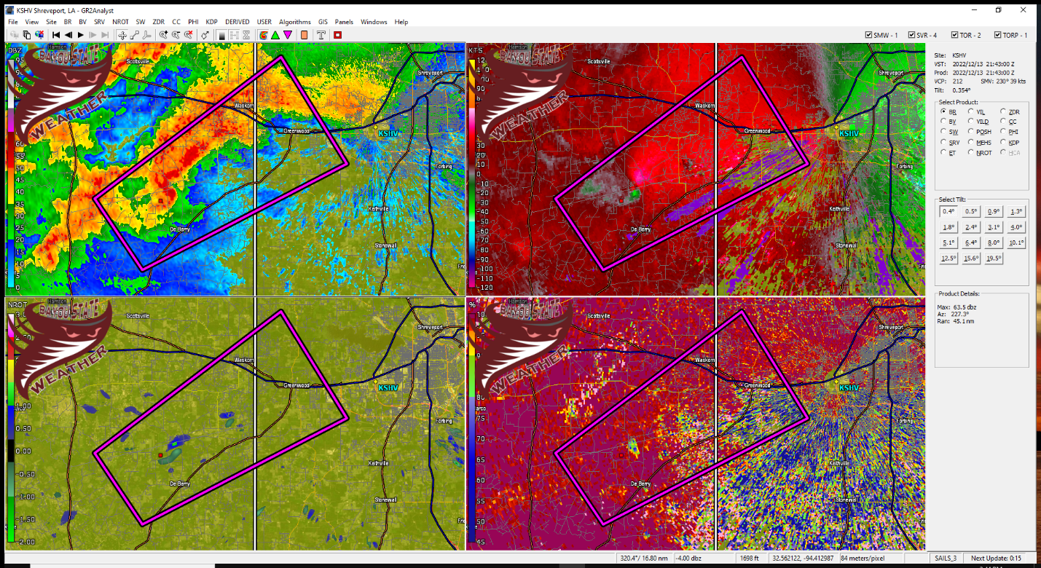
Figure 9 - Radar showing evidence of a tornado on the ground with debris signature (lower right frame) in east Texas
Keachi Tornado

At 4:10 PM another tornado warning was issued for northwestern DeSoto Parish, southwestern Caddo Parish, and southeastern Panola County (TX). Radar showed a possible tornado seven miles north of Tenaha, Texas moving northeast at 40 mph. This storm, unfortunately, did produce a tornado six miles northwest of Keachi that caused injuries and took the lives of two individuals. Later storm surveys rated this tornado as an EF-2 with estimated winds of 130 mph. Six singlewide mobile homes were completely destroyed along with a double-wide mobile home where the two fatalities, a mother and child, occurred.

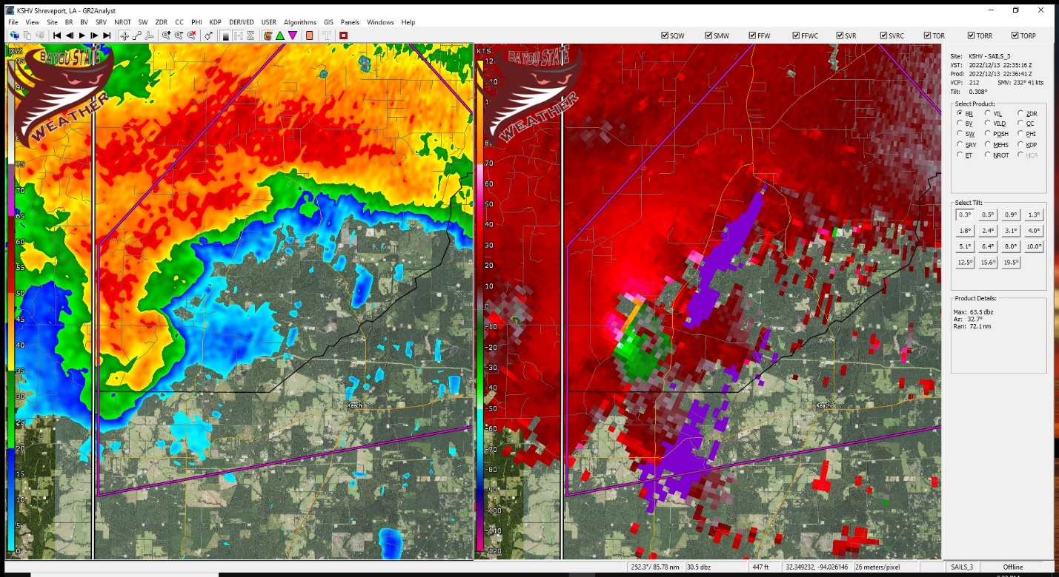
Figure 10 - Deadly tornado near Keachi, Louisiana in southern Caddo Parish
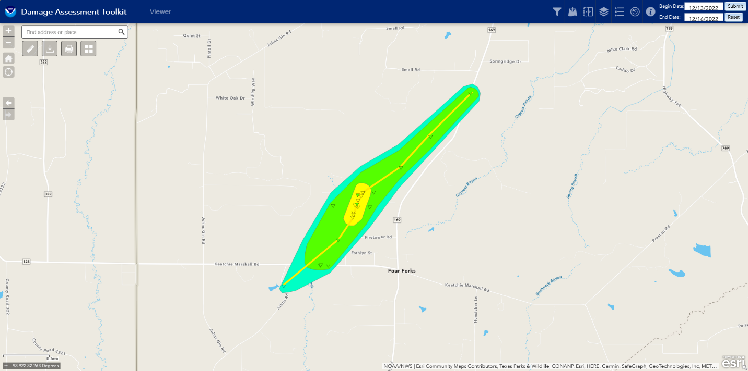
Figure 11 - Keachi Damage Path from NWS Storm Survey
Below is the storm survey summary from the National Weather Service in Shreveport.

.Tornado # 2...Southwest Caddo Parish, LA

Rating: EF-2
Estimated Peak Wind: 130 mph
Path Length /statute/: 3.5349 miles
Path Width /maximum/: 700.0 yards
Fatalities: 2
Injuries: 2

Start Date: 12/13/2022
Start Time: 04:36 PM CST
Start Location: 6 WNW Keachi / Caddo Parish / LA
Start Lat/Lon: 32.221 / -94.0102

End Date: 12/13/2022
End Time: 04:41 PM CST
End Location: 6 NNW Keachi / Caddo Parish / LA
End Lat/Lon: 32.2569 / -93.969

Summary: A strong thunderstorm began moving into far southwest
Caddo Parish during the afternoon hours just to the northwest of
Keachi. A tornado quickly developed shortly after crossing into
Caddo Parish, first producing minor damage with winds of 80 mph on
Johns Road just to the south of Keatchie Marshall Road. As the
tornado crossed Keatchie Marshall Road it quickly began to
strengthen, producing damage to a number of hardwood and softwood
trees. The tornado continued its northeast track through Rita and
Laurie Ann St, causing more damage to trees and minor damage to
homes along this path. The tornado then approached a number of
manufactured homes as it moved near and across Pecan Road,
producing EF-2 damage with winds estimated at 130 mph. The first
home struck by the tornado was a single wide mobile home, causing
complete destruction of the unit. The tornado caused similar
damage to 3 more single wide homes on Pecan Road as it moved
towards Lareta Street. Two additional single wide mobile homes
were then completely destroyed on both sides of Pecan Road just
south of Lareta St.

As the tornado crossed Lareta Street it lifted a double wide
manufactured home and tossed it to the north and east with two
people inside that did not survive. One was a 30-year-old female
who was thrown an estimated 200 yards where she was found on Paula
Road. The other occupant was an 8-year-old boy who was thrown by
the tornado an estimated 500-600 yards to the north. In addition
to the two fatalities, two other individuals were injured on Pecan
Road as the tornado moved through. Once the tornado reached Paula
Road, it continued to move to the northeast, producing additional
tree damage to the west of Four Forks Road before crossing
Highway 169 just south of Small Road where the tornado then
lifted.

A special thanks to the Caddo Parish Office of Homeland Security
and Emergency Preparedness and the Caddo Parish Sheriff`s Office
for assistance locating damage and aerial data provided during the
survey.

By 6 PM, storms across north Louisiana were becoming less intense; however, a squall line was developing across southwest Arkansas, extreme northwest Louisiana to near Shreveport, and into deep east Texas to near Nacodoches. At first, the line appeared to be somewhat benign but began to take on Quasi-Linear (QLCS) features as it surged east and southeast. The line itself was slow to move east; however, individual cells within the line were moving quickly to the northeast. This storm motion also produced some heavy rainfall amounts.

Farmerville Tornado

Around 7:30 PM a segment of the squall line began to intensify stretching out of south Arkansas from near Hampton to Calion to east of El Dorado. The line extended into Louisiana near Junction City to east of Homer to near Gibsland. At 7:36 PM, a circulation was detected just across the Arkansas/Louisiana border in south Arkansas about 10 miles east-northeast of Junction City.

At 8 PM another bowing segment was getting organized across southwestern Union and northern Lincoln Parishes. A weak circulation became present on radar just south of Dubach with the 02:03 Z (8:03 PM) scan. As the circulation crossed into southwestern Union Parish, about 8.4 miles west-southwest of Farmerville, it became better organized and showed signs of intensification. Rapid intensification was noted between the 02:17Z and 02:20Z scans three miles west of Farmerville. A tornado warning was issued at 8:22 PM. The circulation moved east-northeast at 40 mph and went just to the north of Farmerville proper crossing Highway 15 2.4 miles north of Farmerville.

A debris signature became visible at 8:24 PM (02:24Z) two miles northwest of Farmerville just before it crossed Highway 15. Post-storm survey teams from the National Weather Service in Shreveport showed the tornado began just to the east of D’Arbonne State Park near Duty Road and moved northeast crossing Highway 2. The storm attained its strongest levels as it approached and crossed Highway 15 north of Farmerville where it attained an EF3 rating with 140 mph maximum winds as it tore through an apartment complex. According to the National Weather Service, there were a total of 14 injuries, two of which were deemed critical.

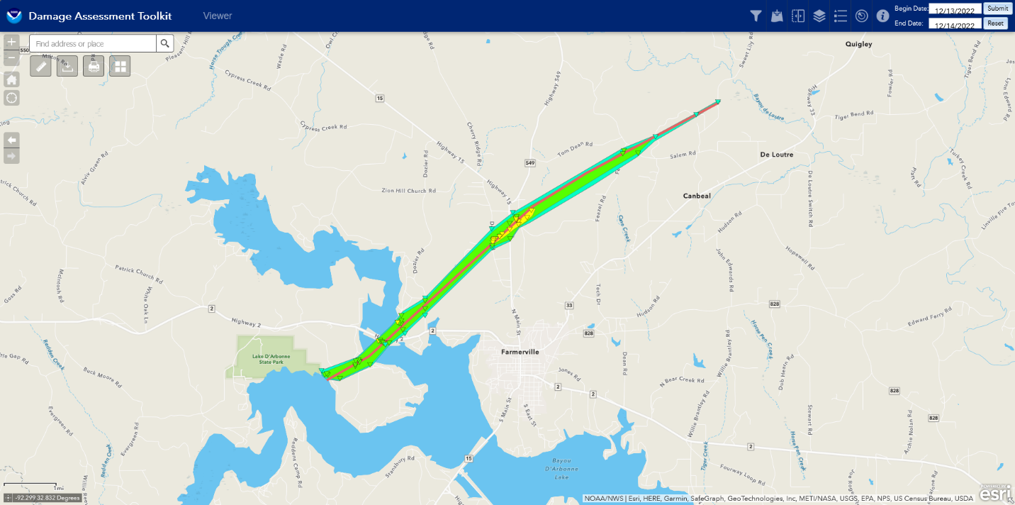
Figure 12 - Damage Path of the Farmerville Tornado from NWS Survey Team
Below is the summary from the National Weather Service.

.Tornado #3...Union Parish, LA

Rating: EF3
Estimated Peak Wind: 140 mph
Path Length /statute/: 9.13 miles
Path Width /maximum/: 500 yards
Fatalities: 0
Injuries: 14

Start Date: 12/13/2022
Start Time: 08:23 PM CST
Start Location: 4 W Farmerville / Union Parish / LA
Start Lat/Lon: 32.772 / -92.4683

End Date: 12/13/2022
End Time: 08:34 PM CST
End Location: 6 NNE Farmerville / Union Parish / LA
End Lat/Lon: 32.8477 / -92.3409

Survey Summary:
This tornado began in the Bayou D`Arbonne Lake area, touching
down initially along Spring Lake Road. Tracking northeast, in
this area the tornado uprooted and snapped many hardwood and
softwood trees and trees falling on homes produced areas of
structural damage. The tornado then briefly moved over the lake
before crossing Highway 2 where several residences were heavily
damaged and a at least a few shops and outbuildings destroyed.
The most heavily-damaged structure, warranting a 130 mph peak
wind speed estimate, was a two-story residence which had its
roof and much of the second story removed or destroyed. Here
there were also two non-critical injuries. The tornado then
tracked over a small portion of the lake again before coming
ashore and moving across Corney Creek drive and Dozier Road.
In this area there were several residences damaged by falling
trees, although one cabin was largely destroyed due to what
seemed to be a combination of falling trees and wind forcing.

The tornado then tracked over a nearly 2-mile span where the
survey team had no access, although a tornado debris signature
on radar gives confidence the circulation remained on the
ground. The tornado had grown to a width of approximately 500
yards by the time it next crossed Denton Road where a multitude
of EF-2 damage indicators were found and 4 residences heavily
damage or destroyed. One double wide mobile home here was
thrown and completely destroyed and 5 injuries were reported
at this location. There was also a single wide mobile home
thrown and destroyed, although no injuries were known to the
survey team at this location. Two one or two family residences
in this location also suffered damage to roofs and some walls.
Additionally, at this location there was extreme tree damage
with at least a few trees exhibiting some debarking.
Significant tree damage continued to the northeast as the
tornado crossed Highway 15 and moved across Camp Road.

The most significant damage associated with this tornado
occurred in the Camp Road area as the 400 to 500 yard wide
tornado struck an apartment complex and an adjacent mobile
home park. In this mobile home park area, 7 of the 9 single
wide mobile homes were thrown and completely destroyed. It is
estimated that the strongest core of the tornadic winds only
clipped the south end of the apartment complex, but one
building in this area had a large portion of its roof and
some exterior walls removed. This damage warranted the
peak 140 mph EF-3 rating of the tornado with widespread
mid to strong EF-2 damage occurring throughout this area.
The survey team received a confirmation of 14 total injuries,
two critical, associated with the entire tornado, although
the details of which injuries occurred in association
with which structures in the Camp Road area are not
currently known to the survey team.

From here the tornado went across another nearly 2 mile gap
through the woods and inaccessible to the survey team,
although the team did confirm heavy EF-2 level tree damage did
continue well into the woods east of Camp Road. The tornado
had obviously weakened a good deal when it crossed the Feazel
Road after traversing the wooded area. Here there was only EF-1
level structural and tree damage. The tornado ultimately
tracked another mile or so, doing only EF-0 damage before
lifting altogether in the vicinity of Sweet Lily Road.

A special thanks to the Union Parish Office of Homeland Security
and Emergency Preparedness and the Union Parish Sheriff`s Office
for assistance locating damage.

EF Scale: The Enhanced Fujita Scale classifies tornadoes into the
following categories:

EF0...Weak......65 to 85 mph
EF1...Weak......86 to 110 mph
EF-2...Strong....111 to 135 mph
EF3...Strong....136 to 165 mph
EF4...Violent...166 to 200 mph
EF5...Violent...>200 mph

Line Wave Echo Pattern and Tornadoes

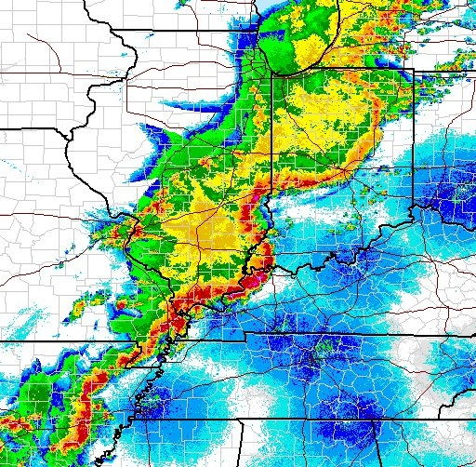
A Quasi-Linear Convective System (QLCS) is a type of mesoscale convective system that typically exist as a line of storms moving together. They are more commonly known as a squall line (Chance, 2001). These are quite frequent across Louisiana and the Deep South and can occur at any time of the year. Of more concern is a sub-feature that can develop with a QLCS known as a Line Wave Echo Pattern (LWEP). This feature is when segments of a QLCS/squall line take on a characteristic of having multiple bowing features down a portion or the length of the squall line. Each of the bow features on radar is known as a “bow echo.” These bow features are the result of air surging forward from behind the line due to a rear inflow jet. Sometimes the top of the surging bow develops a cyclonic rotation and a tornado. This was the case with the Farmerville tornado.
Figure 13 - A QLCS Showing a Line Wave Echo Pattern

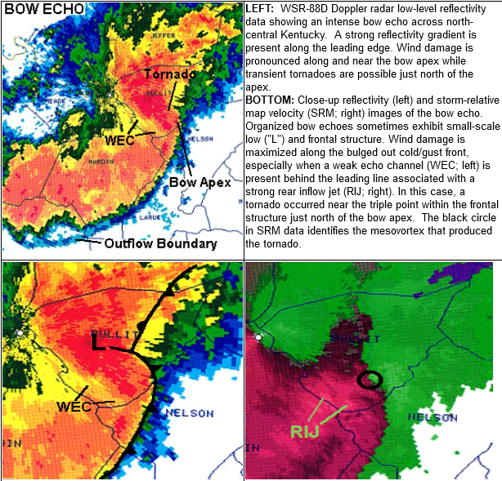
Figure 14 - Illustration of a Bow Echo and its Components – NWS-Louisville, Kentucky
Residents in the affected area expressed some concerns with the lead time of the warning and the arrival of the actual tornado. One must realize there are several ways a tornado can form. Each has its own signature on radar and each has general times from the initialization of rotation to actual tornado formation. Typical supercell tornadoes that are spawned from an independent thunderstorm can give on average 13 minutes (NOAA). However, other types of storms or storm systems that produce tornadoes often give much less of a lead time. LWEP and tropical systems often produce tornadoes with little to no lead time.

A radar analysis of the Farmerville tornado showed that a rather short lead time was indeed the case.

- 0203Z or 8:03 PM, radar indicated little to no indication of a possible tornado. Perhaps a slight rotation south of Dubach in northern Lincoln Parish. The line had not yet begun to bow
- 0212Z or 8:12 PM, a bow feature was beginning to form southwest of Farmerville near the Union/Lincoln Parish line. Some slight rotation was noted seven miles west-southwest of Farmerville
- 0217Z or 8:17 PM, rotation significantly strengthened 4.5 miles west-southwest of Farmerville
- 0222Z or 8:22 PM, Tornado Warning issued by the National Weather Service. Rotation 3 miles west of Farmerville near Highway 2
- 0223Z or 8:23 PM, WEA Alerts toned on phones

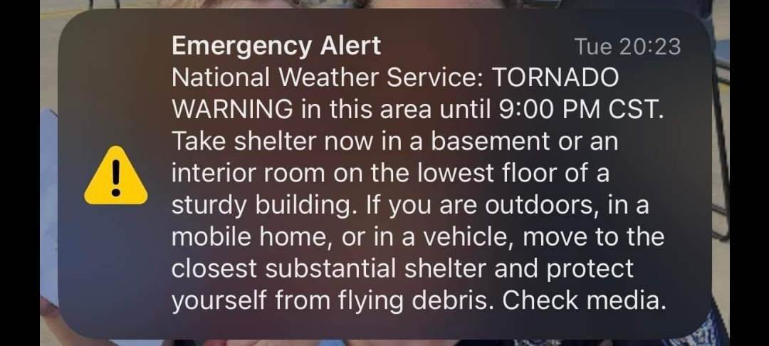
Figure 15 - Actual WEA Alert Message for the Farmerville Tornado – Courtesy of Burt Green/Weather UP
Given how quickly the circulation spun up, it is likely the tornado had just touched down near or just south of Highway 2 near the northern end of Lake D’Arbonne or touched down only a minute or two after the warning.

An interview with a witness on Denton Road, whose single-wide trailer was moved on its blocks, said the tornado was striking her home only 30 seconds to 1-minute after receiving the WEA alert. Given the speed of the tornado at 40 miles per hour or 0.67 miles per minute, it would have taken only 2- to 2.5 minutes for the tornado to get from its origin to the Denton Road location, supporting the short lead time. Other given factors would be: 1) the time the forecaster decided to issue the warning, 2) entering the information into the computer system, and 3) lag time in radar image processing. While WEA alerts are quite rapid in relaying severe weather alerts, in this case a minute or less, the minute lag time was more significant than usual. In addition, those that chose to stay in their mobile homes until the warning was issued, had no time to abandon and seek a sturdier shelter. Typically, NOAA Weather Radio tones/alerts at or very close to the time of the issuance of a warning. However, none interviewed had a NOAA Weather Radio that was operational. Even so, the difference is usually less than one minute between a NOAA Weather Radio alert and a WEA alert.

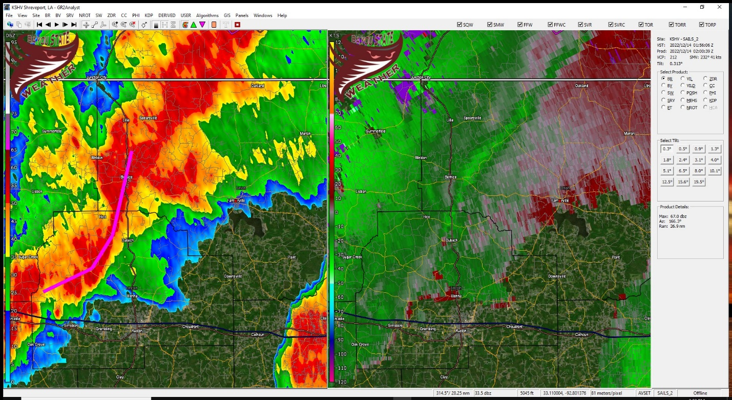
Figure 16 - Line at 0200Z showing little bowing
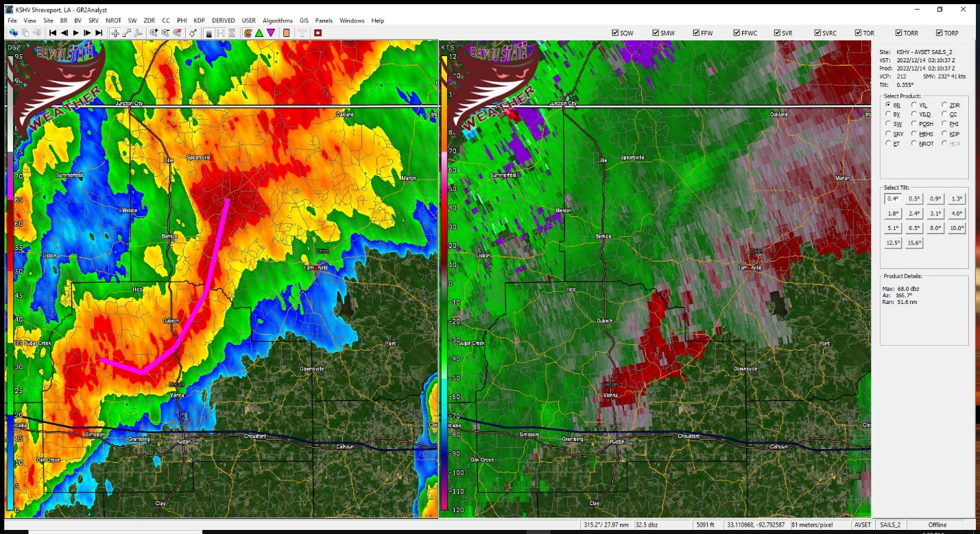
Figure 17 - Line at 0210Z showing bow feature rapidly forming
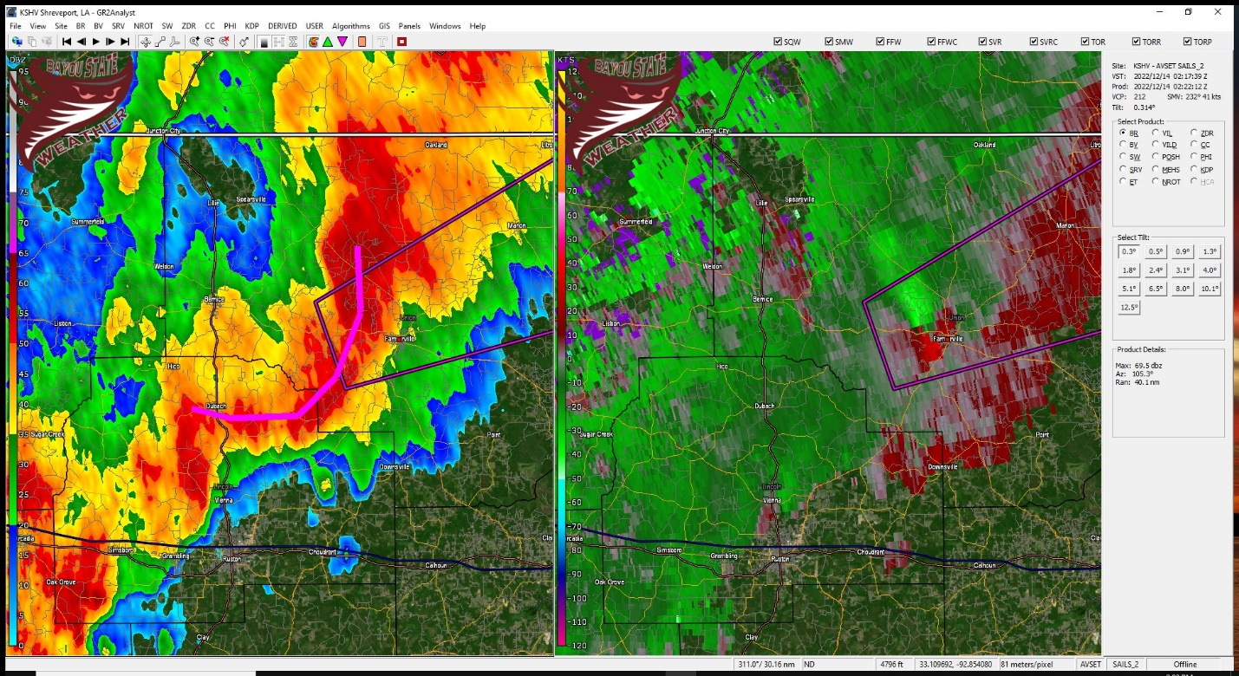
Figure 18 - Pronounced bow feature at 0222Z with Tornado Warning just issued
Tensas/Madison Tornado

By 9:25 PM scattered strong thunderstorms over northeast Louisiana that had been forming ahead of the initial squall line over northeast Louisiana began to show signs of better organization. This newly formed line stretched from western Mississippi near Greenville southwest to near Oak Grove to between Rayville and Delhi. Further south the line became broken with a strong storm 18 miles southwest of Winnsboro. This storm began showing signs of weak circulation as it moved northeast at 35 mph.

At 9:28 PM a severe thunderstorm warning was issued for this storm for northwestern Catahoula and southwestern Franklin Parishes. The heart of the storm moved between Winnsboro and Gilbert where radar continued to show an intensifying circulation. At 9:56 PM a tornado warning was issued for this storm for northwestern Tensas, southwestern Madison, and eastern Franklin Parishes. A possible tornado was indicated 8 miles south of Winnsboro moving northeast at 40 mph.

The National Weather Service in Jackson issued a special weather statement at 10:13 PM indicating that spotters reported a funnel cloud south of Winnsboro. The storm continued to intensify as it moved rapidly to the northeast at 40 mph. At 10:28 PM, radar began to show a debris signature with a tornado 15 miles northeast of Winnsboro or 4 miles southeast of Crowville. Survey teams later found the track began in extreme northeastern Franklin Parish near the Franklin, Tensas, and Madison Parish lines. The tornado, an EF1, mainly tracked across rural areas downing trees and powerlines but did damage a few homes and a vehicle.
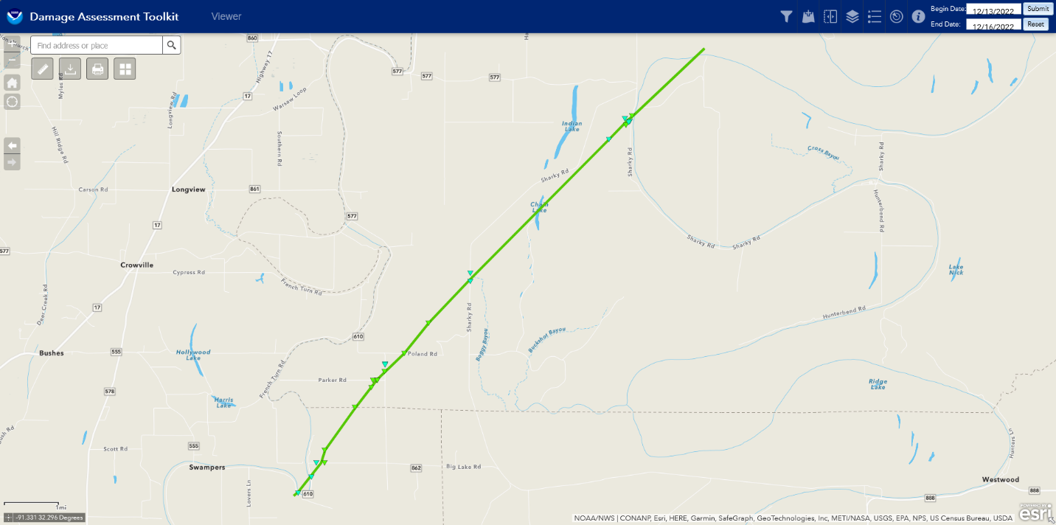
Figure 19 - Track of the Tensas/Madison Parish Tornado from the NWS Survey Team
.Franklin-Madison Parish Tornado...

Rating: EF1
Estimated Peak Wind: 105 mph
Path Length /statute/: 11.12 miles
Path Width /maximum/: 300 yards
Fatalities: 0
Injuries: 0

Start Date: 12/13/2022
Start Time: 10:19 PM CST
Start Location: 10 E Winnsboro / Franklin Parish / LA
Start Lat/Lon: 32.1807 / -91.5396

End Date: 12/13/2022
End Time: 10:35 PM CST
End Location: 11 SSE Delhi / Madison Parish / LA
End Lat/Lon: 32.2988 / -91.4113

Survey Summary:
This tornado began along LA Highway 610 in eastern Franklin
Parish, snapping sporadic trees and downing a utility pole. It
reached its peak intensity as it crossed into southwestern
Madison Parish, snapping several more trees. On Parker Rd, a home
was shifted on its block foundation, with portions of the roof
removed and most windows shattered. A car was crushed by a large
tree at this location as well. The tornado crossed LA 610 again
then Poland Rd before overturning an irrigation pivot. It then
moved into the Big Lake Wildlife Management Area, downing more
trees as it crossed Mill Road. As it approached the Tensas River,
it damaged multiple camp buildings off Sharkey Rd. A few roofs
were peeled back, and some carports were blown away along with
continued snapped and uprooted trees. The tornado crossed the
Tensas River and ended shortly thereafter.

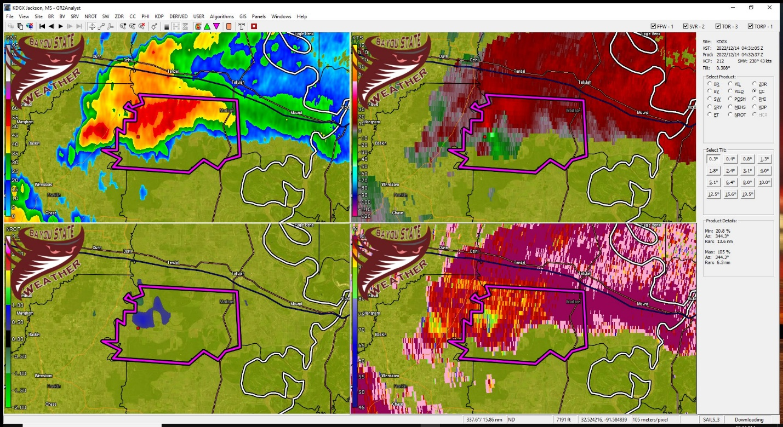
Figure 20 - Radar imagery showing a debris signature with the Franklin/Madison Tornado
Summary

A powerful upper-level storm system and associated surface low and cold front generated numerous showers and thunderstorms on December 13 across southeast Oklahoma, east Texas, south Arkansas, and northern Louisiana. Numerous tornado and severe thunderstorm warnings were issued throughout the day and evening hours; however, only a few storms actually produced confirmed tornadoes, with three confirmed in north Louisiana. Unfortunately, the tornado in southern Caddo Parish resulted in two fatalities and several injuries. The tornado that struck Farmerville produced considerable damage to homes, including several mobile homes and apartments. Fourteen people were injured with this storm. This tornado was spawned within a bowing line segment of a squall line. It spun up quickly, dramatically lowering the warning lead-time for residents. The third tornado occurred over mainly rural areas of northeastern Franklin and southwestern Madison Parishes but did cause some damage to a home and automobile there.

The following day, the same system brought another round of severe weather to southeast Louisiana. A similar pattern was observed with numerous tornado warnings issued due to rotation on radar but with only seven confirmed touchdowns. This included an EF-2 that produced a 10.74-mile-long track just south of the New Orleans metro area that moved through Marrero, Gretna, and Arabi on the West Bank.

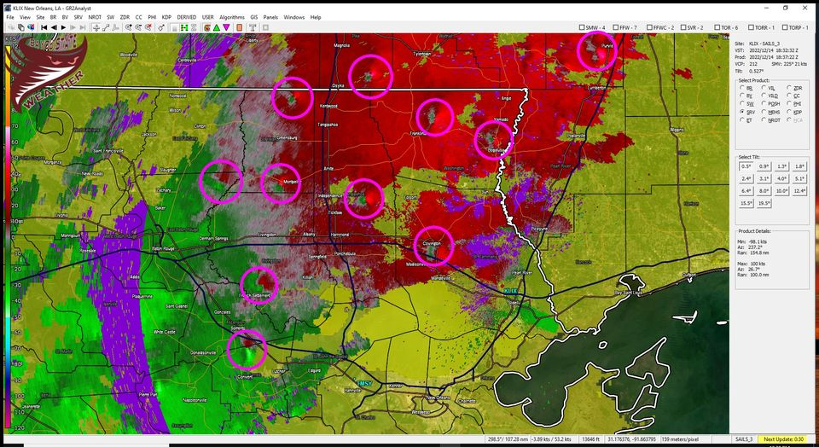
Figure 21 - Velocity from New Orleans radar showing 11 rotating storms on 12/14/2022 at 1837Z
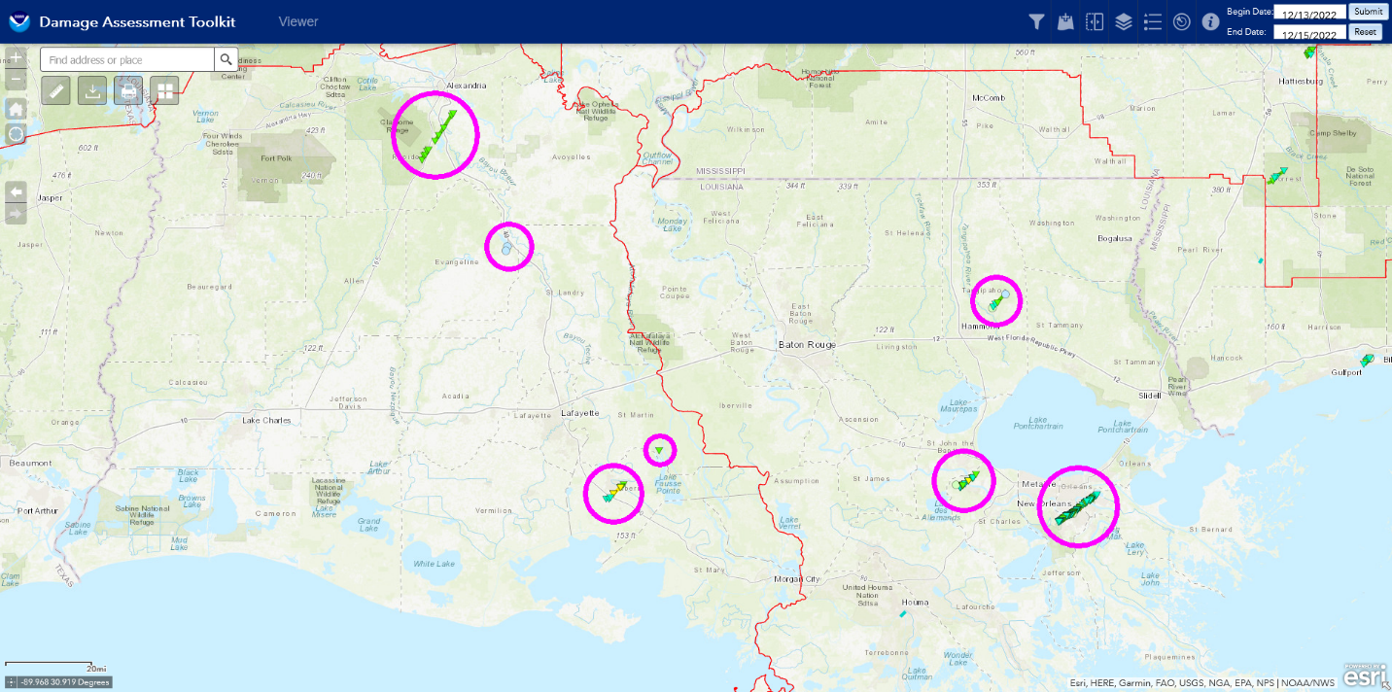
Figure 22 - Seven confirmed tornadoes via NWS survey teams across south Louisiana on 12/14/2022
Keachi Tornado Damage Photos
Courtesy of NWS-Shreveport
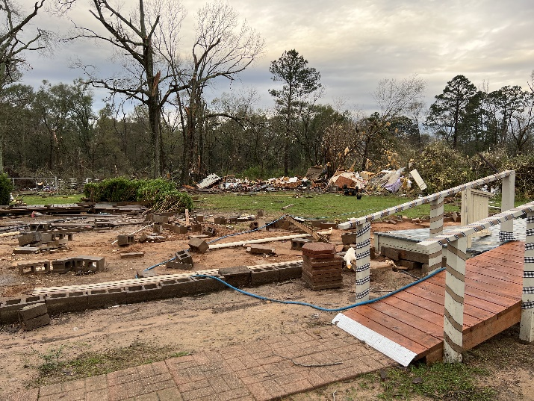 | 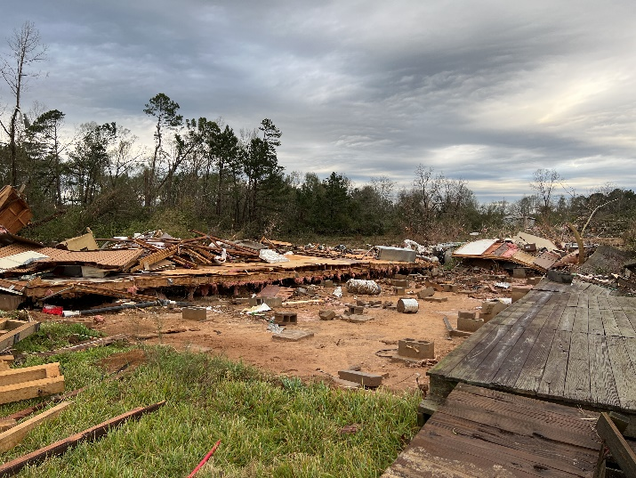
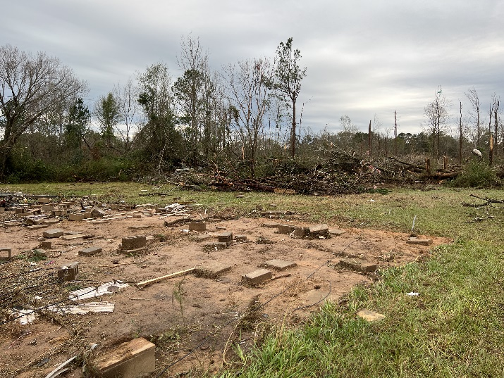 | 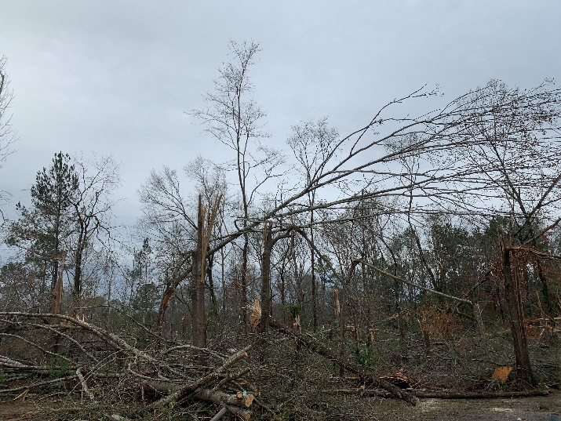

Farmerville Damage Photos
Courtesy of Burt Green/Weather UP and NWS-Shreveport
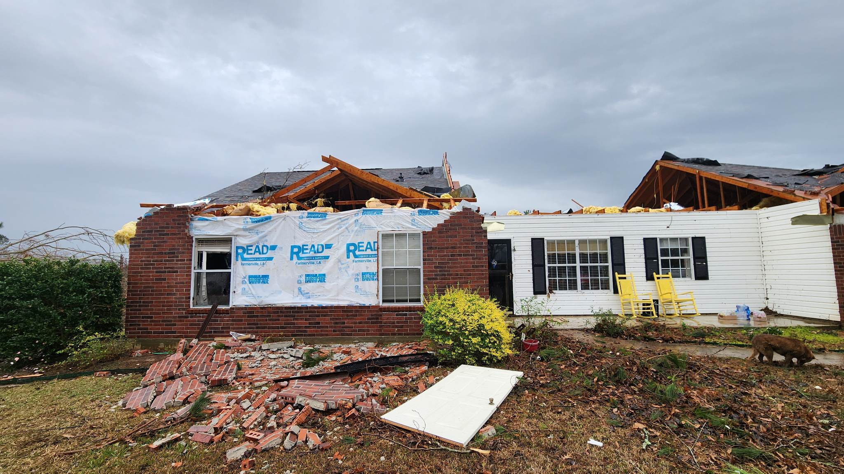

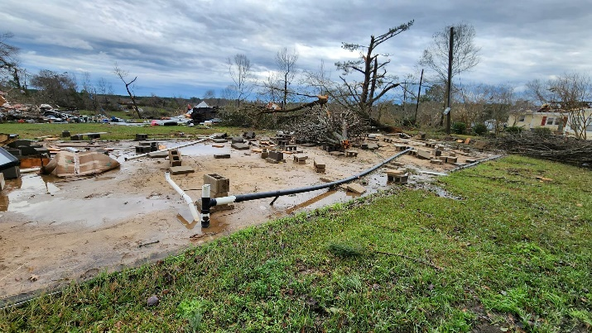 | 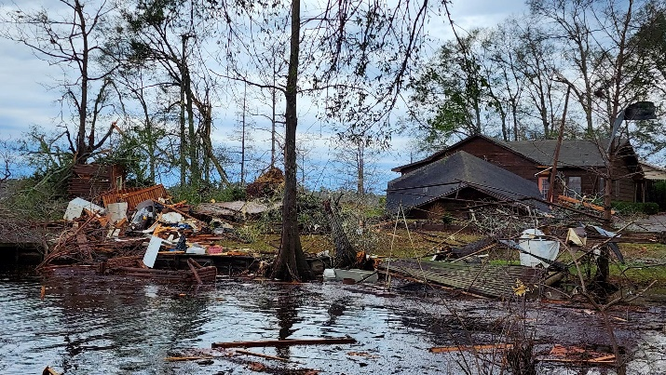
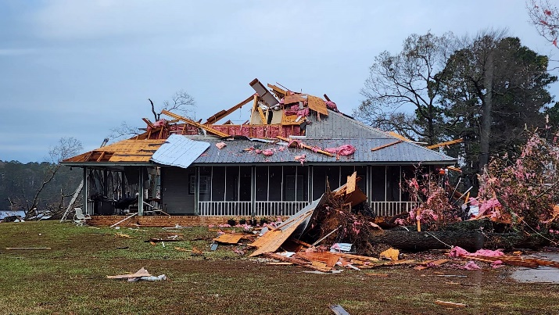 | 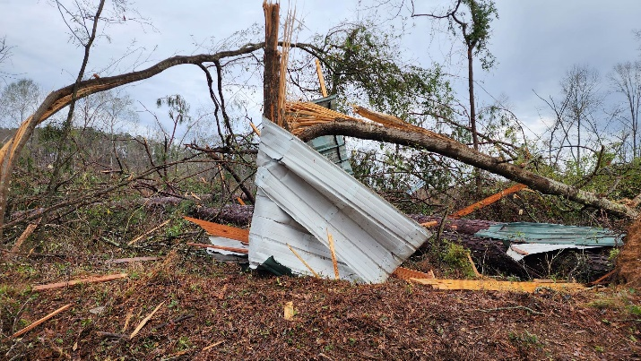

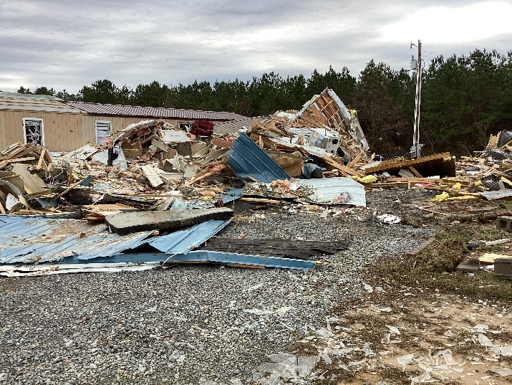 | 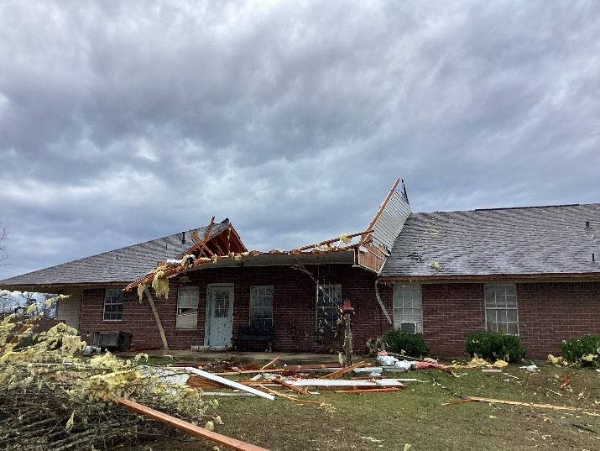
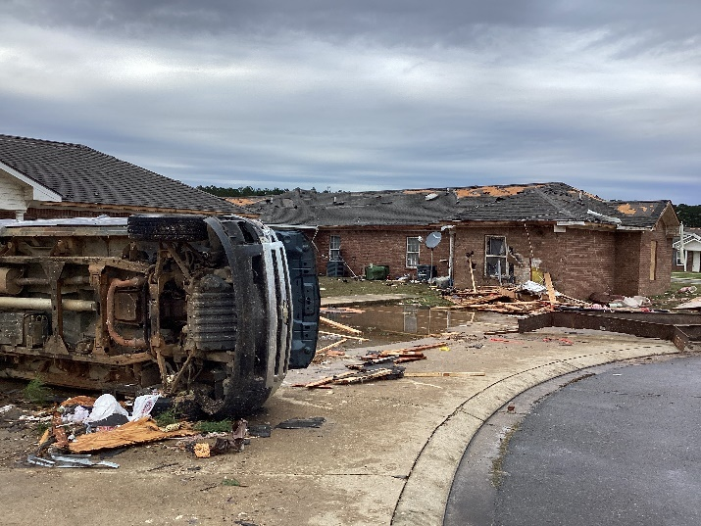 | 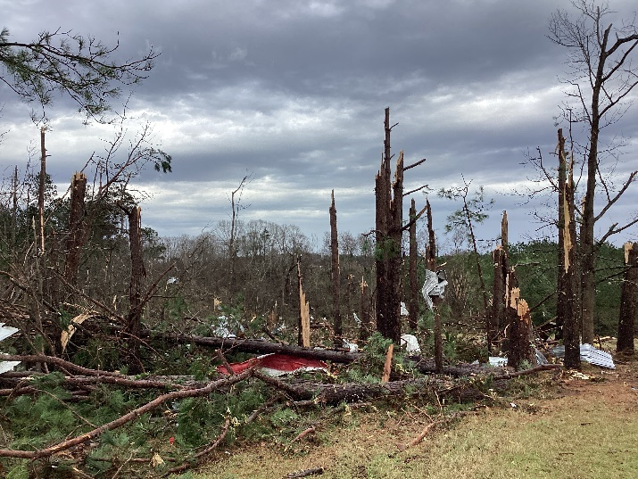
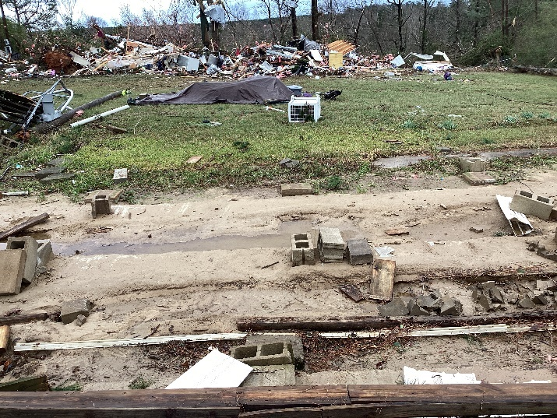 | 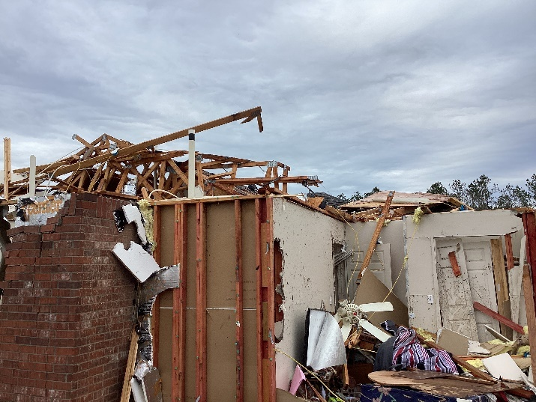
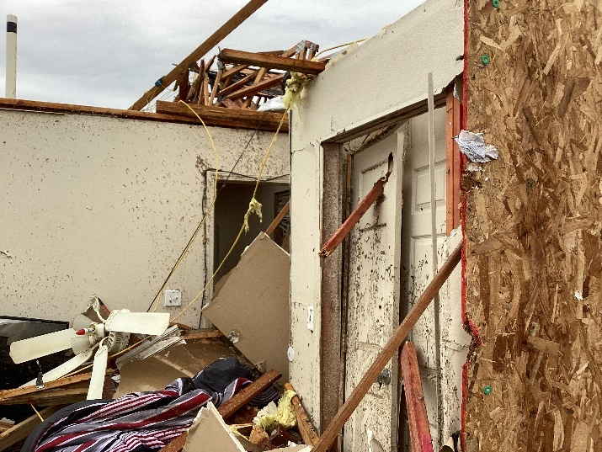 | 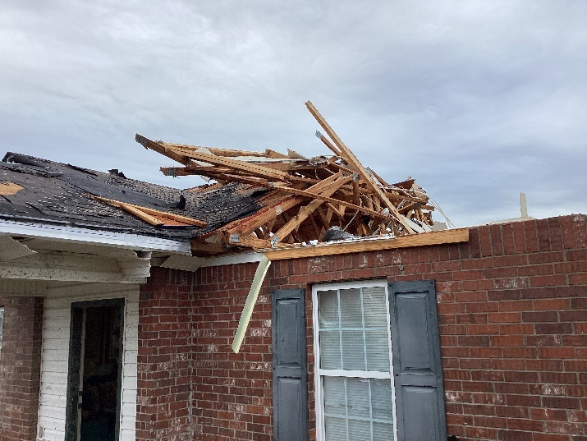

Visible Satellite Imagery from the Morning of December 13, 2022

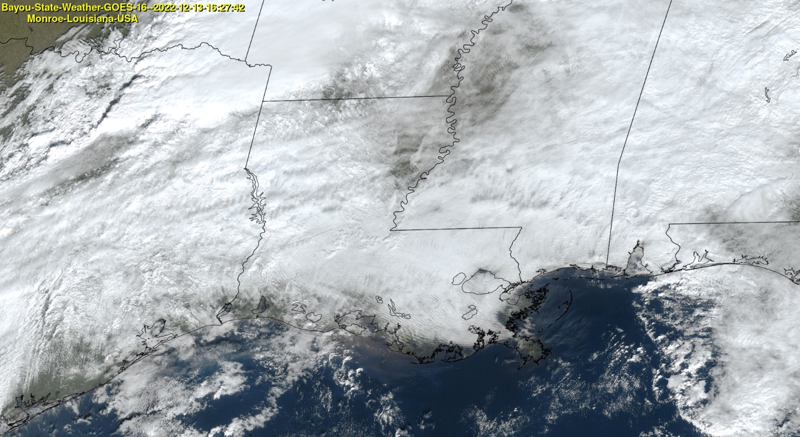

Sources and Contributions

Bayou State Weather, LLC – www.bayoustateweather.com

CNN – www.cnn.com

National Weather Service – Jackson, Mississippi - www.weather.gov/jan/

National Weather Service – Louisville, Kentucky - www.weather.gov/lmk/squallbow

National Weather Service – Shreveport, Louisiana - www.weather.gov/shv/

Storm Prediction Center - www.spc.noaa.gov/

Weather UP – Burt Green - www.facebook.com/BurtGreenWX

Acknowledgement: A special thanks to Mr. Burt Green of Union Parish and “Weather UP” for his contributions to this report and to the weather community in Union and surrounding parishes.

