Louisiana Heavy Rainfall Event – August, 2022

By: Don Wheeler, Meteorologist

Synopsis and Overview
The summer of 2022 began quite hot and dry across north Louisiana. For much of the time our region was dominated by a strong upper ridge of high pressure that kept our temperatures well into the 90s and lower 100s while also suppressing rainfall. From time to time the strength and position of the upper ridge would change so that north Louisiana would get some temporary relief in the form of afternoon showers and thunderstorms, primarily from an active sea breeze front. For south Louisiana, the sea breeze front along with several disturbances in the northern gulf kept rainfall rates quite high from June through August. Some stations across southeast Louisiana saw over 15-inches of rainfall between June 1 and July 30 while most north Louisiana stations saw less than 5-inches over the same period.

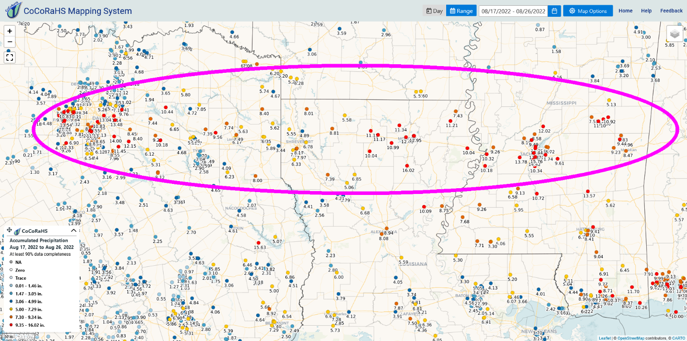
Figure 1 - Heaviest swath of rain totals extended from the Dallas/Ft. Worth areas east along the I-20 corridor to Jackson, Mississippi. Period is from August 17-26.
August 9-10 Event
The first week of August saw a similar pattern to that of June and July. By August 8 and 9 the weather pattern began to change. The upper-level high that had brought persistent hot and dry conditions finally began to significantly lose its grip on our area. On the morning of August 9 an upper-level low was noted spinning over southwest Oklahoma with a nearly stationary frontal boundary across western and northern Oklahoma. Several outflow boundaries from early storms to our northwest were noted across Arkansas. To our south, a tropical wave was progressing west across the north and central gulf providing additional instability and moisture.

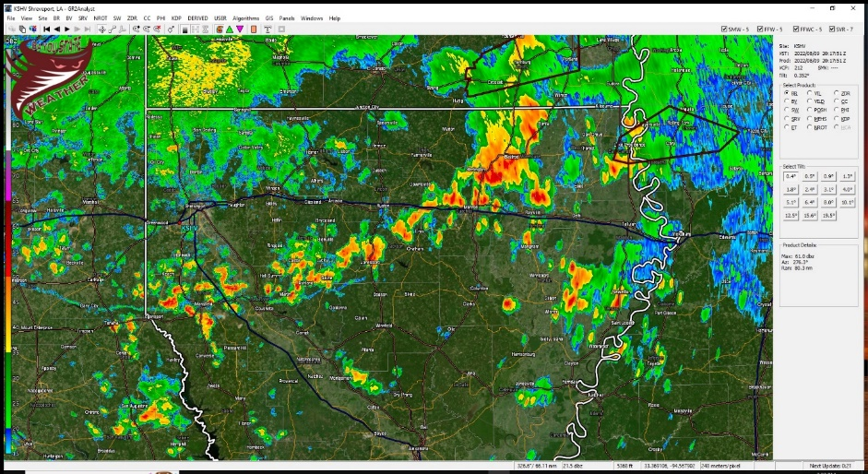
By late morning a line of showers and thunderstorms had formed across southwest Arkansas along an ahead of an old outflow boundary. These storms progressed southeast into north Louisiana during the afternoon hours producing heavy rainfall in some locations. The Monroe Airport recorded a total of 3.53” which set a new record for August 9.
Figure 2 – KSHV Radar 2017Z 08/09/2022

The stationary front that was across Oklahoma on the morning of August 9 progressed southward by the next morning and was situated across central Oklahoma into central Arkansas. Two clusters of showers and thunderstorms formed during the morning hours of August 10 – one over northwest Louisiana and the other over northeast Louisiana. The cluster over northeast Louisiana produced heavy rainfall over a short period of time. Radar estimates showed nearly 4-inches in a couple of hours south of Richwood in Ouachita Parish. The National Weather Service in Shreveport issued a flash flood warning for portions of Ouachita Parish at 11:34 AM. Street flooding was also noted in portions of West Monroe. This rainfall was on top of 1.5 to 3.5 inches that fell the prior day on August 9.

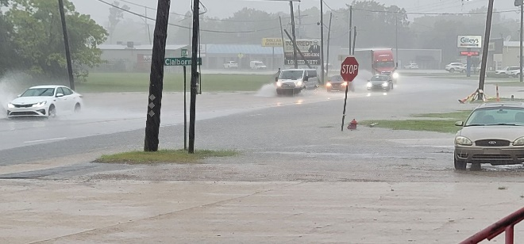  Figure 3 - Street Flooding along Cypress Street in West Monroe. Courtesy of Ben Green and Burt Green/Weather UP | 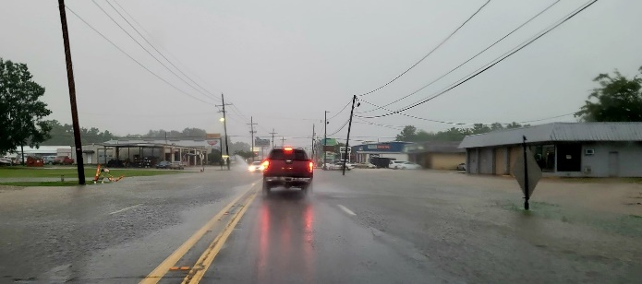  Figure 4 - Street Flooding along Cypress Street in West Monroe. Courtesy of Ben Green and Burt Green/Weather UP

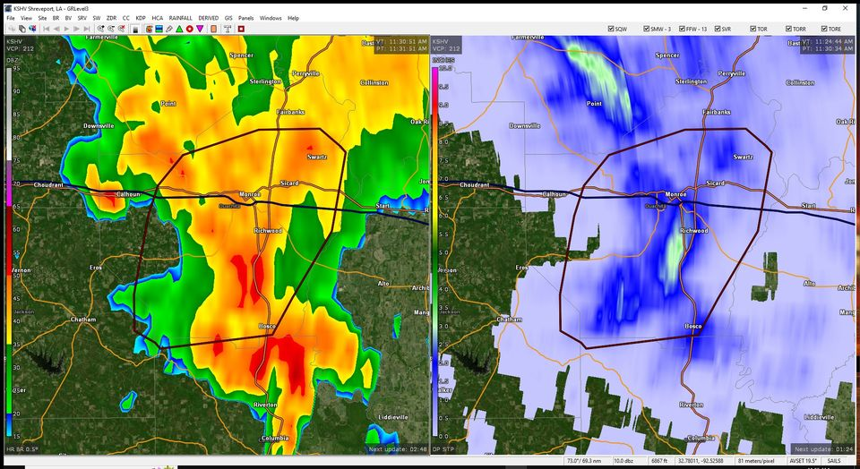
Figure 5 - Slow moving thunderstorm complex over Ouachita Parish 8/10/22 11:30 AM producing flash flooding.
After the heavy rain event on August 10, our weather pattern slowly returned to one similar to that experienced during early summer. Hot temperatures in the upper 90s to lower 100s with only light rainfall amounts were noted on August 11 and 12. The hot temperatures continued through August 16 with little or no rainfall over north Louisiana as the upper-level high briefly re-established itself. By August 17, the upper-level high had retreated west and was replaced by a large-scale upper trough across the eastern U.S. The positioning of these two features allowed for a northwesterly upper-level flow across our region.

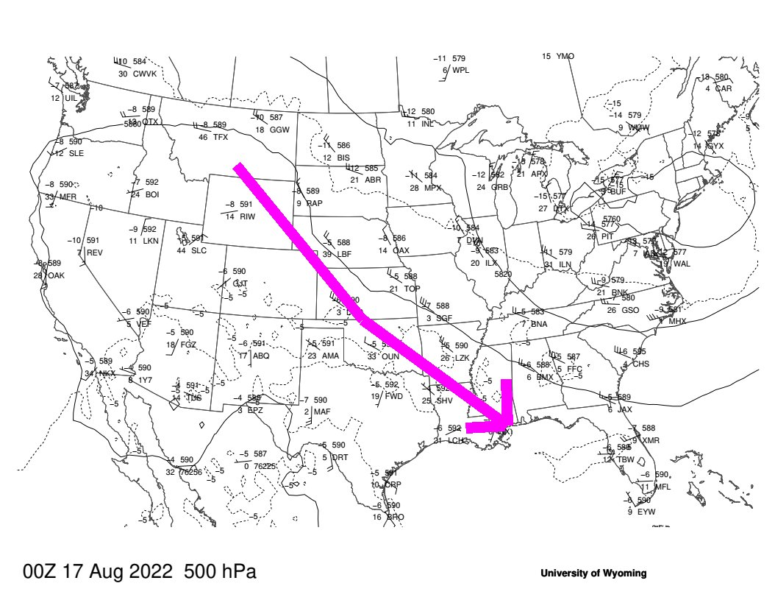
Figure 6- 500mb upper-level depiction showing northwesterly upper-level flow
Ample low-level moisture continued to advect north into the region while the upper-level flow was conducive for periodic upper disturbances to push southeast across. At the surface, a slow moving nearly stationary front set up across the southcentral part of our country providing additional focus for shower and thunderstorm development. On the evening of August 16 (00Z – August 17), the front stretched from a low in northeastern Oklahoma southwestward to the Arkansas/Louisiana/Mississippi borders. This front would weaken and dissipate by the 20th but was quickly replaced by another front on the 22nd. This front set up residency across our state meandering from north to south through August 27 before dissipating.

August 17-27
Between August 17 and August 27, numerous rounds of showers and thunderstorms developed across much of our state adding to the heavy rainfall totals that fell between August 9 and 12. Model guidance picked up on this extended event predicting 7-day totals of 4 to 8-inches across much of north Louisiana. Flash flood watches were issued for much of north Louisiana for Sunday, August 21 through Monday August 22 and would be further extended in both coverage and time.

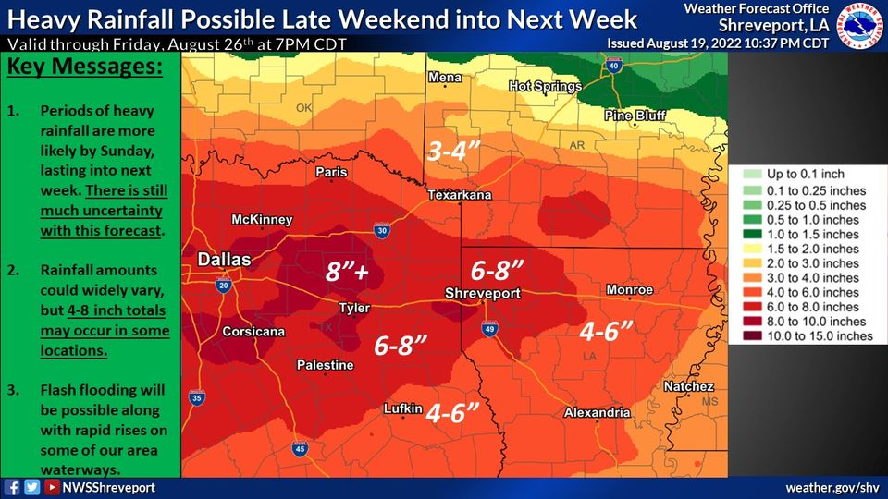
Figure 7 - Rainfall forecast for north Louisiana and surrounding areas August 19-26
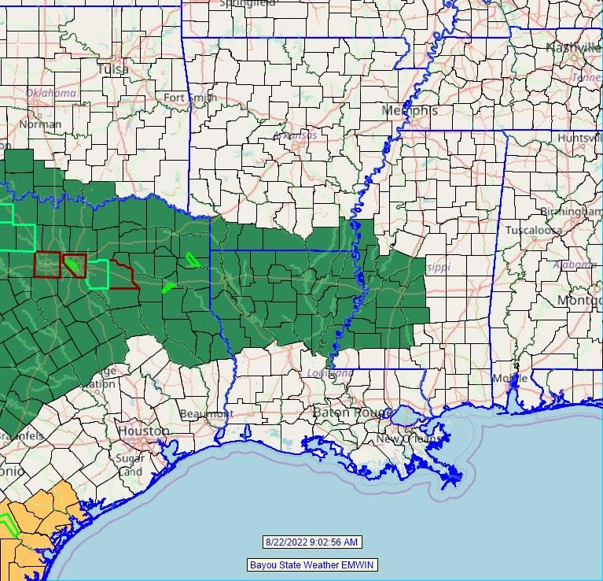
Figure 8 - 9AM August 22, 2022 Flash Flood Watches (green).
The most notable rainfall event came during the very early morning hours of August 22 continuing into the afternoon hours. Models had been focusing on this time frame for the greatest potential of heavy rainfall which would extend from north Texas across north Louisiana. The Weather Prediction Center placed a swath of “Moderate Risk” for excessive rainfall across the Red River area of Texas and Oklahoma southeast into southwest Arkansas and northwest Louisiana. The remainder of north Louisiana was in a “Slight Risk” for excessive rainfall.

Sandbagging stations were set up across both Ouachita and Richland Parishes with four locations in Monroe and one in West Monroe and in Rayville.

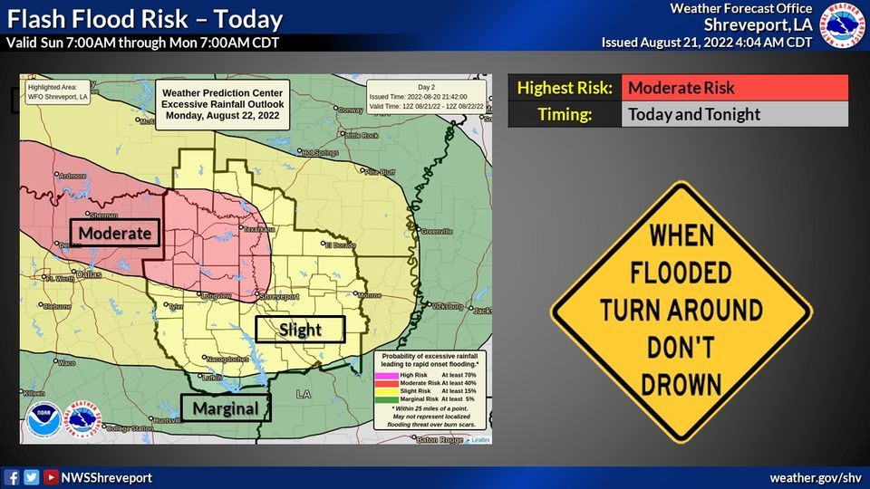
Figure 9- Excessive rainfall outlook for August 21-22
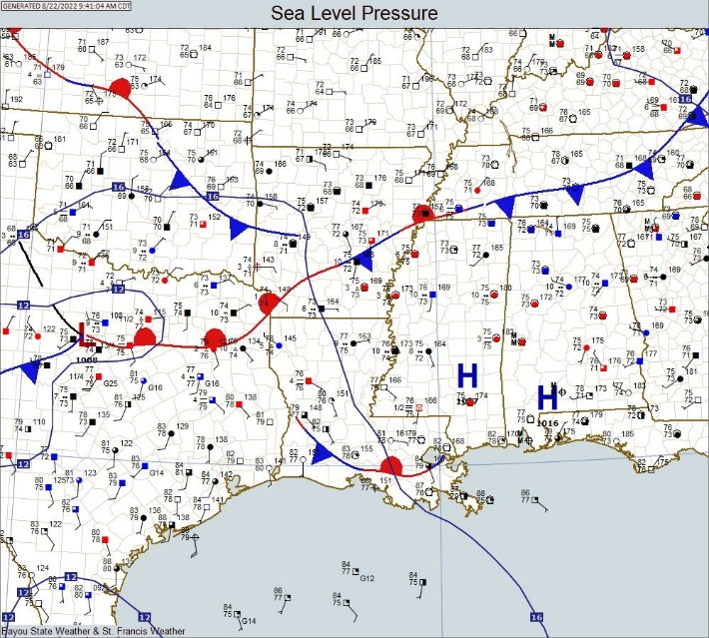
An area of low pressure was centered over northcentral Texas with a warm front extending east of the low into northeast Texas, then northeast into southwestern Arkansas. During the overnight hours of August 21-22, an intense cluster of thunderstorms developed over the Dallas/Ft. Worth area producing copious amounts of rainfall in a short period of time. Totals in excess of 10-inches occurred producing widespread flash flooding.
Figure 10 - Surface map for the morning of August 22

Additional showers and thunderstorms producing heavy rainfall developed along the warm front and marched east during the post-dawn hours overspreading northwest and then northeast Louisiana. During the late morning and into the afternoon hours, multiple waves of showers and thunderstorms overspreading north Louisiana. Rainfall totals based on CoCoRaHS rainfall reports indicate that high-end totals ranged from five to over seven inches across north Louisiana paralleling the I-20 corridor.

Localized flooding during the event included some minor road overflow during the periods of heavier rainfall. One report indicated water over LA-134 in northeast Ouachita Parish. Kiroli Park in West Monroe temporarily closed all trails due to flooding. Other reports of flooding (courtesy of KNOE-TV News) included high water over “many parish and state roads” in Claiborne Parish via reports from the Claiborne Parish Sheriff’s Office. Additional reports of flooding in the Sicily Island area with flooding on Hwy. 921 and some water entering homes near Hwy. 8.

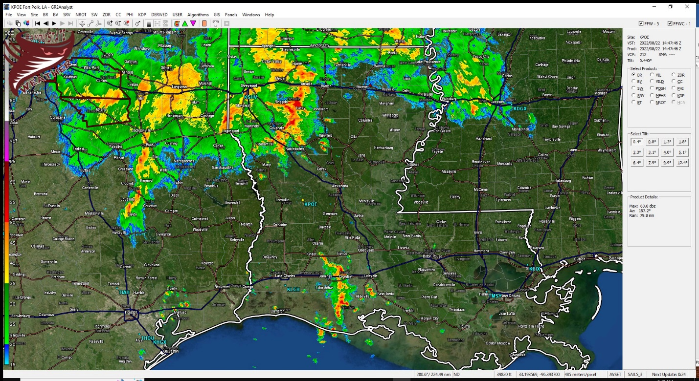
Figure 11 - KSHV radar image of developing rain mass at 9:47 AM, August 22
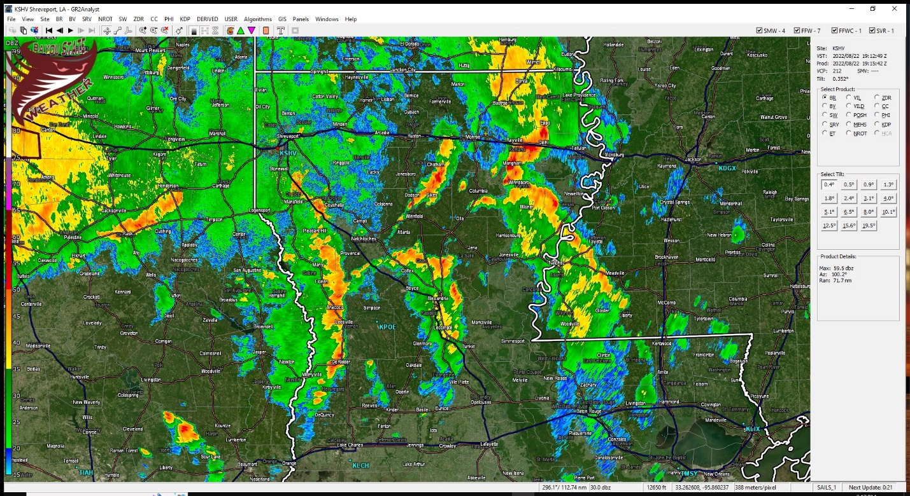
Figure 12 - KSHV radar image of multiple lines of storms at 2:12 PM, August 22
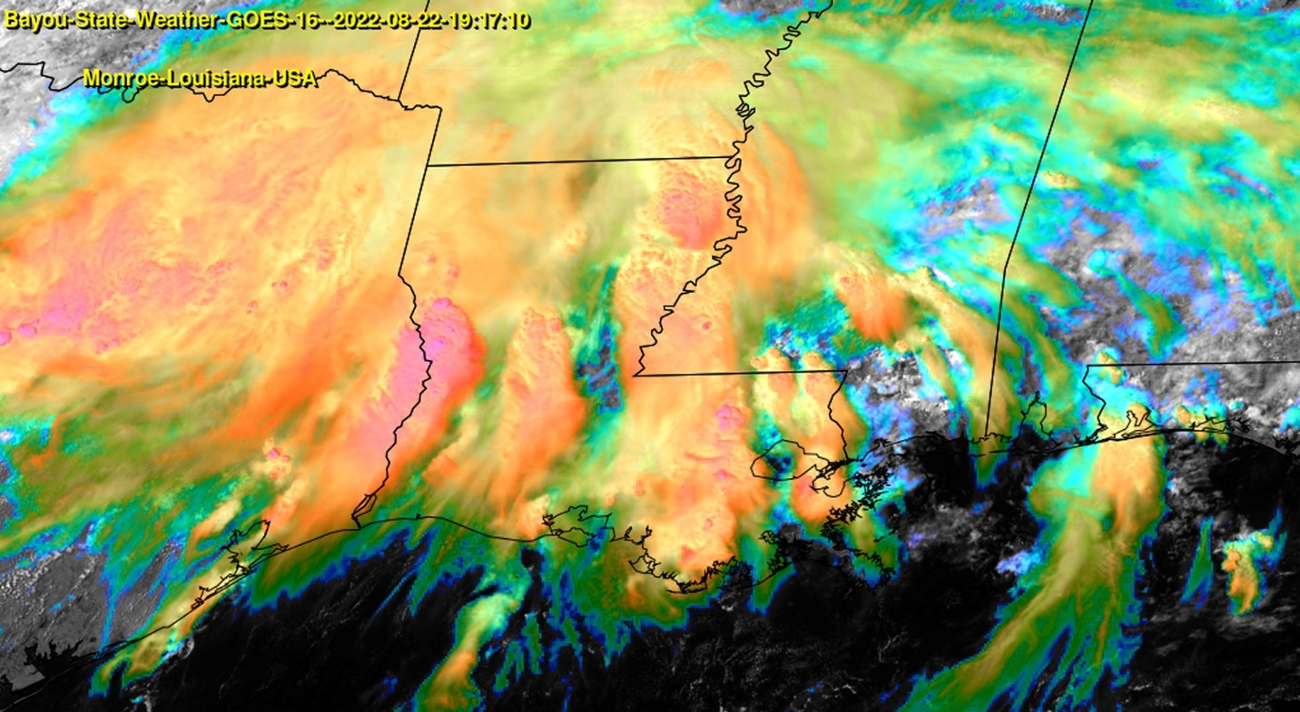
Figure 13 - Enhanced satellite imagery showing multiple lines of storms at 19:17Z
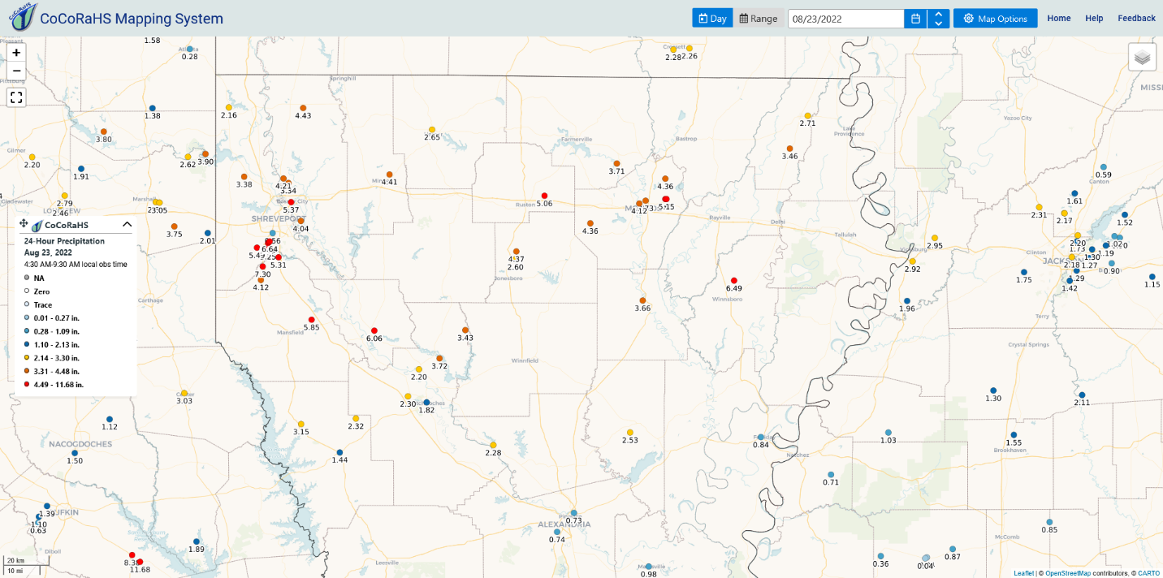
Figure 14 - CoCoRaHS rainfall totals for the 24-hour period from 7AM August 22 through 7AM August 23.
Following the north Louisiana event of August 22, the heavy rainfall threat shifted east to include northeast Louisiana and central Mississippi. During the pre-dawn hours of August 23 another large area of numerous showers and thunderstorms developed across northeast Louisiana extending east into Mississippi. By mid-morning flash flood warnings were prompted for portions of northeast Louisiana for portions of Catahoula and Franklin Parishes. This round of showers and thunderstorms acted as a primer for yet another round of heavy rainfall and flash flooding over the same areas during the pre-dawn hours of the 24th. Flash flood warnings were issued for Grant and LaSalle Parishes northeast to include Madison Parish. Later in the evening, flash flood warnings were extended further northeast to include East Carroll and West Carroll Parishes.

The heavy rainfall in and around the Franklin Parish area caused flooding along the Boeuf River, mainly affecting rural areas and farmlands. Nearby Bayou Lafourche along the Ouachita Parish/Richland Parish line also experienced a significant rise during the month. Smaller streams, bayous, and other tributaries saw rises with the heavier rainfall events while the Ouachita only saw modest rises. Black Bayou and Black Bayou Lake saw a temporary rise as well flooding the boat ramp and many of the walking trails adjacent to the visitor center and within the refuge.

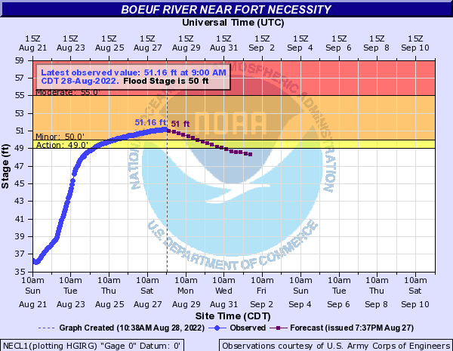
Figure 15 - Boeuf River stage and forecast for August 28
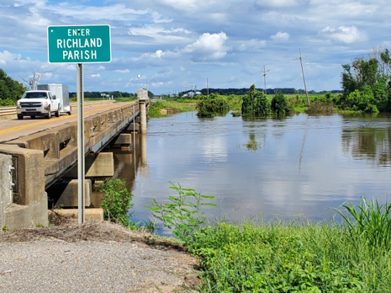  Figure 16 - Bayou Lafourche at LA Highway 15 8/27/22 – Courtesy Tom Malmay | 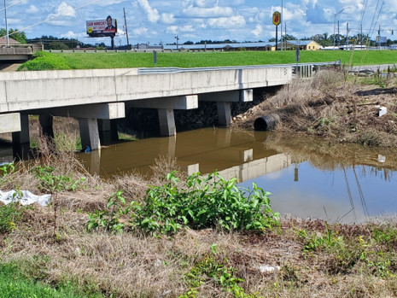  Figure 17 - Youngs Bayou at US Hwy 165 Service Road 8/27/22 – Courtesy Tom Malmay

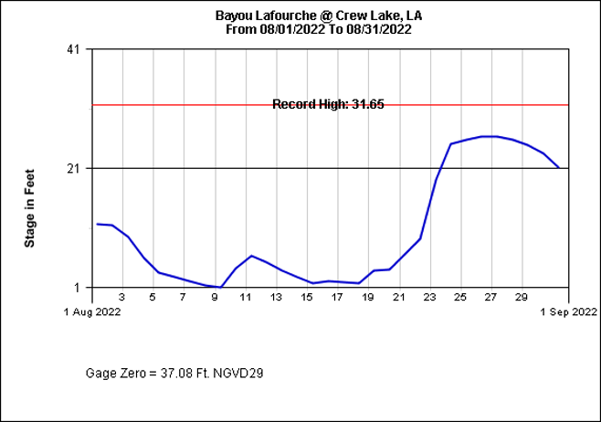
Figure 18 - US Army Corps of Engineers - Vicksburg District - Water Control Center

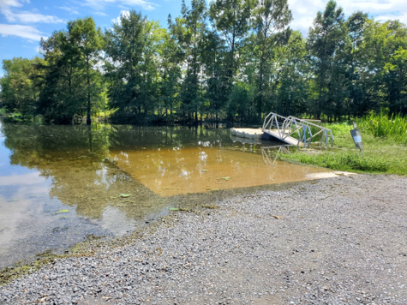  Figure 19 - Black Bayou Lake National Wildlife Refuge Boat Ramp 8/27/22 – Courtesy Tom Malmay | 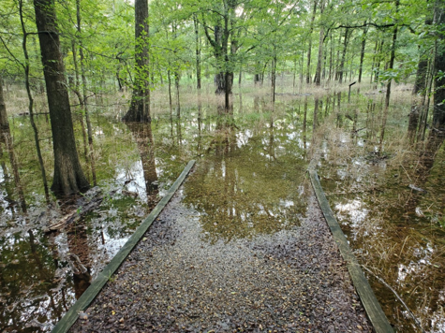  Figure 20 - Black Bayou Lake National Wildlife Refuge Trails 8/26/22 – Courtesy Tom Malmay

The eastern section of this large rain mass extended into central Mississippi where it added heavy rainfall totals to that which fell the day before. Two-day totals for the Jackson area ranged between 10 and just over 15-inches causing the Pearl River to flood.

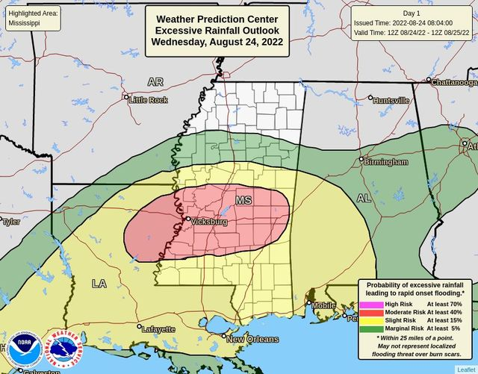
Figure 21 - Excessive Rainfall Outlook for Wednesday, August 24, 2022
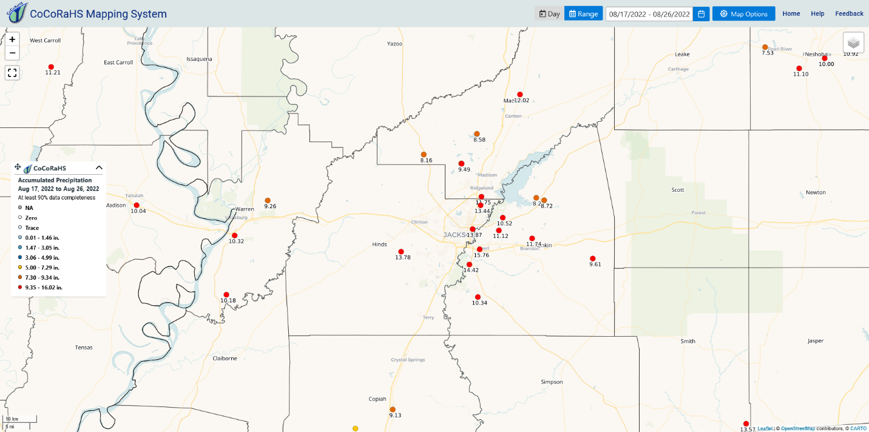
Figure 22 - CoCoRaHS rainfall totals for the Jackson, MS area for August 17-26
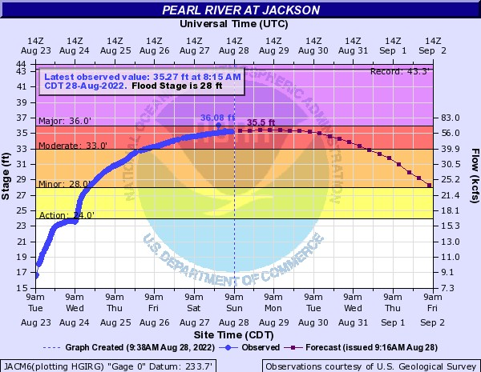
Figure 23 - Pearl River levels and forecast at Jackson, MS for August 28
By August 25, the stationary front that was providing the focus for the waves of heavy rainfall had shifted into central and south Louisiana where it meandered through the 27th before gradually dissipating. Rain-soaked north Louisiana was still seeing scattered shower activity but it was not as widespread and was beginning to limit itself to the afternoon and early evening variety. Unfortunately, south Louisiana was seeing an uptick in heavy rainfall along with the issuance of flash flood warnings, especially across southwest Louisiana. High pressure aloft was beginning to re-establish itself from the east allowing our pattern to resume to more of a sea breeze scenario.

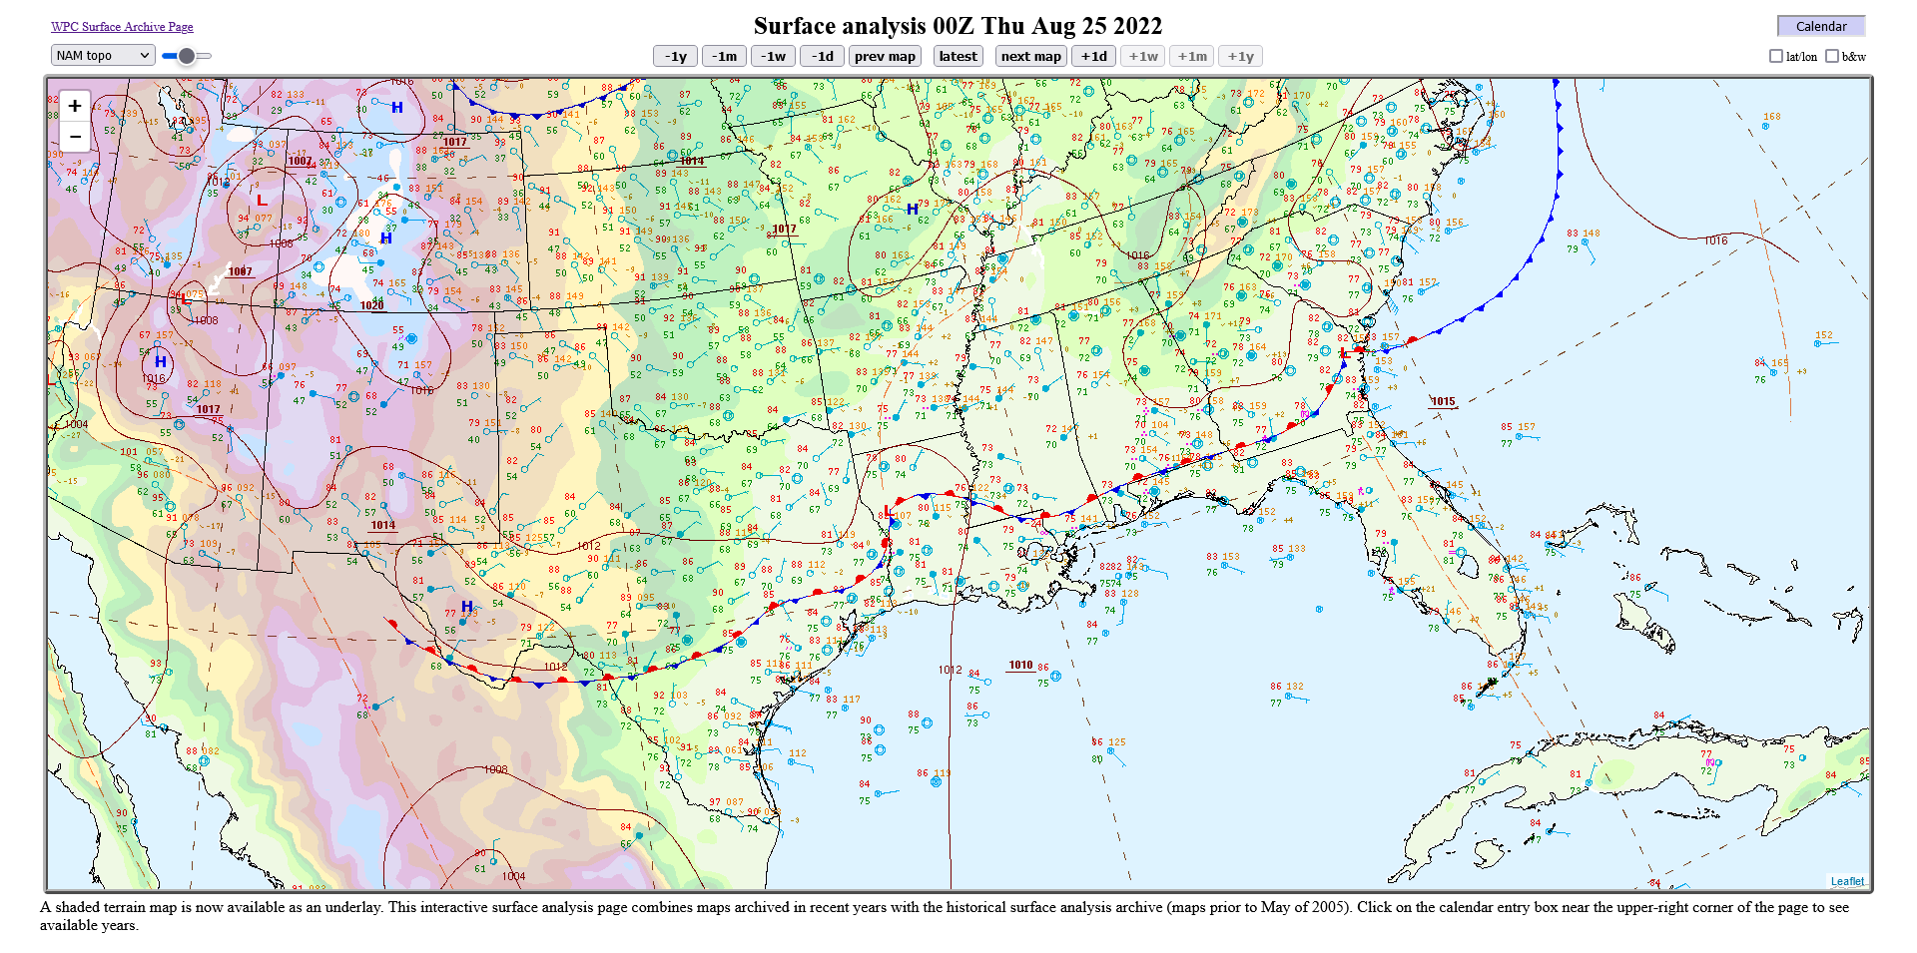
Figure 24 – Surface analysis showing persistent stationary front across Louisiana – 8/25/22 @ 00Z
The last week of August saw a return to a more typical summer-like pattern for late August with diurnal scattered showers and thunderstorms during the afternoon aided by the sea breeze front. The abundant moisture in place and the lack of suppressing systems did keep slightly higher rain chances in place across the state, especially across south Louisiana.

Summary

Multiple rounds of showers and thunderstorms affected most areas of the state during the month of August, 2022. An unusual upper pattern shift for this time of year allowed for several scenarios where slow-moving frontal boundaries set up across the region and provided focus for repeated storm development. With time, these storms would move over the same general area allowing for rainfall totals to accumulate to near-record or record levels. For northern areas of the state saw heavy rainfall over the course of several weeks, widespread river flooding was not observed as excessively dry and hot conditions prevailed during the June and July. Area river and reservoir levels were low and the dry soil conditions allowed for much of the water to adequately be absorbed and/or runoff.

For the Monroe area, a new monthly record rainfall total was established. The old record of 9.43 inches set in 2008 was shattered. The new record for the month of August is 18.40” which is 14.84” above normal for August. This total also ranks as the 5th highest of all months for total rainfall.

All-Time Monthly High Rainfall Totals for Monroe, Louisiana
24.38 (March 2016)
20.56 (October 2009)
18.52 (April 1991)
18.45 (July 1933)
18.40 (August 2022)
18.21 (December 1911)
18.01 (December 1931)
16.30 (May 1989)
16.14 (May 1983)
16.07 (December 1982)

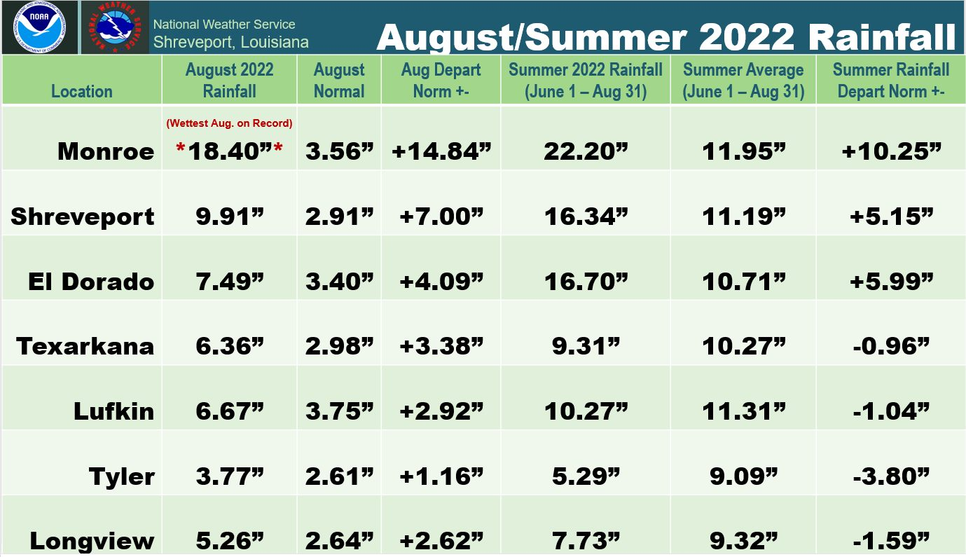
Figure 25 - NWS Shreveport Regional Monthly and Summer Rainfall Totals and Normals

Sources

Bayou State Weather, LLC – www.bayoustateweather.com

CoCoRaHS Rainfall Network - https://www.cocorahs.org/

Iowa State University - https://mesonet.agron.iastate.edu/

KNOE-TV News – https://www.knoe.com

Malmay & Associates (Tom Malmay) - https://malmay-malma.hub.arcgis.com/

National Weather Service Jackson, MS - https://www.weather.gov/jan

National Weather Service Shreveport, LA* – https://www.weather.gov/shv

University of Wyoming - http://weather.uwyo.edu/

Weather Prediction Center - https://www.wpc.ncep.noaa.gov/#page=ovw

Weather UP (Burt Green and Ben Green) - https://www.facebook.com/BurtGreenWX

*A special thanks to Jason Hansford of the National Weather Service at Shreveport for his assistance.

